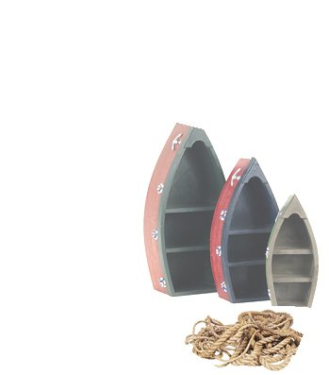
WEST HARBOR GROUP

The Directors of West Harbor Group announce the 2014 Annual Meeting. The West Harbor Group is a non-profit organization composed of the owners of units in West Harbor Landing Boataminium, West Harbor Marina Boataminium, and the Owners of the Cove. The directors are the presidents of the Boataminiums and an owner of the Cove. The purpose of this organization is to maintain the common areas including the pool and grounds.

2014 Directors:
Leo Monroe – West Harbor Marina Boataminium
Alice Randolph – West Harbor Landing Boataminium
Bob McCallen – The Cove

WEST HARBOR GROUP
ANNUAL MEETING
JULY 11, 2014 6PM
Water Park on Constitution

Agenda
- President’s Report
- Treasurer’s Report
- Organizational Update
  - Zoning
  - Signage Internal Rules
  - Township Rules
- Pool Security
  - Discussion of Video Surveillance
  - New Pool Signage
  - Vandalism and Protective Measures
- Golf Cart Operation and Safety
- Street Sign Replacement
- Garage Sale Date and Change in Procedures
- Document Revision – Update
- Condition of Marina
- Shareholders’ Input
- Projects
  - Mounds
  - Diseased Foliage
  - Play Area Fence
- Review of Insurance Coverage
- Shareholders’ Input
- Adjournment

