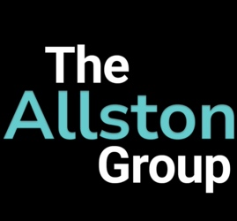
The Allston Group - Data Privacy Agreement (DPA)
Effective Date: [Insert Date]
Parties: The Allston Group (“Service Provider”) & [Client Organization] (“Client”)

1. Purpose & Scope
This Data Privacy Agreement (DPA) governs the handling of donor-related information provided by the Client to The Allston Group for the purpose of Prospect Briefings, Contact Information Verification, and Custom Capacity Ratings.
For Wealth Screenings, no personally identifiable donor data is required or exchanged. We use anonymized database IDs and existing capacity ratings to generate updated financial insights. As such, this DPA does not apply to Wealth Screening services.

2. Data We Require for Other Services
To provide Prospect Briefings, Contact Info Updates, and Custom Capacity Ratings, we require:
- Donor’s first and last name
- Publicly known affiliations (e.g., employer, board memberships)
- Location (City & State or Country)
- Known giving history (if applicable)
This ensures we are researching the correct individual (because there are a lot of “John Does” out there).

3. Data Handling & Security
- All data is used solely for research and advisory purposes.
- Data is not shared, sold, or stored beyond the agreed research period.
- Upon project completion, all files are permanently deleted within 30 days unless the Client requests ongoing services.

4. Client Responsibility
By engaging The Allston Group, the Client confirms that all provided data is lawfully obtained and that they have the authority to share it.

5. Agreement & Termination
This agreement remains in effect for the duration of the services provided. Either party may terminate this agreement with written notice. Upon termination, all Client data will be permanently deleted.
By proceeding with our services, the Client acknowledges and agrees to the terms of this Data Privacy Agreement.
----------------------------------------------------------------------------------------------------------------------------------------------------------------------

Organization:___________ Signature: ___________________
Contact Name:___________ Date: ______________________
Adam Morrow (The Allston Group): _________________ Date: ________

Invoice Number:
Invoice Date:
Payment Due Date:
Services Start Date:
Services End Date:

