
Welcome

Anderson Creek Garden Club
January 20th, 2026
Agenda
Opening Ceremony
- Pledge of Allegiance
- Purpose
- Introduction of Board
- Member Round Table
- Business
- Program “Elliot Rare Plant & Orchids” Eric Walton
Business Meeting
- Financial report, Treasurer
- Membership Drive report
- Gold Star project
- Calendar of Upcoming events
Program “Elliots Rare Plant & Orchids” Eric Walton
Q &A
Reminders Adjourn
Opening Ceremony
Official Collect
The Garden Club of North Carolina, Inc
Our Heavenly Father, who dost feed the birds and clothe the flowers and who knoweth and careth for every need of us, Thy children, so enlighten our minds to use wisely all the gifts of Thy Mighty Hand that we, being imbued with Thy Holy Spirit, may work so Thy will that those who come after may mark their path by our footsteps.
For all the beauty of the earth, Father, in Heaven, we thank Thee.
For our families, our friends, our free and beautiful country, Father in Heaven, we thank Thee.
We beseech Thee of Thy great goodness and tender mercy to forgive our sins and grant that we work together in fellowship, we may draw closer to Thee, Almighty God, in whose name we pray.
Amen
Mary Rehder Gerdes

Overview of Our Purpose
- The purpose of this club shall be: to stimulate interest in horticulture, gardens, youth gardening, and flower arranging; to encourage and improve civic planning; to cooperate in the protection of wildlife, wild flowers, and native plants; and to support the projects of the Garden Club of North Carolina, Inc. and National Garden Clubs, Inc.

President  Janelle Babbs-Nesbit  1st Vice President Julie Smolin  2nd Vice President  Tarrah Williams | Secretary  Judy Murphy  Treasurer  Sherry Moston  Assistant Treasurer  Alexis Weldon
2025-26 Officers
Effective April 2025
Members Roundtable Introductions

Business Meeting
- Treasurer Report, Alexis
- Membership Drive 36 members, 4 new members to (2026)
- Returning member applications sent out this month, renewal due February for March recharter $28

Finance Report
Financials Anderson Creek Garden Club
ASSETS
YE 2025
YE 2026
CURRENT ASSETS
Cash
$75.00
Checking Account
$2,025.71
Total Current Assets
$2,100.71
$0
Total Assets
$2,100.71
$0
LIABILITIES
YE 2025
YE 2026
CURRENT LIABILITIES
$36
Total Liabilities
$36.00
Net Assets
$2,064.71
NEW MEMBERS ALWAYS WELCOME


Gold Star Memorial Progress



Anderson Creek Garden Club 350 Rolling Pines Drive
Spring Lake, NC 28390 P. 2533701757
E. andersoncreekgardenclub@gmail.com

January 12, 2026

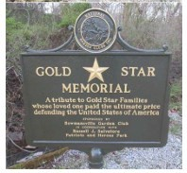
COL K. Chad Mixon
Commander, U.S. Army Garrison – Fort Bragg
2843 Normandy Drive
Fort Bragg, NC 28304

COL K. Chad Mixon,

I, Janelle D. Babbs-Nesbit, as Board Chair of Anderson Creek Garden Club, am offering an unsolicited gift to the United States Army of a Gold Star Memorial on the condition that the Army use it to benefit Fort Bragg Servicemembers, Department of the Army and Air Force Civilians, and their Families. The gift has a total value of $2600 and will be provided at no cost to the Army.

On behalf of the Anderson Creek Garden Club, we respectfully request permission to place a Gold Star Memorial at the corner of Nursery Road and Highway 87 on Fort Bragg property. This memorial would stand as a permanent tribute, honoring the ultimate sacrifice made by service members and their families. Our club is fully committed to installing and maintaining this marker with the utmost care, ensuring it serves as a lasting and dignified point of reflection for all who pass by this honored ground.

The placement of a Gold Star Memorial at the corner of Highway 87 and Nursery Road, near the heart of Fort Bragg, holds profound significance. It transforms a highly visible public space into a permanent, sacred site of remembrance for the fallen heroes of our nation and the Gold Star Families who bear the ultimate sacrifice. At a post like Fort Bragg, a cornerstone of American military power, this memorial serves as a crucial, solemn counterpoint—a daily reminder to the surrounding community and the soldiers who pass by that freedom is secured through profound loss. Its placement on a major artery ensures that this tribute is not hidden, but integrated into the fabric of daily life, fostering continuous reflection and honoring the enduring legacy of service and sacrifice that defines Fort Bragg and the nation it protects.

I understand that the Army will make no public announcement of this gift or in any other way endorse Anderson Creek Garden Club. Furthermore, I understand that Anderson Creek Garden Club will receive no special privileges, concessions, or consideration from the Army upon acceptance of this gift.

My point of contact for this action is the undersigned by phone at:.2533701757 or email at Janellednesbit@aol.com or andersoncreekgardenclub@gmail.com.

Respectfully,

Janelle D. Babbs-Nesbit
MEMORIAL MARKER (BLUE &
GOLD STAR FAMILIES)
Permitted on the grounds of
National Cemeteries, Veteran
Administration Medical Centers and any other appropriate civic location, as approved by NGC Blue Star Chairman
COLOR: Same as Highway
Marker All details of Highway Marker apply. Both Markers are delivered with eight setscrews PRICE: $2460. (includes 7’ post)
$2635. (includes 10’post)

Save the dates:

The Year • February 17-6:30 pm meeting
Ahead In • March 17-11am meeting
PROGRESS • April 11- Roadside Clean-up
Strategic Plan • April 21 – 6:30 pm Meeting
- May 19 –tbd
- June 16- 6:30 pm meeting

February Meeting “Pinecone Posie Bouquets”
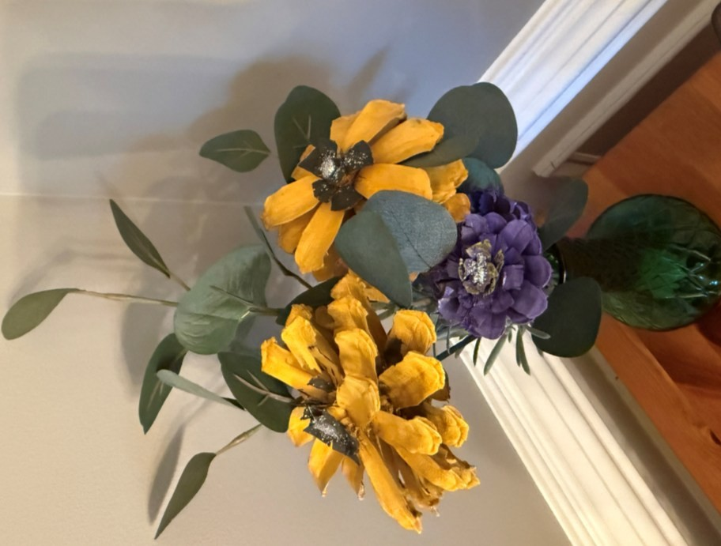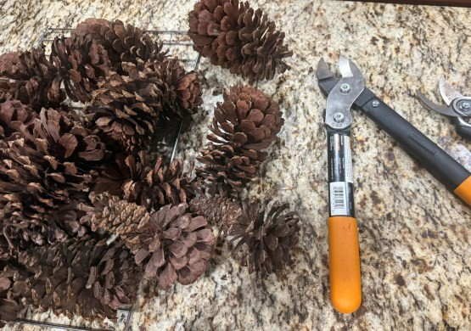

Business Meeting -Save the Dates
February 17th 6:30 pm
- ACGC meeting , Pinecone Posie
Bouquets $5 members, $10 non-members o
SAR Meeting -Blennerhassett Hotel in Parkersburg, WV
March 20–23, 2025
from
- GCNC Annual Convention & Meeting,
MAY 17-18, 2026
Hilton Garden Inn Greensboro-
"Growing Together
Communication – Collaboration Education“ o National Garden Club Annual Conference- May 4, 5, and 6,
2026-St. Louis, Missouri o Youth Garden Club, focus group
- Gold Star Highway Project---Next step –site selection,
fundraising $3000

The Garden Club of North Carolina State Meeting
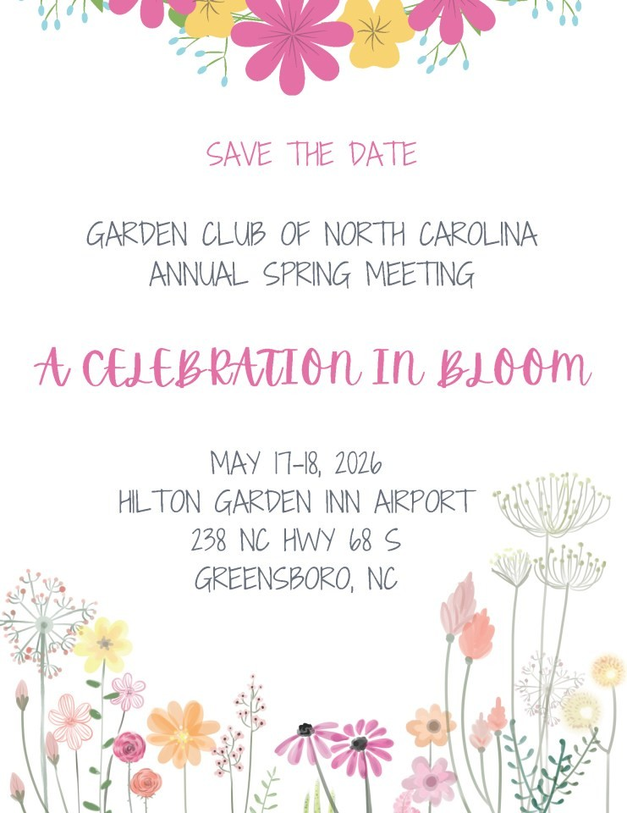
NGC Convention

St. Louis, MO May 4 - 6 2026
2026 Convention
St. Louis, MO--May 4 - 6 2026
Overview

2026 National Convention May 4 – May 6, 2026
"Meet Me in St. Louis, Where the River Bends and The Arch Reaches the Sky!" Registration Now Open: CLICK HERE TO REGISTER!
$100 Late Fee for Registrations After March 31, 2026
Deadline for All Registrations: April 14, 2026
REGISTRATION POLICY
Walk-in registrations will not be accepted.
Registrations are NON-REFUNDABLE after April 14, 2026.
LATE FEE: All registrations submitted after March 31, 2026 will require an additional $100.00 late fee.
No registrations will be accepted after the deadline of April 14, 2026.
HOTEL INFORMATION
Please reserve your accommodations directly with the Hilton St. Louis at the Ballpark using the link below:
https://book.passkey.com/e/51176836
Room Rate: $189.00 per night (single or double occupancy)
Total with taxes & fees: $224.76 per night
Self-Parking: $35.00 per day (in-and-out privileges)
Valet Parking: $50.00 per day
Hotel Reservation Deadline: April 14, 2026


2026 SOUTH ATLANTIC REGION CONVENTION
March 21-22, 2026
“A Garden for All”
Convention – South Atlantic Region

SAR Convention Schedule Friday,
March 20, 2026 –
SAR Convention 8:00-5:00 ………………………………………….… Registration 9:00-10:00………………………………………….... SAR Finance Committee 10:00-11:00………………………………………..… SAR Exec Committee 11:15-12:15…………………………………………..
SAR Lunch* No Speaker Not in package 12:30-1:30
……………………………………..…….
SAR BOD Meeting 2:30-4:30 ……………………………………........…
Tea at Parkersburg Art Center (PAC) 6:00-7:00 ……………………………………….…… Cocktails – Cash Bar 7:00-10:00 ……………………………………..…….
Dinner A Red White Blue Birthday Speaker - Becky Park – Col. Bradley
Saturday, March 21, 2026
– SAR Convention 8:00-5:00
……………………………………………
Registration 9:00-5:00..…………………………………...…........
Boutique/Vendors 8:00-9:00 …………………………………………… Breakfast 9:00-11:00……………………………………………
SAR General Session 11:30-1:30……………………………………………
SAR Award Lunch Speaker - Tara Ranson –
Membership 1:45-2:30 ……………………………………………
Workshop 1 2:30-3:15 …………………………………………… Workshop 2 3:30-4:15 ……………………………………………
Workshop 3 6:00-7:00 ………….…………………………………
Cocktails – Cash Bar 7:00-10:00…………………………………..………..Vintage Design Dinner Speaker -Adam Dotson
Workshops
Workshop 1 Garden Therapy Sheila Rose
Content: The workshop will cover the history, models of garden therapy, and share personal experiences. Attendees will participate in a garden therapy exercise and bring home ideas for garden club activities.

Workshop 2 Make A Wreath Gary Harrison
Content: Join Gary as he teaches us the art of spring wreath design. Provided will be silk flowers, wreaths, ribbons and knowledge. Please bring a hot glue gun, scissors and wire cutters. The wreath will be the highlight of your front door for years to come. The cost of the workshop is $50.
Workshop 3 Grow with Social Media Brandi Ross
Content: Brandi will share her passion of building community using social media with an emphasis on Facebook. She also plans to offer some tips to help increase club membership and strengthen community support. Gardening is her passion, teaching others is her mission.
Please complete form; make checks payable to “SAR” and mail to: Ernie Simien 5229 Staunton Ave SE Charleston, WV 25304
- Email: e_simien@hotmail.com
- Phone: 713-582-7935
- Postmarked by February 27, 2026 for on time registration.
- No late registration!
- Hotel Registration All hotel registrations should be made directly with The Blennerhassett Hotel by calling 304422-3131 or on the website https://booktheb.com/ and by using the WV Garden Club Reservation Group ID 69793. Room Rates: Double - $140, Traditional King - $150, Deluxe King - $160, Superior King $170, Junior Suite - $220 Hotel reservations must be made by Friday, February 20, 2026 to obtain these rates.

January Program



General Program Resource Links
- https://harnett.ces.ncsu.edu/horticulture-resources/
- https://harnett.ces.ncsu.edu/categories/lawn-garden/extensionmaster-gardener-volunteers/
- https://extensiongardener.ces.ncsu.edu/extension-gardenerhandbook/
- Herbaceous Ornamentals | NC State Extension Publications • Ensuring Long-Term Viability of your Forest Resources
- Find a Plant | North Carolina Extension Gardener Plant Toolbox
- Platanthera (Butterfly Orchid, Fringed Orchid) | North Carolina Extension Gardener Plant Toolbox
- Graceful and Glorious: A Beginner’s Guide to Orchids | N.C.
Cooperative Extension

QR Code for Plant NCSU Plant Tool Box

Meeting Questions
• Q & A Session

Closing Remarks Adjournment
                - February 17th, 6:30 pm Pinecone Bouquets
                - March 17th 11 am,
                - Carvers Creek
                - State Park
                - April 11th Roadside Clean-up
                - Youth involvement, Western Harnett
FFA, Anderson
Creek Charter &
PreK

QR Code for ACGC Facebook Page
Facebook, follow us #Andersoncreekgardenclub

https://www.facebook.com/share/1ELzoXjKhD/?mibextid=wwXIfr

