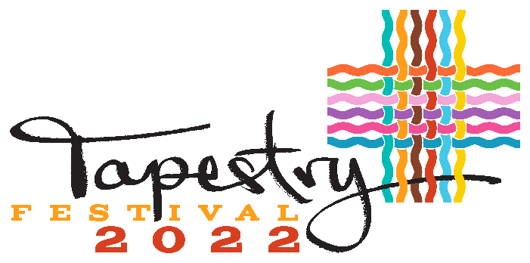

Kamloops 1st Annual Multicultural Festival
September 24th, 12pm – 5pm

Art Pavilion Application Form
Name of (Country) / Ethno-Cultural Group
________________________________________________
Contact Name: ___________________________________________________________
Mailing Address: __________________________________________________________
City: ______________________ Prov.______________ Postal Code: ______________
Email: ______________________Cell Phone: __________________Emergency#:___________________
Pavilion Details
Describe your art & how you what you will story tell to your visitors ______________________________________________________________________________________________________________________________________________________________________________________________________________________________________
❑ Tapestry festival’s goal is to deliver a collection of exciting art in the Art Pavilion representing a specific country, culture or ethnicity.
❑ We have our Country flag for display ❑ We need our Country flag for display
Art Pavilion:
The Art Pavilion will consist of 4 -5 Artists from all areas & cultures. We will ask that you bring your art to the Pavilion to set up. You are also welcome to create art while you are at the Festival to show the visitors more about your art. You will be expected to tell a story about your art & how you create it in reference to your own culture. We want the visitors to go away having a better understanding of your art & your culture
Please complete the form below and submit by Aug 3rd /22 to reserve your spot.
Event Date/Time:
2022 Sept 24th, 12pm~5pm
Location: McDonald Park

EVENT MISSION
TAPESTRY FESTIVAL 2022 celebrates our city’s rich multiculturalism and diversity with an inclusive and welcoming event featuring music, dance, food and the arts.
EVENT VISION
TAPESTRY FESTIVAL 2022 highlights the cultural diversity of our City to create a positive, inclusive Community where members feel recognized, accepted, with a strong sense of self.
INVITATION
Tapestry Festival 2022 invites you to celebrate Kamloops rich multiculturalism and diversity by proudly hosting a Cultural Pavilion featuring your country of origin and engaging with visitors.
A performance stage will be erected to feature local and regional artists and talents, and the event will feature a pop-up Art Exhibit, Cultural Foodies Court and Around the World Kids Zone.
We anticipate the advertisement for the event to reach out to over 50,000 people & expect to have 4,000+ visitors attending out Tapestry 2020!
Art Pavilion:
The Art Pavilion will consist of 4 -5 Artists from all areas & cultures. We will ask that you bring your art to the Pavilion to set up. You are also welcome to create art while you are at the Festival to show the visitors more about your art. You will be expected to tell a story about your art & how i=you create it in reference to your own culture. We want the visitors to go away having a better understanding of your art & your culture
The applicant’s operations must reflect the culture and heritage of an identifiable ethno-cultural group of which they are a part.
Eligibility Criteria:
- Set up begins at 10:00 am on Saturday Sept 24th 2022 and exit must be completed by 6:00 pm.
- Applicants are prohibited from displaying, speaking, handing out or promoting any forms of content that are offensive.
- Applicants promoting any political parties, affiliated groups and their policies will not be allowed to participate.
- Applicants promoting religious content for the purpose of advocacy, conversion or expanding membership will not be allowed to participate.
- Applicants are not allowed to discuss, display or promote content that discriminates based on gender, race, religion, caste, creed, origin disability, handicap, age, sexual orientation or any other basis prohibited by law and as deemed by the Tapestry Festival.
- The Tapestry Festival has the sole discretion, at any time and at any stage to refuse participation of any group that does not adhere to the stipulations set out in the terms and conditions of the eligibility criteria in order to maintain the vision and mission values of the Festival.
- Applicants are responsible for keeping their area clean at all times during the festival and cleaning up afterwards.
- Valuables should not be left unattended in the tent or at your table. Tapestry Festival will not be responsible for lost, stolen or damaged items.

**Parking: Limited –
You will be able to unload between 10:00am and 11:00am, then park your vehicle on the neighborhood streets.
***Duration: Your pavilion must be attended until 5:00pm

** I acknowledge that I have carefully read and understood the eligibility criteria.
Signature: ___________________________ Date: _____________________
*** I acknowledge that any pictures taken during the Festival will be used for marketing purposes for the Multicultural Festival.
Signature: ___________________________ Date: _____________________
North Shore BIA. 115 Tranquille Road Kamloops BC V2B 3M5 Ph: 250.376.2411 patti@nsbia.com

