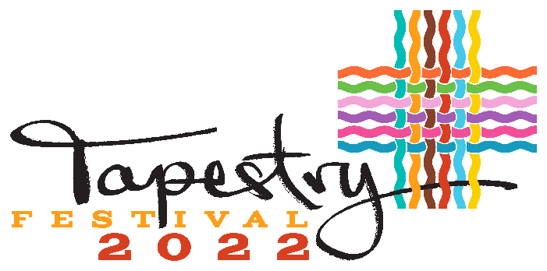

Kamloops 1st Annual Multicultural Festival
September 24th, 12pm – 5pm

Cultural Pavilion Application Form
Name of Pavilion (Country) / Ethno-Cultural Group
________________________________________________
Contact Name: ___________________________________________________________
Mailing Address: __________________________________________________________
City: ______________________ Prov.______________ Postal Code: ______________
Email: ______________________Cell Phone: __________________Emergency#:___________________
Pavilion Details
❑ Submit the Country biography and a photo (JPG) that best represents the country you are representing at Tapestry Festival. This will be displayed at https: www.tapestryfestival.ca
Describe what the audience can expect to see, learn, try, etc.: ______________________________________________________________________________________________________________________________________________________________________________________________________________________________________
❑ Tapestry festival’s goal is to deliver a collection of exciting pavilions representing a specific country, culture or ethnicity. Please confirm that your pavilion meet at least one of the two criteria listed below: (Circle)
1. Cultural Entertainment (audio/visual) ❑ Will require access to electrical outlet
2. Cultural activity i.e. crafts, games, etc.
❑ Our group will bring its own tent What size is it? ___________ What color?______________
❑ Our group is not bringing a tent but do need a space (size) ______’____ft_x_________’____ft_
❑ Our group will bring chairs and tables needed|
❑ We have our Country flag for display ❑ We need our Country flag for display
EQUIPMENT RENTAL REQUEST - We can provide you with:
Item | Cost/unit | Quantity | Total
Tent 10’ x 10’ | $75 installed |  | $ +tx
Tent 10’ x 20’ | $305 installed |  | $ +tx
Chairs | $2 |  | $ +tx
Tables 6’ | $10 |  | $ +tx
Add 5% GST and 7% PST to Tent, chairs and tables
Grand Total: $___________.____
Paid cash or by cheque to: North Shore Business Improvement Association
Registration to host a Cultural Pavilion at Tapestry Festival 2022 is FREE
Please complete the form below and submit by Aug 3rd /22 to reserve your spot.
You must pay the rental fees by Sept 12th /22.
Event Date/Time:
2022 Sept 24th, 12pm~5pm
Location: McDonald Park

EVENT MISSION
TAPESTRY FESTIVAL 2022 celebrates our city’s rich multiculturalism and diversity with an inclusive and welcoming event featuring music, dance, food and the arts.
EVENT VISION
TAPESTRY FESTIVAL 2022 highlights the cultural diversity of our City to create a positive, inclusive Community where members feel recognized, accepted, with a strong sense of self.
INVITATION
Tapestry Festival 2022 invites you to celebrate Kamloops rich multiculturalism and diversity by proudly hosting a Cultural Pavilion featuring your country of origin and engaging with visitors.
A performance stage will be erected to feature local and regional artists and talents, and the event will feature a pop-up Art Exhibit, Cultural Foodies Court and Around the World Kids Zone.
We anticipate the advertisement for the event to reach out to over 50,000 people & expect to have 4,000+ visitors attending out Tapestry 2020!
Cultural Pavilion:
- A pavilion is 10’ x 10’ or 10’ x 20’
- Ethno-cultural groups may have a maximum foot print of 20’ x 20’
- Cultural pavilions must include an interactive activity
- Hosts can be: a cultural group, a family or group of families, a group of friends
- You will have the opportunity to create a cultural prop or a sign for your pavilion with Kamloops Makespace
Interactive and Engaging:
In addition to featuring exciting cultural displays, see examples of interactive activities a pavilion could feature:
– Exhibits: could include paintings, posters, arts, crafts, jewellery, books, traditional outfits
– Calligraphy: Visitors can have their name written in the country’s language
– Kids and parents: Can learn a new traditional game played in your country of origin
– Photo Setting: Visitors can get their photo taken in your country’s traditional costume
– Documentary: You could feature a video/audio presentation about your country’s history, culture, tourism
and a brief Bio about some famous Legends
The applicant’s pavilion operations must reflect the culture and heritage of an identifiable ethno-cultural group of which they are a part.
- For the purposes of this application, an ethno-cultural group is defined as: “A group which differs significantly from other groups in some, or all of such cultural components as language, food, dance, dress, music, arts & crafts, and relates to a specific country of origin”
- Please note that there can only be one pavilion per country of origin. We encourage groups to work together to be inclusive where possible.
If the number of applications exceeds the amount of space on site, Tapestry 2022 Organizing Committee reserves the right to limit the size of a cultural pavilion and has final approval of all pavilion footprints and locations.
Eligibility Criteria:
- Set up begins at 10:00 am on Saturday Sept 24th 2022 and exit must be completed by 6:00 pm.
- Applicants are prohibited from displaying, speaking, handing out or promoting any forms of content that are offensive.
- Applicants promoting any political parties, affiliated groups and their policies will not be allowed to participate.
- Applicants promoting religious content for the purpose of advocacy, conversion or expanding membership will not be allowed to participate.
- Applicants are not allowed to discuss, display or promote content that discriminates based on gender, race, religion, caste, creed, origin disability, handicap, age, sexual orientation or any other basis prohibited by law and as deemed by the Tapestry Festival.
- The Tapestry Festival has the sole discretion, at any time and at any stage to refuse participation of any group that does not adhere to the stipulations set out in the terms and conditions of the eligibility criteria in order to maintain the vision and mission values of the Festival.
- Applicants are responsible for keeping their area clean at all times during the festival and cleaning up afterwards.
- Valuables should not be left unattended in the tent or at your table. Tapestry Festival will not be responsible for lost, stolen or damaged items.

**Parking: Limited –
You will be able to unload between 10:00am and 11:00am, then park your vehicle on the neighborhood streets.
***Duration: Your pavilion must be attended until 5:00pm

** I acknowledge that I have carefully read and understood the eligibility criteria.
Signature: ___________________________ Date: _____________________
*** I acknowledge that any pictures taken during the Festival will be used for marketing purposes for the Multicultural Festival.
Signature: ___________________________ Date: _____________________
North Shore BIA. 115 Tranquille Road Kamloops BC V2B 3M5 Ph: 250.376.2411 patti@nsbia.com

