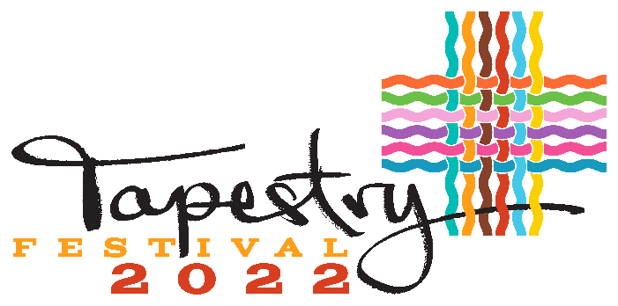

Kamloops 1st Annual Multicultural Festival
Sept 24th, 12pm – 5pm

Cultural Vendor Application Form

Company/Vendor Name: ___________________________________________________
Contact Name: ___________________________________________________________
Mailing Address: __________________________________________________________
City: ______________________ Prov.______________ Postal Code: ______________
Email: _______________________Cell Phone: ___________________Emergency#:___________________

Booth Details REGISTRATION COST $75.00
**Product(s)/service(s) must feature cultural item(s) or heritage.
Describe what product(s)/service(s) the audience can expect to see, experience or purchase.
Please confirm the following:
❑ I have my own tent What size is it? ___________ What color?______________
❑ I am not bringing a tent but do need a space (size) ______’____ft_x_________’____ft_
❑ I will bring the number of chairs and tables I need
❑ I will require access to electrical outlet
EQUIPMENT RENTAL REQUEST - We can provide you with:
Item | Cost/unit | Quantity | Total
Tent 10’ x 10’ | $75 installed |  | $ +tx
Tent 10’ x 20’ | $305 installed |  | $ +tx
Chair | $2 |  | $ +tx
Table 6’ | $10 |  | $ +tx
BOOTH REGISTRATION | n/a | n/a | $75.00 (no tax)
Add 5% GST and 7% PST on Tent, tables and chairs Grand Total: $___________.____
The total amount of the registration and rental fees must be paid by Sept 12th 2022
**Paid cash or by cheque to: North Shore Business Improvement Association
Provide details if you require a larger space (greater than 10’ x 10’).
_________________________________________________________________________________________________________________________________________________________
Please read carefully below, sign and return by Aug 3rd /22 to reserve your spot. You must pay by September 12th, 2022

Event Date/Time:
2022 Sept 24th , 12pm~5pm
Location: McDonald Park

EVENT MISSION
TAPESTRY FESTIVAL 2022 celebrates our city’s rich multiculturalism and diversity with an inclusive and welcoming event featuring music, dance, food and the arts.
EVENT VISION
TAPESTRY FESTIVAL 2022 highlights the cultural diversity of our City to create a positive, inclusive Community where members feel recognized, accepted, with a strong sense of self.
All vendors agree to follow these regulations which govern their participation in the festival:
- Set up begins at 10:00 am on Saturday Sept 24th 22 and exit must be completed by 6:00 pm.

- Applicants are prohibited from displaying, speaking, handing out or promoting any forms of content that are offensive.

- Applicants promoting any political parties, affiliated groups and their policies will not be allowed to participate.

- Applicants promoting religious content for the purpose of advocacy, conversion or expanding membership will not be allowed to participate.

- Applicants are not allowed to discuss, display or promote content that discriminates based on gender, race, religion, caste, creed, origin disability, handicap, age, sexual orientation or any other basis prohibited by law and as deemed by the Tapestry Festival.

- The Tapestry Festival has the sole discretion, at any time and at any stage to refuse participation of any group that does not adhere to the stipulations set out in the terms and conditions of the eligibility criteria in order to maintain the vision and mission values of the Festival.

- Refunds will not be made after Sept 17th /22. Under special circumstances (i.e. medical or compassionate), applicant may submit a written request to Tapestry Festival with an explanation for non-attendance. If the reason is deemed valid, the committee will consider refunding a portion of the fee not exceeding 50%.

- The Tapestry Festival is an outdoor festival, which can be affected by weather. While we are targeting approximately 4000 people attending, the festival committee cannot guarantee crowd size or profit.

- Applicants are responsible for keeping their area clean at all times during the festival and cleaning up afterwards.

- Valuables should not be left unattended in the tent or at your table. Tapestry Festival will not be responsible for lost, stolen or damaged items.

**Parking: Limited –
You will be able to unload between 10:00am and 11:15am, then park your vehicle on the neighborhood streets.

** I acknowledge that I have carefully read and understood the eligibility criteria.
Signature: ___________________________ Date: _____________________

*** I acknowledge that any pictures taken during the Festival will be used for marketing purposes for the Tapestry Festival.
Signature: ___________________________ Date: _____________________

North Shore BIA. 115 Tranquille Road Kamloops BC V2B 3M5 Ph: 250.376.2411 patti@nsbia.com

