
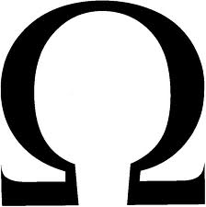Mega Gymnastics
Birthday party reservation

How did you hear about us? Website/Magazine/Other ___________________

RESERVATION INFORMATION:

Date of Party: _____________________Time: _______________ Estimated amount of children___________

Party for_________________________________________________________Age_____________________

Parents: ________________________________Phone Number_____________________________________

Address: ________________________________________________________________________________

PAYMENT INFORMATION: Email address:______________________

We accept: Visa/MasterCard/ Discover/ Check/Cash Paid amount: _____________

Credit card # __________________________________ Exp date___/___ Crv # ______

Name on the Card ________________________________________

I (print name) _________________________ understand that my card will be charged $175.00 for this reservation.

__________________________________ ____________________________
Signature of card holder Date

Or mail in a check along with this form to:
Omega Gymnastics
4145 Ferncreek Dr.
Fayetteville, NC 28314

All additional charges for extra kids or extra time can be paid the day of the party.

