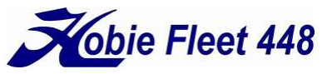
Conimicut Cup 2026
AMENDMENT 1 (0715, 26 August 2026) TO THE
NOTICE OF RACE (NOR), (v2, dated 3 February 2026)
This amendment supersedes previous Notice of Race information. Changes are highlighted below in bold text.
The NOR is amended to postpone the race date to Sunday, 27 September, 2026.
Paragraph 2 is amended to read:
" Only members of the Hobie Class Association of North America (HCANA) in good standing (as of 9:15 am on 27 September) will be eligible for regatta points (IHCA 26).

Paragraph 3 is amended to read:

“The online official notice board is located at https://fleet448.org/events (Downloadable Documents) through 27 September, and post-race at 72 Shawomet Avenue. The Sailing Instructions (SI) will be available electronically, and at a Competitors’ meeting at 10:00 am on race day at the Conimicut Point Beach boat launch, 400 Shawomet Avenue, Warwick.”

Paragraph 7 is amended to read:
“The scheduled time of the warning signal for the first race is 12:00 pm (noon). At least four (4) races will be scheduled. The last warning signal will be not later than 4:00 pm.”


