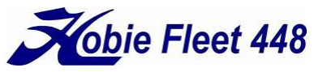
Conimicut Cup 2026
AMENDMENT 1 (0700, 26 August 2026) TO THE
SAILING INSTRUCTIONS (dated 23 August 2026)
This amendment supersedes previous Sailing Instruction (SI) guidance and has precedence over any conflicts in the Notice of Race (NOR), and updates SI paragraph 4.3 to eliminate differences with Sections 3 or 7 of the NOR. Changes are highlighted below in bold text.

The SI is amended to postpone the race day to Sunday, 27 September, 2026.
Section 2.2 is amended to read:
"2.2 There will be a Competitor’s Meeting on 27 September at 10:00am at the Conimicut Point Beach boat launch area.“

Addendum A – Illustrating the Course is amended to add:

“A Reaching Mark (‘B” mark) may be designated as part of the course with existing government navigation aids within the course area, based on prevailing conditions. This may modify standard Course 1 or 5.”



