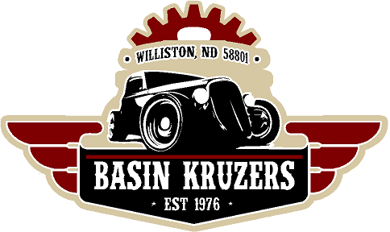

Pre-Registration

Fall Round Up Car & Bike Show

September 24th, 2022

Black Magic Harley Davidson, Williston, ND

Name:________________________________________

Vehicle:_______________________________________

Car Club:______________________________________

Phone number:____________________ E-Mail:_______________________________

Registration Fee: enclosed $15.00 per vehicle.

Number of vehicles:_________________

Amount Enclosed:___________________

Please return with registration fees for early registration to:

Basin Kruzers c/o: Janelle Groenhout

3403 34th St W Williston ND, 58801

Or email the filled out form to basinkruzers@hotmail.com

We also accept payment via Venmo – Basin Kruzers