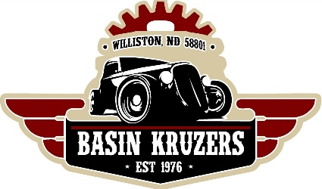

Basin Kruzers Pre-Registration
50th Annual Band Day Car Show
May 9th, 2026 ~ 10am to 4pm
Raymond Family Community Center

Band Day Registration Form
The first 90 registrants are guaranteed an indoor spot
Owner’s Name:_________________________________________________________________
Hometown & State:_____________________________________________________________
Phone Number:____________________ E-Mail:____________________________________
Vehicle(s):______________________________________________________________________
Pre-Registration Fee: $15.00 per vehicle
OR
Day of Show Registration Fee: $25 per vehicle

Affiliated Car Club Name:_______________________________________________________
Join Basin Kruzers or renew your membership for $20 per family per year

Number of Vehicles Registered:____________
Basin Kruzers Membership:________________
Total Amount Enclosed:___________________

Please return form with fees to:
Basin Kruzers c/o: Matt Post- 910 15th Ave W, Williston ND, 58801
OR
Email the filled-out form to basinkruzers@hotmail.com

Parking for show is Friday May 8th at 6-8pm or Saturday May 9th at 8-10am
*Starting at 9am on Saturday, we will start contacting registrants that have not
arrived to confirm their attendance plans. If we don’t reach you, we reserve the right
to sell your spot*

