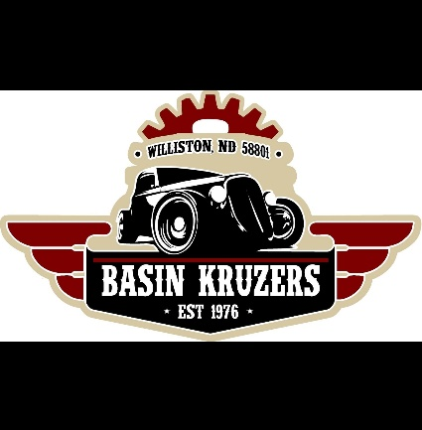

Basin Kruzers Pre-Registration
48th Annual Band Day Car Show
May 10th, 2025 ~ 10am to 4pm
Raymond Family Community Center

Band Day Registration Form
The first 90 registrants are guaranteed an indoor spot
Owner’s Name:_________________________________________________________________
Hometown & State:_____________________________________________________________
Phone Number:____________________ E-Mail:____________________________________
Vehicle(s):______________________________________________________________________
Pre-Registration Fee: $15.00 per vehicle
OR
Day of Show Registration Fee: $25 per vehicle

Affiliated Car Club Name:_______________________________________________________
Join Basin Kruzers or renew your membership for $20 per family per year

Number of Vehicles Registered:____________
Basin Kruzers Membership:________________
Total Amount Enclosed:___________________

Please return form with fees to:
Basin Kruzers c/o: Janelle Groenhout- 3403 34th St W, Williston ND, 58801
OR
Email the filled-out form to basinkruzers@hotmail.com and Venmo @basin-kruzers

Parking for show is Friday, May 9th at 6-8pm or Saturday, May 10th at 8-10am
*Starting at 9am on Saturday, we will start contacting registrants that have not
arrived to confirm their attendance plans. If we don’t reach you, we reserve the right
to sell your spot*

