**MEDICAL/PERMISSION AND RELEASE OF LIABILY**

(**PLEASE PRINT LEGIBLY)**

FULL NAME (Same as Passport):___________________________________________________ BIRTHDATE____/_____/____

ADDRESS__________________________________________ CITY____________________ STATE________ ZIP__________

PHONE______________________________ EMAIL_____________________________________________________________

Passport No.: __________________________________ Driver’s License No.: _________________________ State: __________

In Case of Emergency Notify: _____________________________________________ Phone _____________________________

Family Physician _______________________________________________________ Phone _____________________________

Family Insurance Co. ________________________________________ Policy # _______________________________________

IMMUNIZATIONS (List dates if known) : Tetanus____________ Polio Booster_______________ Measles_________________

Mumps____________ Other________________________________________________________________________________

**PAST MEDICAL HISTORY** (Check giving appropriate information):

Asthma___________ Sinusitis____________ Bronchitis___________ Kidney Trouble___________ Heart Trouble___________

Diabetes ________ Dizziness ________ Hay Fever__________ COVID-19________________ Other______________________

ALLERGIES:

Food ____________________________________________________________________________________________________

Penicillin or another drug (Name) _____________________________________________________________________________

Insect stings/bites _________________________________________________________________________________________

Poison sumac, oak, or ivy ___________________________________________________________________________________

Previous operations or serious illness: _________________________________________________________________________

________________________________________________________________________________________________________

Any current medications: (List name and administration instructions or attach on a separate paper): ________________________

________________________________________________________________________________________________________

________________________________________________________________________________________________________

Childhood Diseases: Chickenpox____________ Measles ____________ Mumps ____________ Whooping Cough____________

Other ___________________________________________________________________________________________________

Mission Insurance Beneficiary Name:__________________________________________________________________________

Address: ________________________________________________ City: __________________ State: _____ Zip:___________

**PERMISSION FOR TREATMENT AND DISCHARGE/RELEASE OF HARM AND LIABILITY**

By signing below, my permission is granted to 4-Fold Ministries/Team Member/sponsor in charge of the Mission Trip to

obtain necessary medical attention for myself or my child ________________________________________ (Participant's Name).

I, the undersigned, understand that there are inherent risks when traveling, flying, and working in a Foreign Country that cannot be foreseen or accounted for, therefore, I, the undersigned, do hereby release, absolve, and forever discharge all Board Members, Staff, Sponsors and other Mission Trip Members, as a whole, and 4-Fold Ministries from any and all claims, demands, actions or cause of action (court or otherwise), past, present, or future arising out of any damage or injury to myself or my child while participating in this Mission Trip. I further accept financial and physical responsibility for the return of myself or my child, should the adult supervision and/or medical staff find it necessary to send me/him/her home due to injury or actions on my/his/her part.

___________________________________________________________________ ________________________

Signature of Self/Parent/Guardian Date

**This Page MUST be copied to the backside of the front page!!**

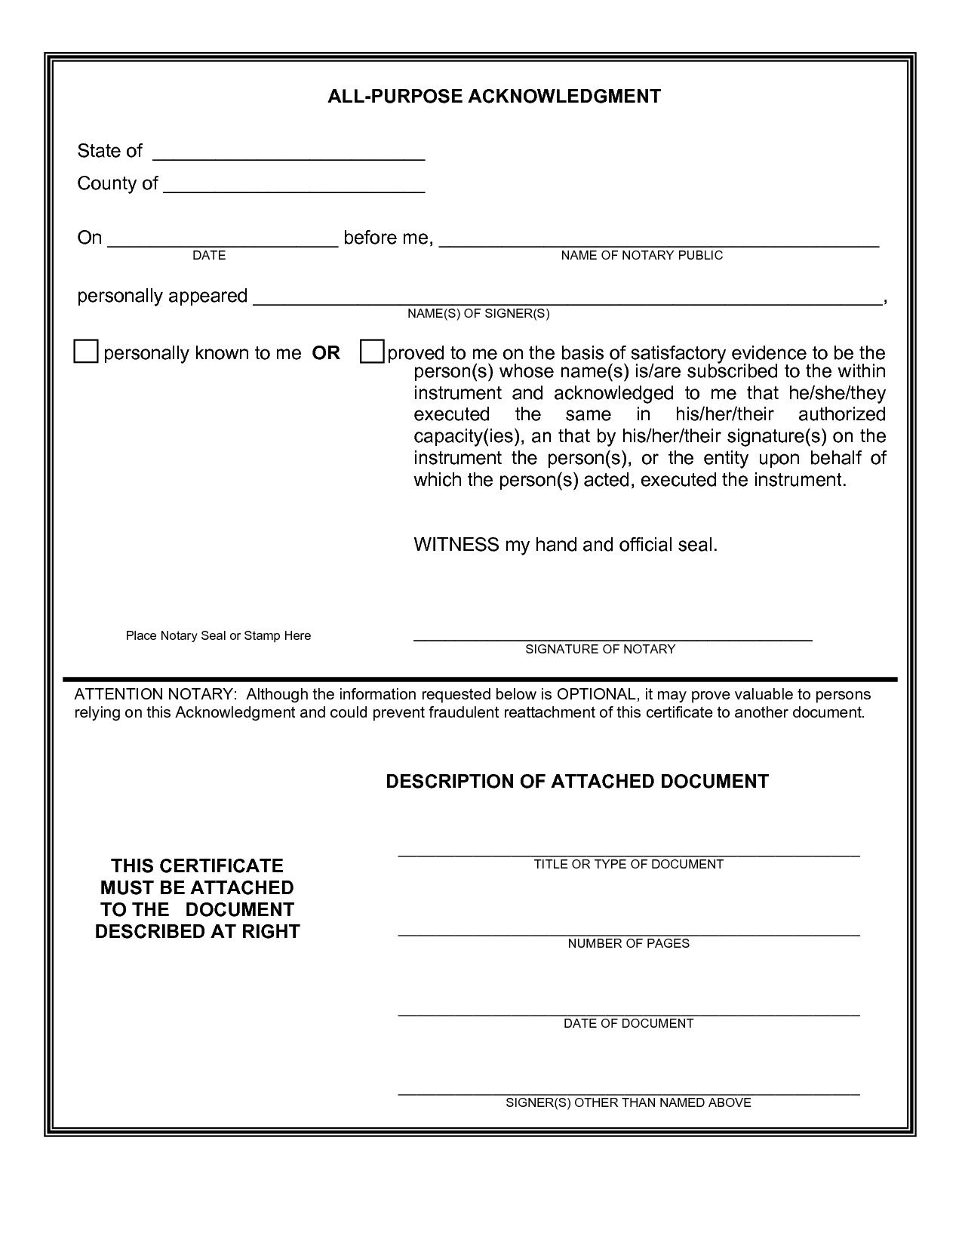

**This Page MUST be copied to the backside of the front page!!**