Did the Hebrew Exodus really happen?
Extra-Biblical evidence says yes!
Jay Schabacker
It’s time for a reminder. Our Lord God is true, and the truth of His miracles reminds us to follow in His ways.
Let’s refer to God’s remarks to Abraham in Genesis 15:13-16, 300 years before the actual Exodus from Egypt: “Then the Lord said to him [Abraham], ‘Know for certain that your descendants will be strangers in a country not their own, and they will be enslaved and mistreated for four hundred years. But I will punish the nation they serve as slaves, and afterward, they will come out with great possessions. You, however, will go to your fathers in peace and be buried at a good old age. In the fourth generation, your descendants will come back here [Canaan], for the sin of the Amorites has not reached its full measure.’”
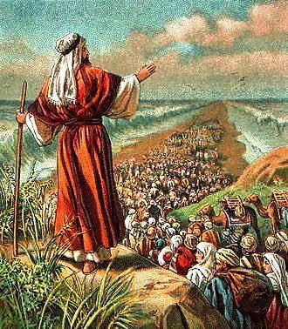
Too many don’t follow and consider all His miracles–including God’s Passover and the Exodus. As it is said in Wikipedia, “The Exodus is the founding myth of the Israelites.” Can this “myth” actually have happened as it says in the Holy Bible? Extra-Biblical sources, including archeological discoveries, point to the truth of the Exodus.

“Strangers in a country not their own.” - The Date of the Exodus
The Holy Bible Old Testament says, In the four hundredth and eightieth year after the Israelites came out of Egypt, in the fourth year of Solomon’s reign of Israel . . . I Kings 6:1. Now, chronologist records fix the fourth year of Solomon’s reign at 966 BC. The above verse tells us that in the fourth year of Solomon’s reign over Israel (966 BC), that was the same as 480 years after the Israelite Exodus from Egypt. So, the Israelites came out of Egypt 966 BC minus 480 years earlier. Then the Exodus was 966 BC plus 480 years earlier or 966 + 480 or 1446 BC.
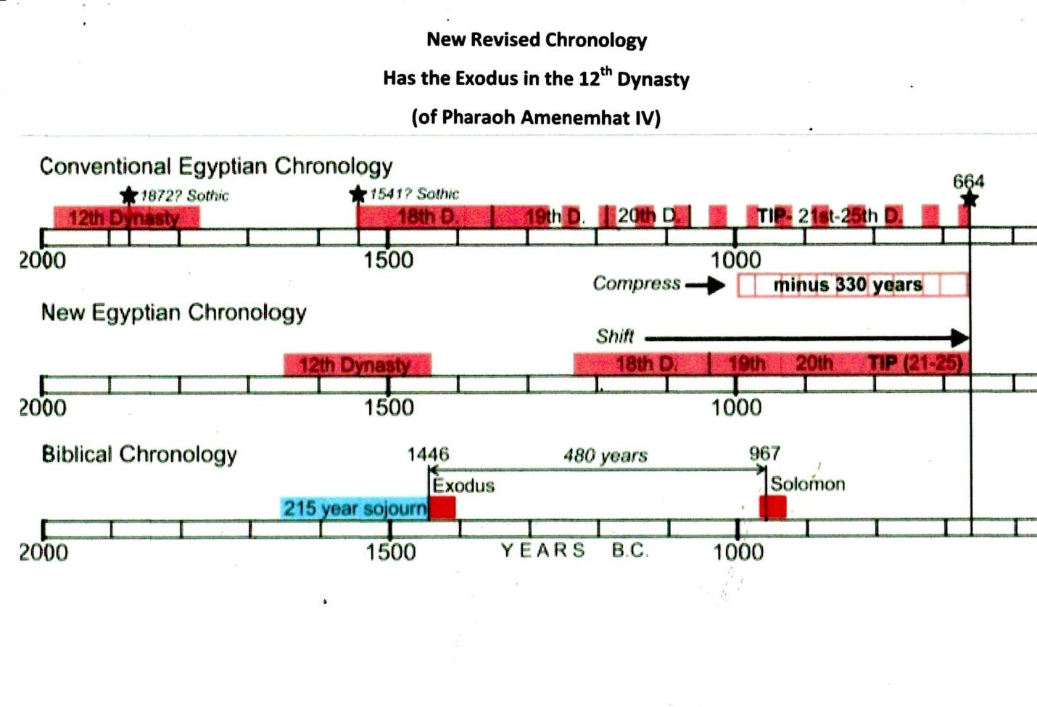
The old Egyptian Conventional Chronology was a problem
For years researchers of the Exodus faced problems because of overlapping pharaohs reigns in Conventional Egyptian Chronology. Their time line was too stretched out and so didn’t jive with the Biblical Chronology. When a match up with the 1446 BC Exodus date was attempted with the Egyptian 18th Dynasty, no Pharaohs seemed plausible, as their bodies were all buried in Egypt. Researchers found a compression was needed (of about 330 years) to make the correction to a New Revised Egyptian Chronology. The date of the Exodus now corresponded with the Egyptian 12th Dynasty instead of the 18th Dynasty!

Let’s go back to where it all got started – with Joseph
God’s plan was to send Joseph to Egypt so he could interpret Pharaoh’s dream. Pharaoh’s dream told of seven years of plenty and seven years of famine. On the island of Seheil, near the first cataract of the Nile, is a great stone called The Famine Stele with inscriptions on it that mention Joseph. The stone tells of Pharaoh Djoser, referencing “seven meagre years and seven rich years.” “Pharaoh Djoser asks Joseph to help him with the coming seven years of famine,” says The Famine Stele. Djoser appointed Joseph in charge of all the needed preparations before the upcoming famine.

Genesis 41:49 says, “Joseph stored up huge quantities of grain, like the sand of the sea; it was so much that he stopped keeping records because it was beyond measure.”
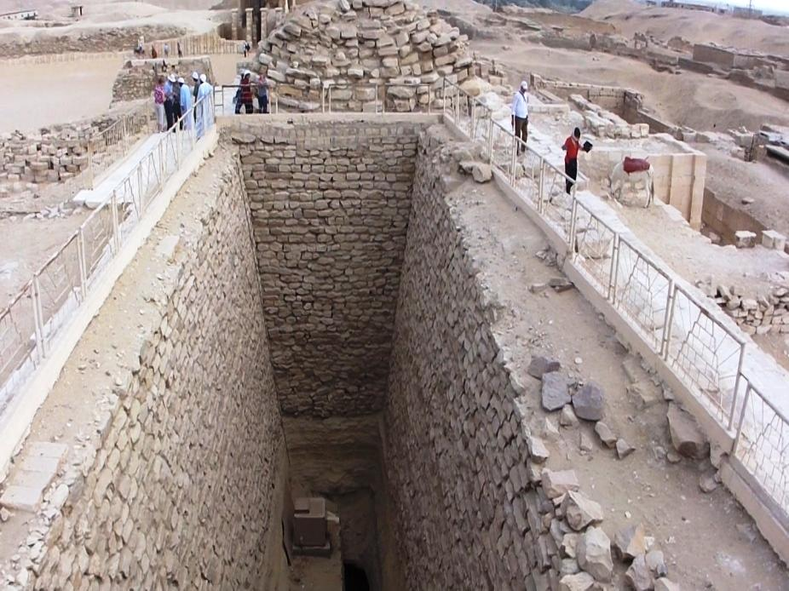

People on top of a huge Egyptian grain pit showing its massive size

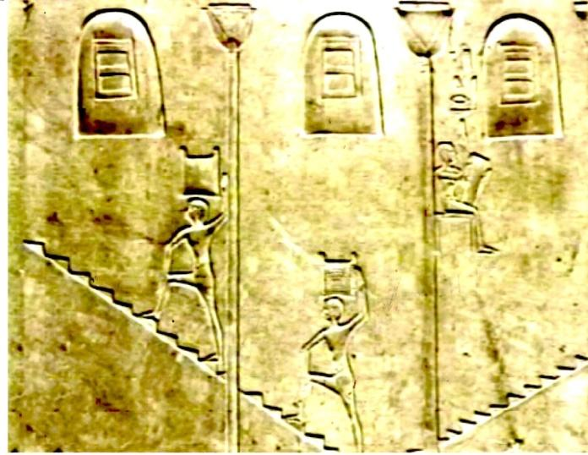
Egyptian hieroglyphs have been found showing workers going up and down the steps transporting the grain. And, indeed, the steps have been uncovered.
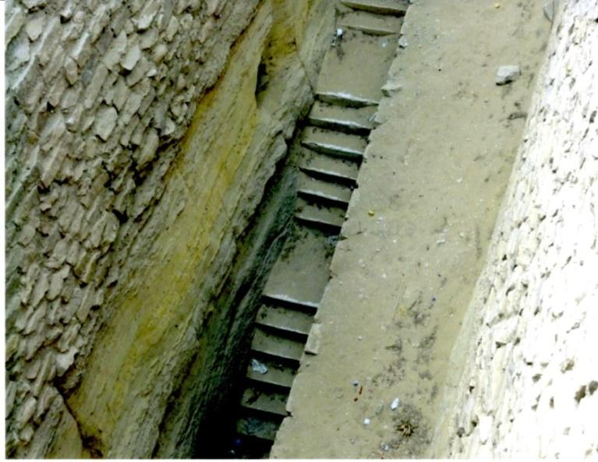

“They will be enslaved and mistreated”
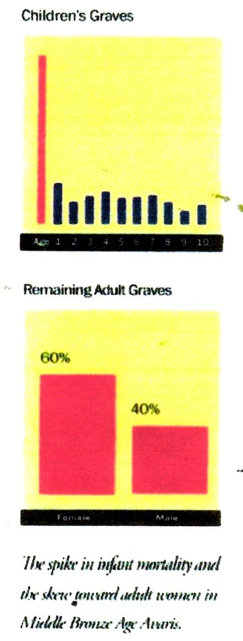
The book of Exodus tells of the mistreatment of Israelites in Egypt. “Then a new king that did not know about Joseph came to power in Egypt” (Exodus 1:8). “So they set slave masters over them to oppress them with forced labor” (Exodus 1:11). “Then Pharaoh gave this order to all his people: ‘Every boy that is born you must throw into the Nile, but let every girl live’” (Exodus 1:22).
Archaeologists have recently found something amazing: the graves of Hebrew boys who died at an early age. Archaeologist Manfred Bietak’s excavations revealed that during the Israelites bondage period, about 1530 B.C., at Avaris, the remains of numerous child-sized graves were found all over the city – innocent victims of a vicious slaughter.
While children’s graves normally make up a quarter of all graves, at Avaris they represent about two thirds of all deaths. Furthermore, for every five adult female burials, they found only three adult males, suggesting that the males died earlier as infants.
Who was the Pharaoh of the Exodus?
The Egyptians kept detailed records – especially of their Pharaohs. The records are numerous of their reigns, their deaths and their burial locations. The information is all there – except for one Pharaoh in the 12th Dynasty.
The 12th Dynasty ruled during a very prosperous time, approximately 1650-1450 B.C. The capital was Itjawy, which was close to the Israelite town of Avaris, where Moses lived. Like all Pharaohs, their exact location of burial was noted, except for one, the seventh Pharaoh, named Amenemhat IV, who drowned in the Red Sea.
Since he had no living son, Amenemhat IV was succeeded by his widow, Sobekkare, the last Pharaoh of the 12th Dynasty. Less than ten years after Amenemhat IV’s death, the 12th Dynasty came to an end and was replaced by the much weaker 13th Dynasty. During the 13th Dynasty, political instability quickly became prevalent and kings rarely ruled beyond a couple of years.
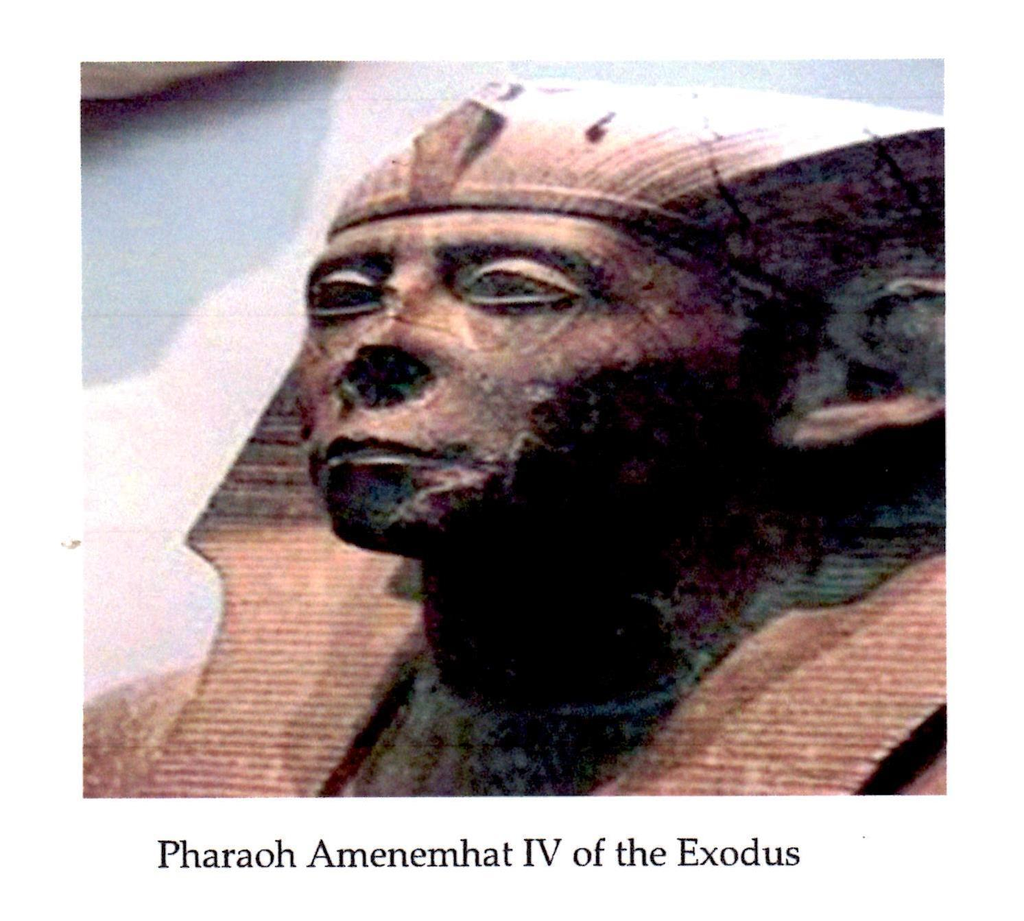

“I will punish the nation they serve as slaves” - The Ten Plagues of Egypt
Our God is a jealous God. The Lord God threw the Ten Plagues at the Egyptians to emphasize that their gods were of no effect when needed:
- Their god of the Nile, Hapi, lacked power as the water was turned to blood
- The god, Heket, had no control of Egypt’s sacred frogs
- Geb, the god of dust and land, had no control of the dust and gnats
- Khepfi, the god of insects, had no control when God called out the flies
- Apis, the god of the bull, had no effect when God struck down the livestock
- Sekhmet and Thoth couldn’t prevent the Plague of Boils in Egypt
- Nut controlled the weather, but had no effect from the destructive hail
- Seth, the god of the crops, had no effect over the destructive locusts
- Ra, the sun god, saw no sun and no light for the extent of three days
- It was God’s plan to destroy Pharaoh, so the death of the first-born, set off the victorious Passover of the Israelites and their trip to the Promised land

“They will come out with great possessions.” - The Chariot Wheels
Researchers over many years have been gathering information of the Israelites’ crossing of the Red Sea at the Gulf of Aqaba – and the destruction of the Egyptian army in their waters. There have been numerous photos taken of chariot wheels and even of human bones.

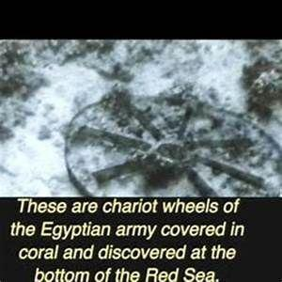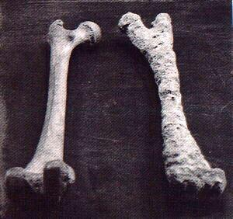

Statements from the Egyptian Ipuwer Papyrus
People have often asked, “Did the Egyptians actually have something to say about the Plagues and the Exodus?” Thankfully, the answer is yes!

The Egyptian Ipuwer Papyrus was written at the end of the 12th Dynasty. It is largely a conversation, in poem form, by an Egyptian called Ipuwer, who is talking to someone called ‘The Lord of All.’ It refers to the complete collapse of Egypt at the end of the Old Kingdom because of God’s Ten Plagues and the Exodus. Some of the text states that ‘the river is blood,’ ‘the grain is lacking,’ ‘groaning is through the land,’ and ‘All Is ruin.’ In fact, many of the calamities mentioned are identical to the calamities mentioned in the Holy Bible:

“Pestilence is throughout the land, and blood is everywhere.
The river is blood, yet men drink it.
All animals, their hearts weep; cattle moan because of the state of the land.
Trees are felled and branches are stripped off.
Men no more because of the condition of the land.”
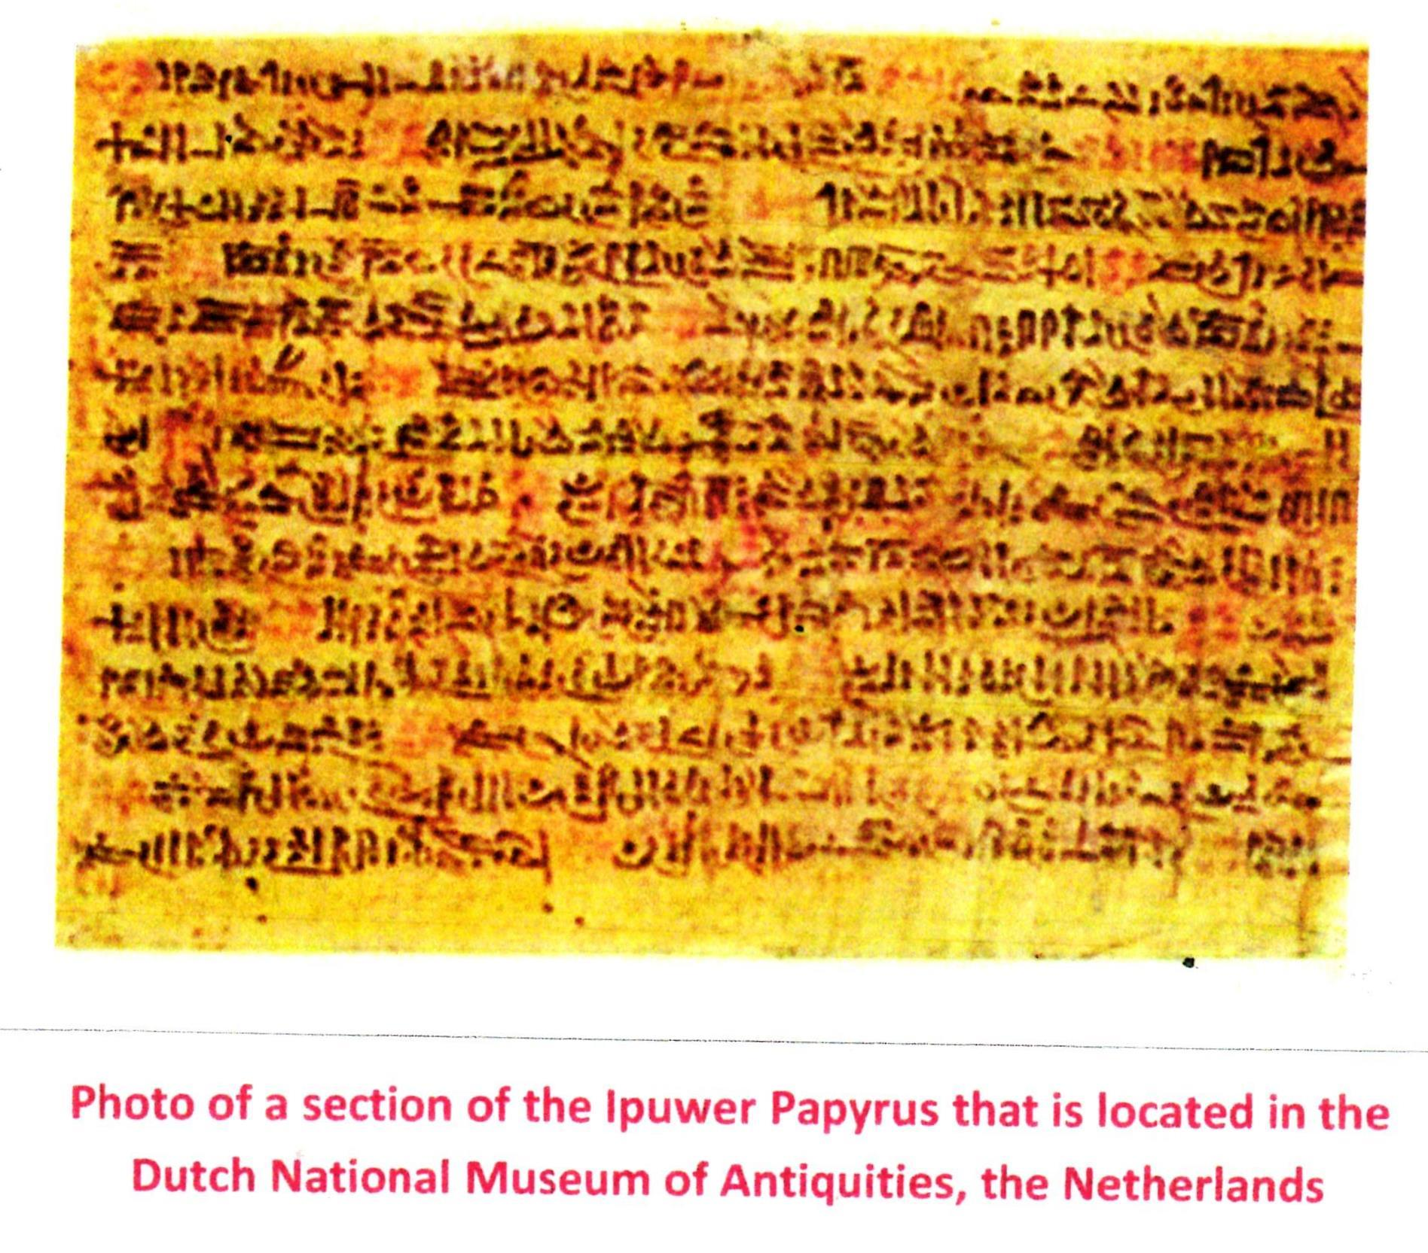

Conclusion

- Revising the Egyptian chronology is key: Joseph as Imhotep, the vizier of Pharaoh Djoser, who built the Stepped Pyramid, with the help of Joseph.
- Archaeologists have unearthed numerous Egyptian grain storage silos built by Joseph.
- The Pharaoh of the Exodus was Amenemhat IV, who drowned in the Red Sea.
- Archaeologists have found, at about 1530 BC, Hebrew boys (and not girls) died as infants at an early age.
- Numerous Egyptian chariot wheels and bones have been found and photographed deep in the Red Sea at the Gulf of Aqaba.
- The Egyptian Ipuwer Papyrus chronicles ‘the river is blood’, ‘the grain is lacking’, ‘groaning is throughout the land’, and ‘All is ruin.’
- Extra –Biblical research finds – the Hebrew Exodus truly did happen!

