“The Hebrew Exodus Did Happen”
Power Point Slide Notes
There are twenty- eight slides in the Power Point presentation, which I intend to present in person or by a YouTube video. Also, below, is presented these additional twenty-eight notes which I hope you will find educational.
You will find among these notes pages some excerpts from my book, “Did the Hebrew Exodus Truly Happen?” (Amazon.com). They will be indicated with a small page number on the bottom, from the book.
The Summary of the Extra-Biblical Discoveries:
- Archaeologists unearthed numerous grain storage pits built by Joseph for Pharaoh Djoser.
- The Egyptian Famine Stele tells of Pharaoh Djoser asking for help in the famine preparations.
- Archaeologists found graves of Hebrew boys (and not girls) who were killed as infants.
- The Pharaoh of the Exodus was Amenemhat IV who was drowned in the Red Sea.
- Egyptian chariot wheels and bones were found by divers in the depths of the Red Sea.
- The Egyptian Ipuwer Papyrus reports ‘the river is blood,’ ‘groaning is in the land,’ and ‘All is ruin.’
- The Egyptian Merneptah Stele records the earliest references to Israel and Canaan outside the Holy Bible.

Slide # 1 Why did I write the book, Did the Hebrew Exodus Truly Happen?
I, Jay Schabacker, am concerned! It seems that many, if not most, don’t believe in miracles and God! Most detractors of the Bible state, ‘There is no evidence for miracles!’
The site Wikipedia states: ‘The Exodus is the founding Myth of the Israelites.
Because of such thinking, I believe our faith is weak and our culture has slid downhill. Here are some surveys:
- From a survey in 2008: Only 48% of those surveyed said miracle stories presented in religious texts should be taken as literally true.
- Another survey in 2018: ‘Do you believe in the God as described in the Bible?’ The response: Protestants 72%, Catholics 69%, Jews 33%
- From a survey in 2019: ‘Percent surveyed that say religion is very important’: United States 47%, Israel 39%, United Kingdom 20%.
There are reports that numerous Jewish Rabbis believe the Exodus story is “not substantiated by hard facts”, but continue to perpetuate the story for the sake of those celebrating the Passover.
Archaeologists have recently informed us that the Hebrew Exodos happened just as in the Bible.
Wouldn’t that good news improve our faith or religion and our culture if we told other about it?
The Exodus was true!
The Holy Bible is true!
We can earn God’s favor by increasing our Belief!

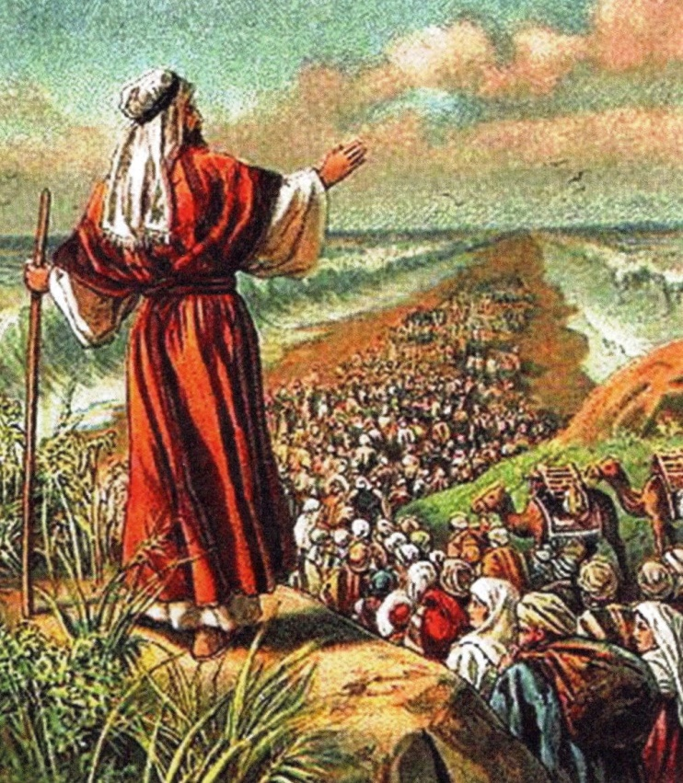

Slide # 2 It was God’s plan
I’m often prone to say something like, “It all started with Joseph” and “It was all God’s plan”.
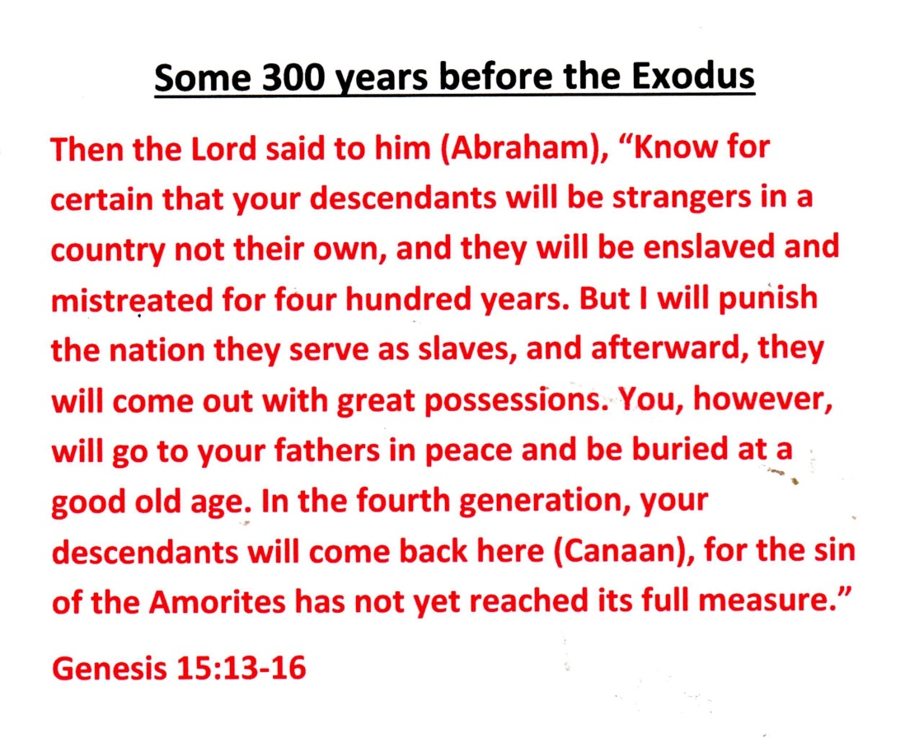

Looking back, it was God’s plan! – from start to finish! God foreordained it, and then Abraham for-new it. Further, God is in charge and is doing all the planning ahead of time. And He executes – for good or for evil – for His ends. It is sometimes labeled ‘Foreknowledge’ and sometime ‘Predestination’.
Some example verses:
Isaiah 14:24 “Jehovah of hosts has sworn, saying; Surely, as I have thought, so shall it come to pass; and as I have purposed, so shall it stand.”
Isaiah 45:7 “I formed the light and create darkness; I make peace and create evil; I am Jehovah that doeth all these things.”
Isaiah 46:10 “I am God, and there is none like me; declaring the end from the beginning, and from ancient times things that are not yet done; saying, ‘My counsel shall stand, and I will do my pleasure’”.
And, of course, in the Exodus, God had a plan – a long term plan! - For ultimate good in all the events. Many verses give indication. Here are just four:
Genesis 50:20 “As for you (Joseph’s brothers) ye meant evil against me (Joseph) , but God meant it for good”.
Exodus 12:36 And Jehovah gave the Israelites favor in the site of the Egyptians, so that they let them have what they asked.
Exodus 14:17 “And I, behold, I will harden the hearts of the Egyptians, and they shall go in (the Red Sea) after them (the Israelites); and I will get my honor upon Pharaoh, and upon his host, and upon his chariots, and upon his horsemen”.
Exodus 19:4 “You have seen what I did to the Egyptians, and how I bore you on eagles’ wings and brought you to Myself”.

Slide #3 Strangers in a country not their own
Looking at the chart, one thing I want to explain. When was the Exodus? In the fourth year of Solomon’s reign it was 966 BC or 967 BC per the Bible. I Kings 6:1 says, “In the 480th year after the Israelites came out of Egypt – that was the 4th year of Solomon’s reign.” So the Exodus works out to be: 966 BC + 480 years or = 1446 BC.
That solved, there was still a problem with the Egyptian Chronology! All the overlapping pharaoh’s reigns caused the Egyptians to incorrectly stretch out their timeline. Per them, 1446 BC was during the 18th Dynasty and pharaohs such as Rameses II were buried – and didn’t drown in the Red Sea. Research showed that it was needed to compress their chronology by 330 years – to get the real dynasty in 1446 BC to be the 12th Dynasty (per the chart).
More Explanation of the Date of the Exodus
The birth of Joseph was around 1900 BC – the 3rd Dynasty.
Joseph and Pharaoh Djoser died about 1800 BC.
Israelite enslavement started about 1550 BC. (About the time of the birth of Moses.)
The Exodus was 1446 BC.
The Hebrew were 40 years wandering in the desert.

Dr. Glen Fritz, on the next several pages, explains the corrections needed to the ‘date of the Exodus’. Hence, the Pharaoh of the Exodus was the 12th Dynasty Pharaoh Amenemhat IV.
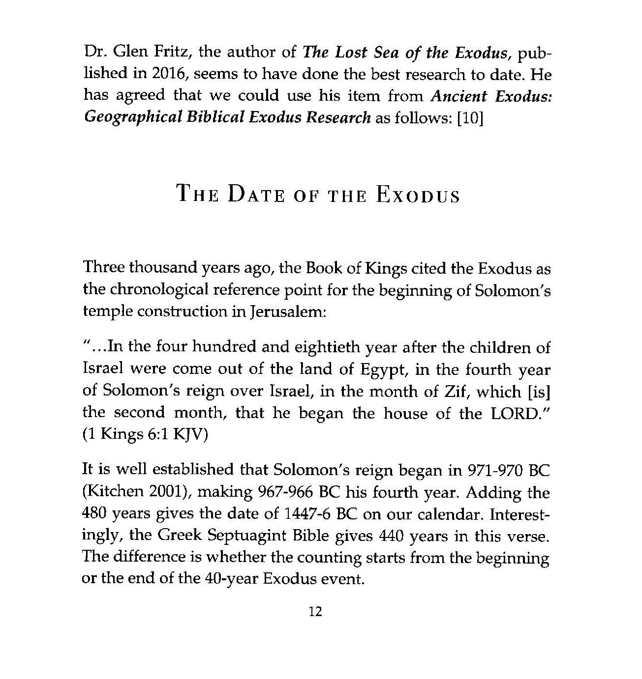

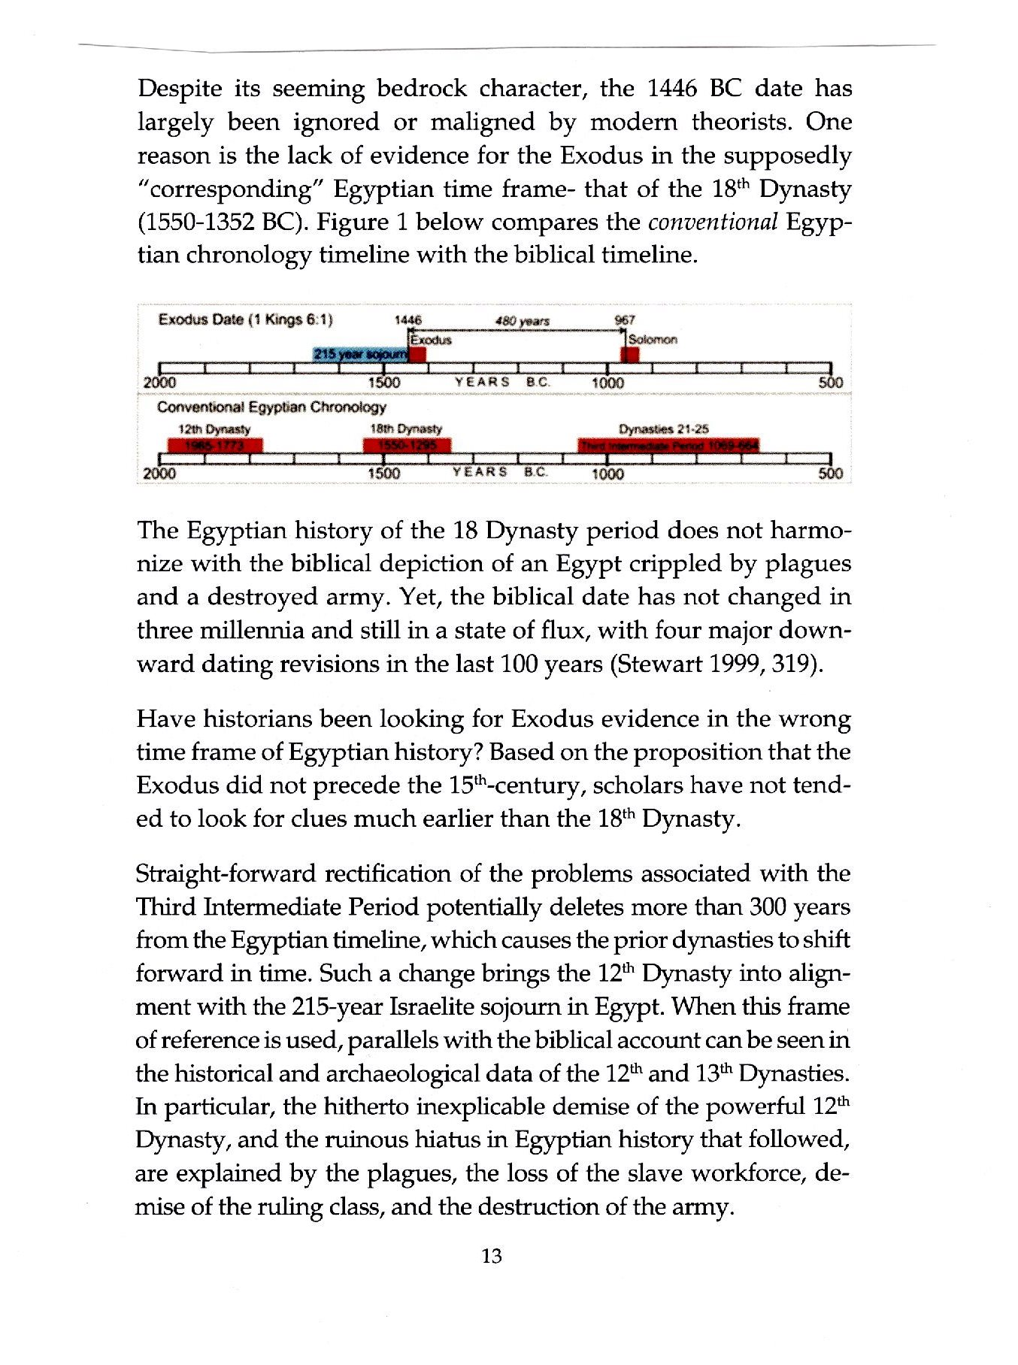
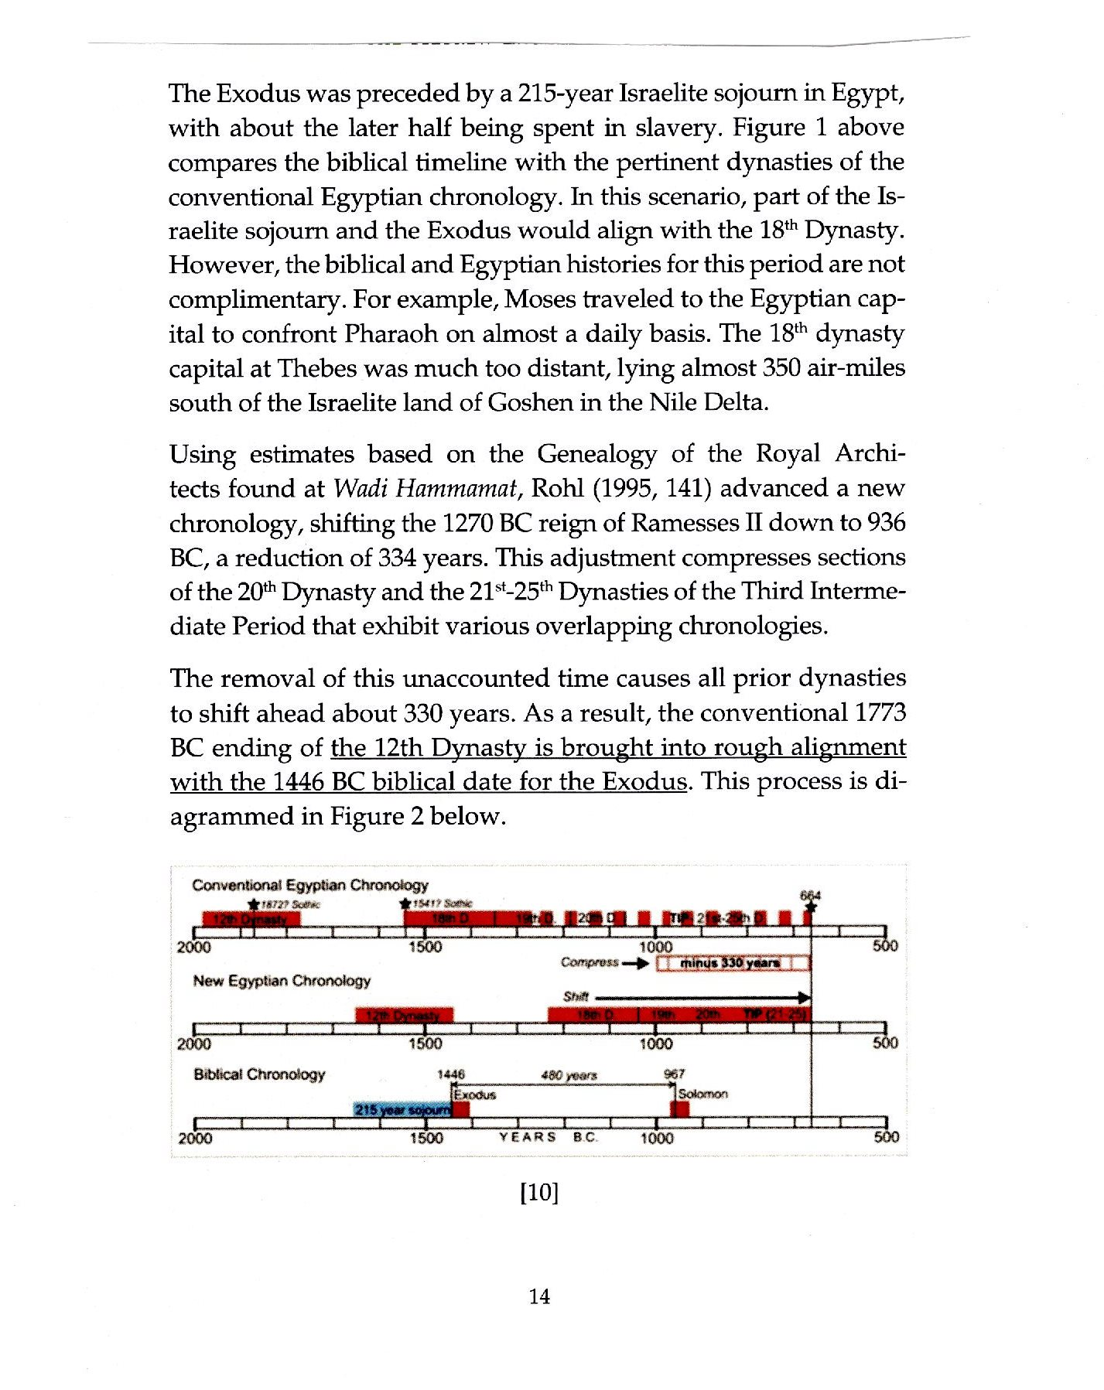

Slide # 4 Joseph got it all started. Joseph was Imhotep, the Vizier to Pharaoh Djoser
There was one man in Egypt who was mentioned as having lived for 110 years, the same as Joseph . It was a man whose fame and accomplishments were seemingly greater than any mortal could actually achieve! His name was Imhotep, which was phonetically similar to (Ye)hosep. Others say an original spelling form of ‘Joseph’ is ‘ihosep,’ and ‘Imhotep’ may be spelled Ihotep.
So, this man, Imhotep, was the ‘Joseph,’ and he was the vizier (advisor) to the Pharaoh Djoser who, with Joseph/Imhotep’s advice, performed marvelous feats during their time in Egypt.
Joseph came to power and high regard because he interpreted Pharaoh Djoser’s dream and implemented a plan to conserve grain during the seven-year time of plenty to sell later during the following seven-year time of famine.
Later, Joseph designed for Djoser the first pyramid in Egypt, the Stepped Pyramid of Djoser.
All of this was according to God’s Plan.
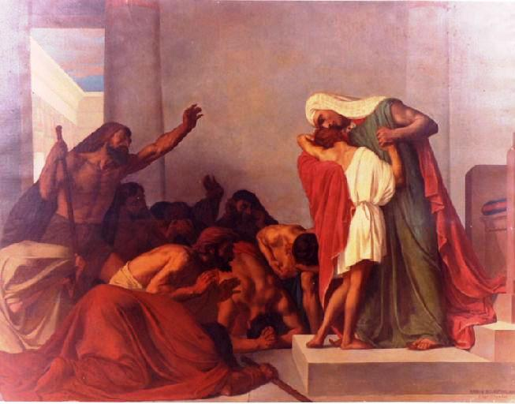
Joseph recognized by his brothers

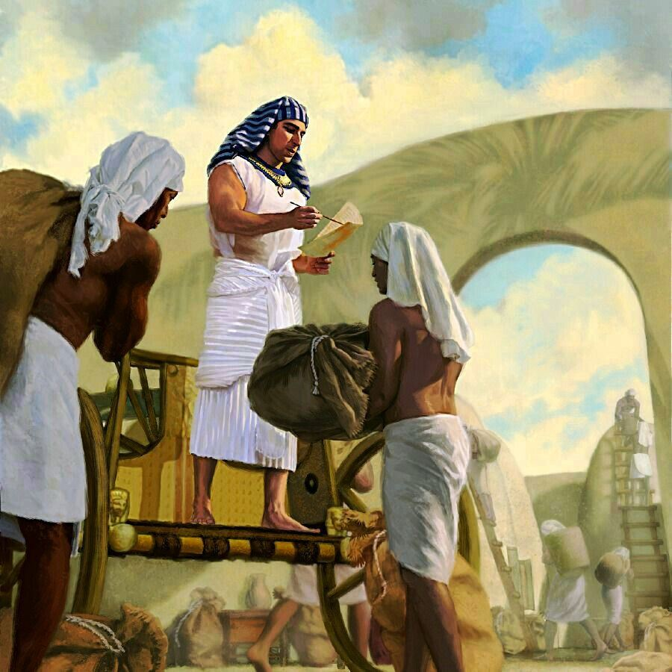
Joseph Giving Out Grain
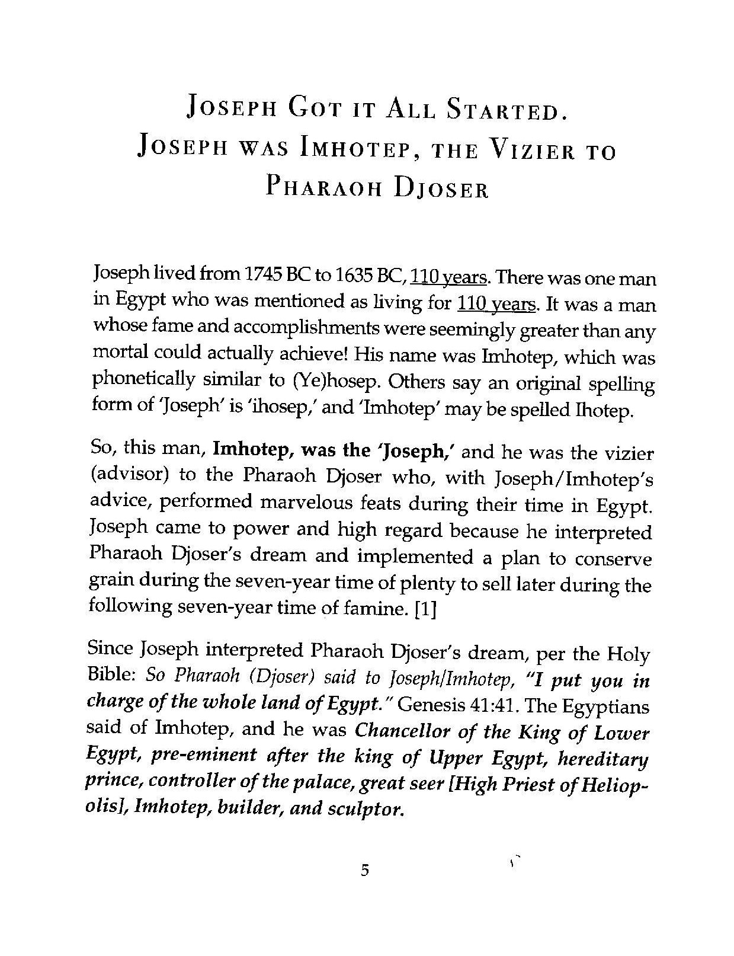

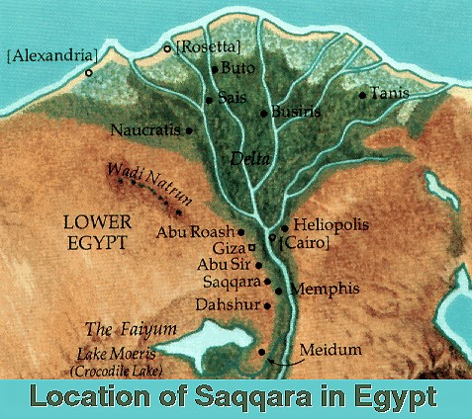
Slide #5 Joseph designed the Stepped Pyramid for Pharaoh Djoser
The first task of Joseph was the grain storage because of the coming famine. The second task was to build the first Egyptian pyramid, the Stepped Pyramid of Djoser, to later become the Pharaoh’s resting place upon his death.
Researchers found the grain storage tunnels and pits basically located under the location of the Stepped Pyramid above.
Actually, there were grain storage facilities constructed all over the land of Egypt, and they were used during the seven years famine.

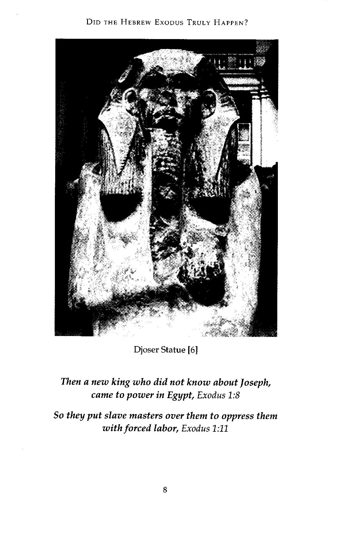

Dr. Zahi Hawass at the Stepped Pyramid of Djoser site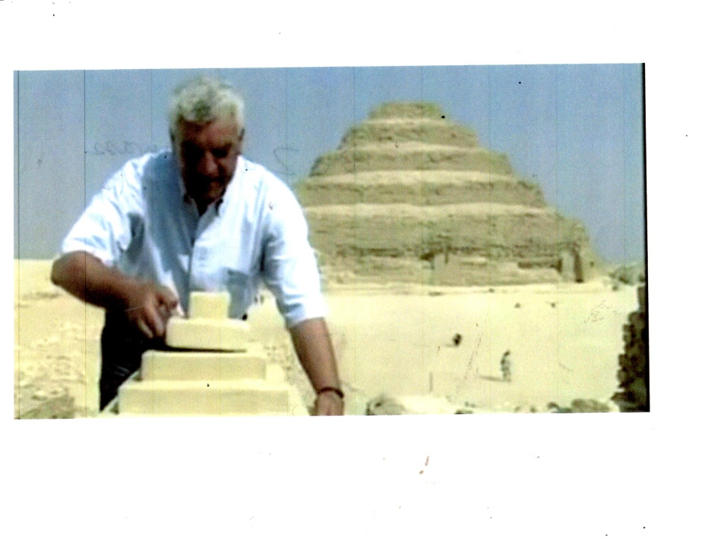
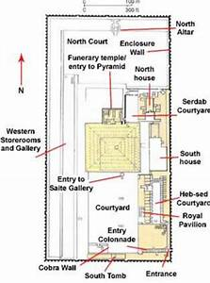
Slide # 6 One of the large grain pits
This is one of the large pits found within the Stepped Pyramid area. Most likely it was for grain storage. The bottom of the pit can be accessed from stairs in an adjacent pit.
More slides to come, such as the pictures shown, below.
I wonder what the Egyptians of now- a- days feel about these latest revelations?

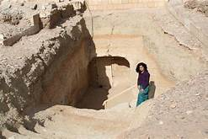
Slide # 7 The stairs to grain storage shown
Egyptian hieroglyphs have been discovered that show workers on steps carrying grain up and down the steps to and from the grain puts.
And, indeed, in the Stepped Pyramid area, the steps have been discovered and photographed.
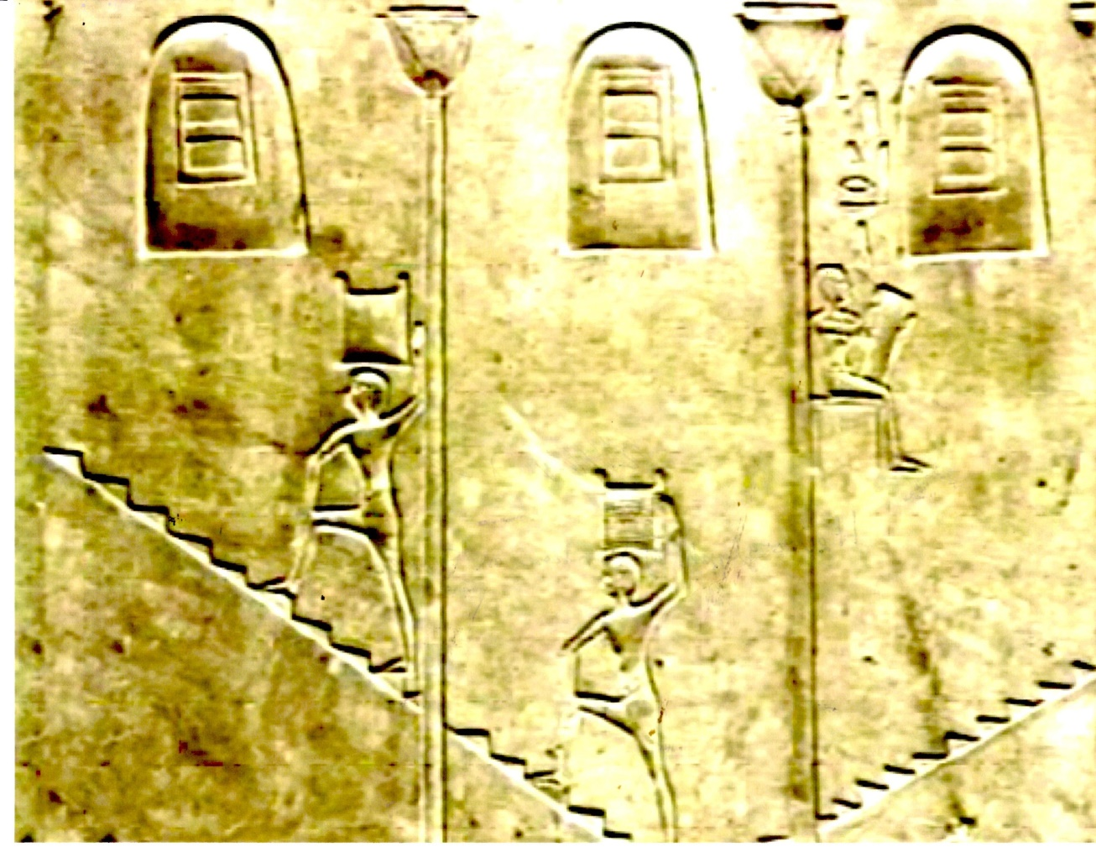
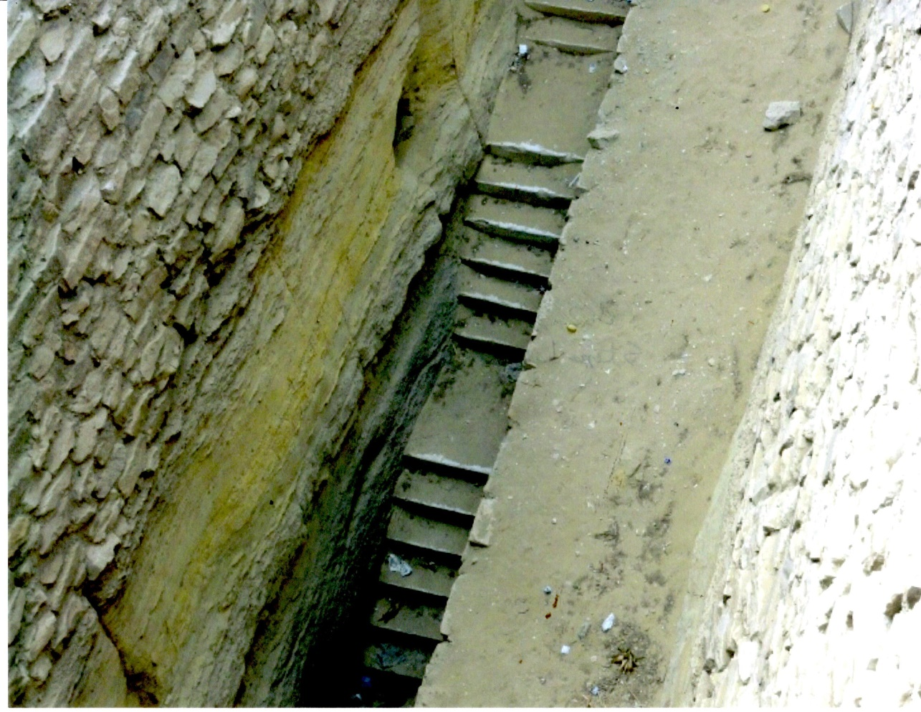
Slide # 8 The huge size of just one grain shaft
This is at the Stepped Pyramid location.
The people indicate the huge size of just one grain shaft and storage pit.

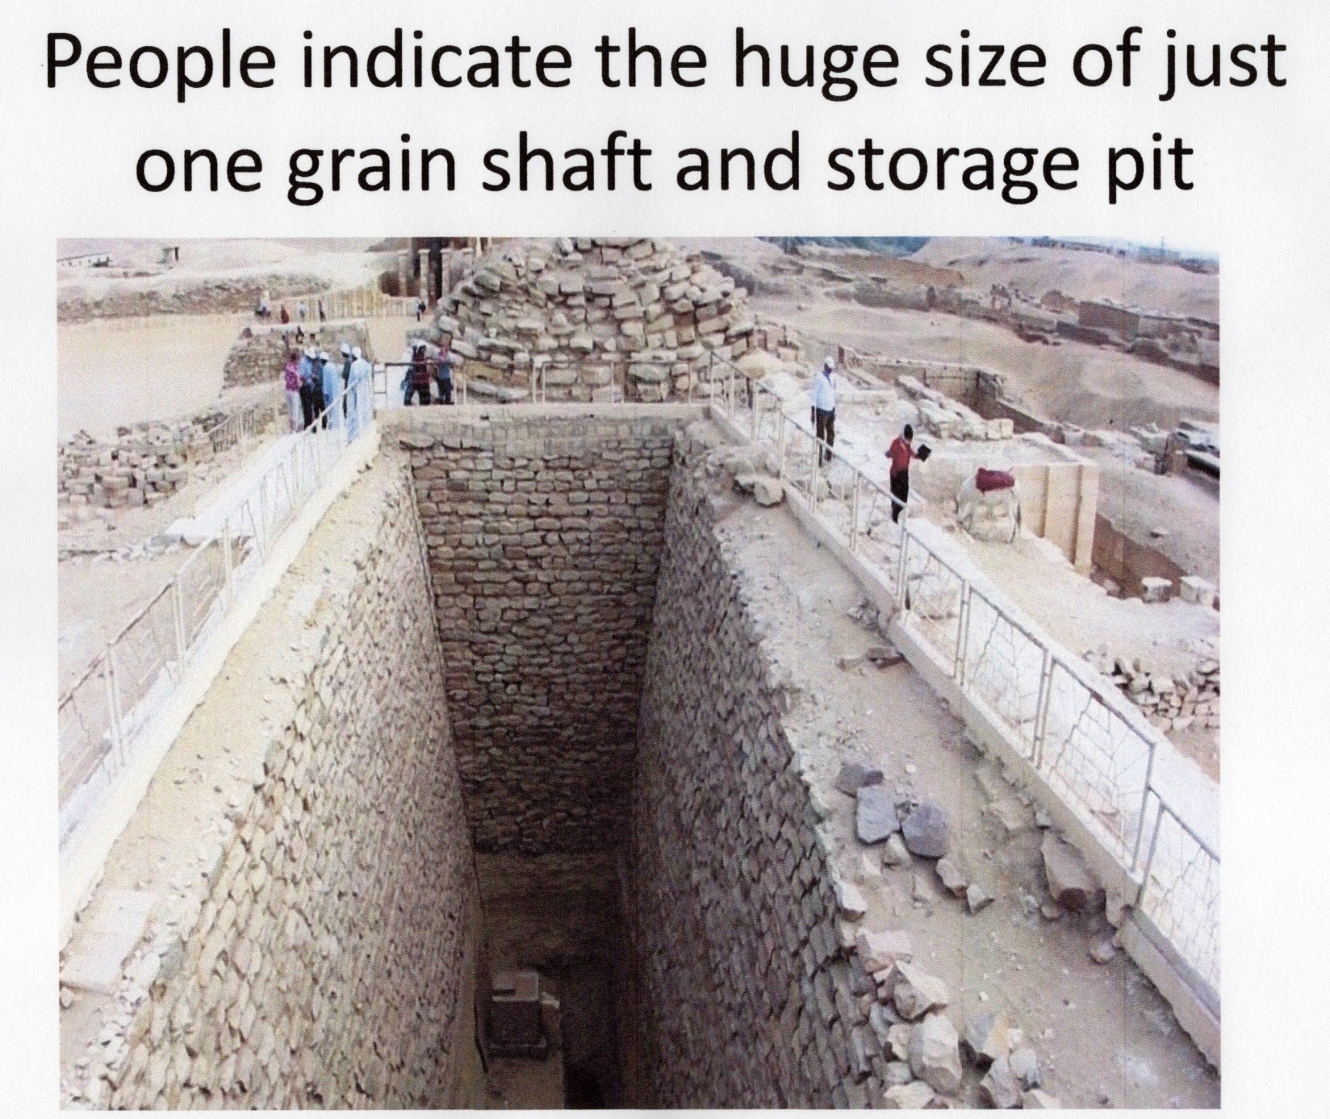

Slide # 9 They stopped keeping records!
Genesis 41:49
Joseph stored up huge quantities of grain, like the sand of the sea; it was so much that he stopped keeping records because it was beyond measure. Genesis 41:49
Remember what they said about him. ‘This was a man whose fame and accomplishments were seemingly greater than any mortal could actually achieve!’

Slide # 10 The Famine Stele
If we look hard enough, we find the ancient Egyptians were very accommodating in giving us records of the ancient past!
One of those is the Famine Stele, discovered in 1890 by Charles Wilber. It describes a seven –year drought that occurred during the reign of Pharaoh Djoser in the Egypt 3rd Dynasty.
Part of the inscription states ‘seven meagre years and seven rich years’.
“Pharaoh Djoser asks Joseph to help him with the coming seven years of famine.”
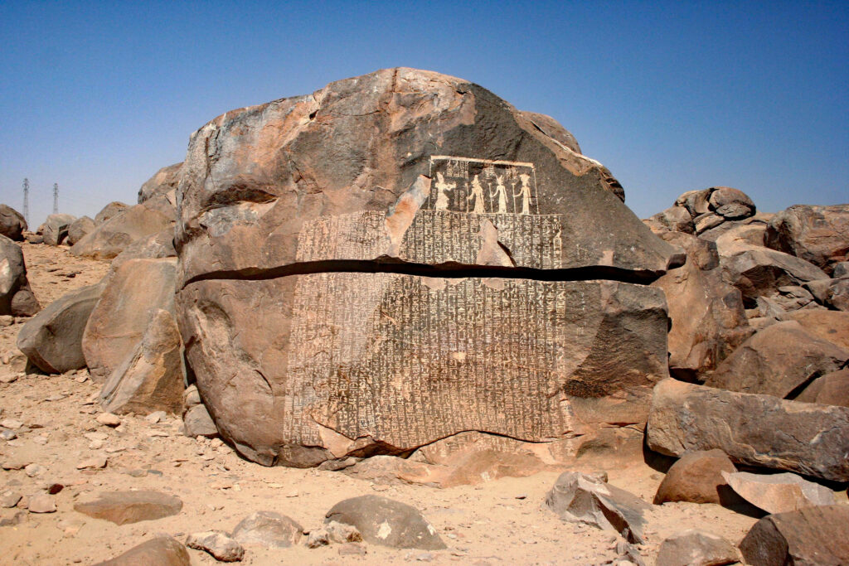

Slide # 11 Graves of young boys unearthed
After Joseph and Pharaoh Djoser died, about 1800 BC:
Then a new king that did not know about Joseph came to power in Egypt,” Exodus 1:8
So they set slave masters over them to oppress them with forced labor, Exodus 1:11
Then Pharaoh gave this order to all his people: “Every boy that is born you must throw into the Nile, but let every girl live.” Exodus 1:22

Is there anything in the Egyptian archaeology that reflects the death of male Israelite infants? The answer is ‘Yes.”
Archaeologist Manfred Bietak’s excavations revealed that during the Israelite bondage at Avaris, about 1530 BC, the remains of numerous tiny graves were found all over the city – innocent victims of vicious slaughter.
While children’s graves normally make up a quarter of all graves, here at Avaris, they represent about two thirds of all deaths. In the left chart, in the red, is shown the great preponderance of children’s graves before age one.
Furthermore, for every five adult female burials, they found only three adult males. In the right side chart, the 60% are the female graves and the 40% are the male graves. The males died earlier as infants.
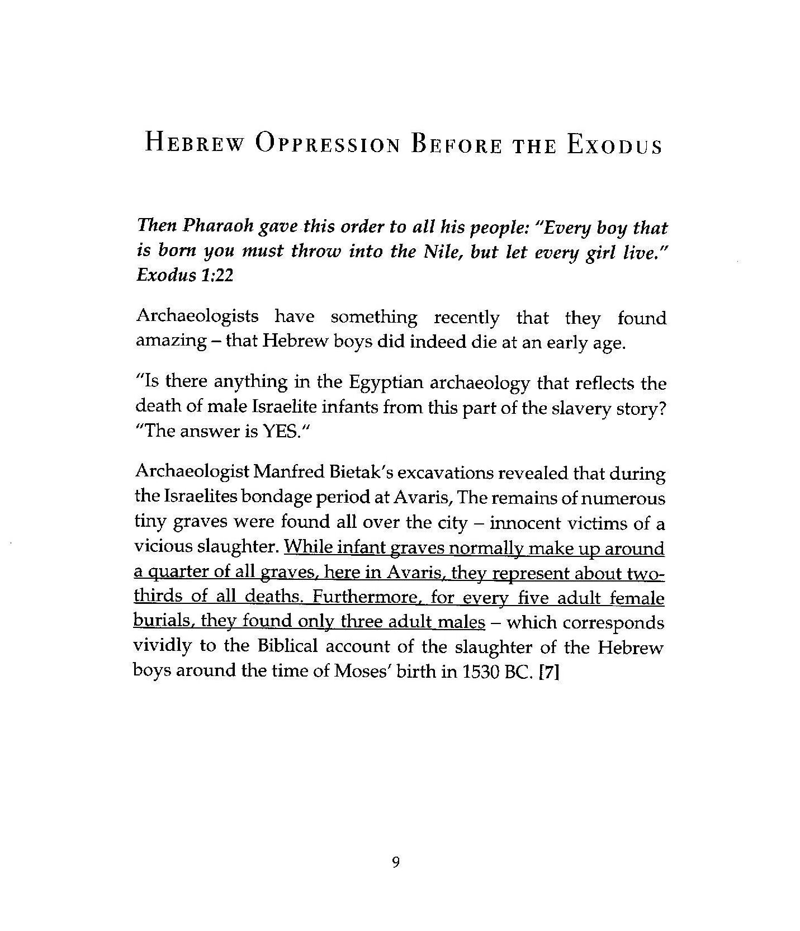
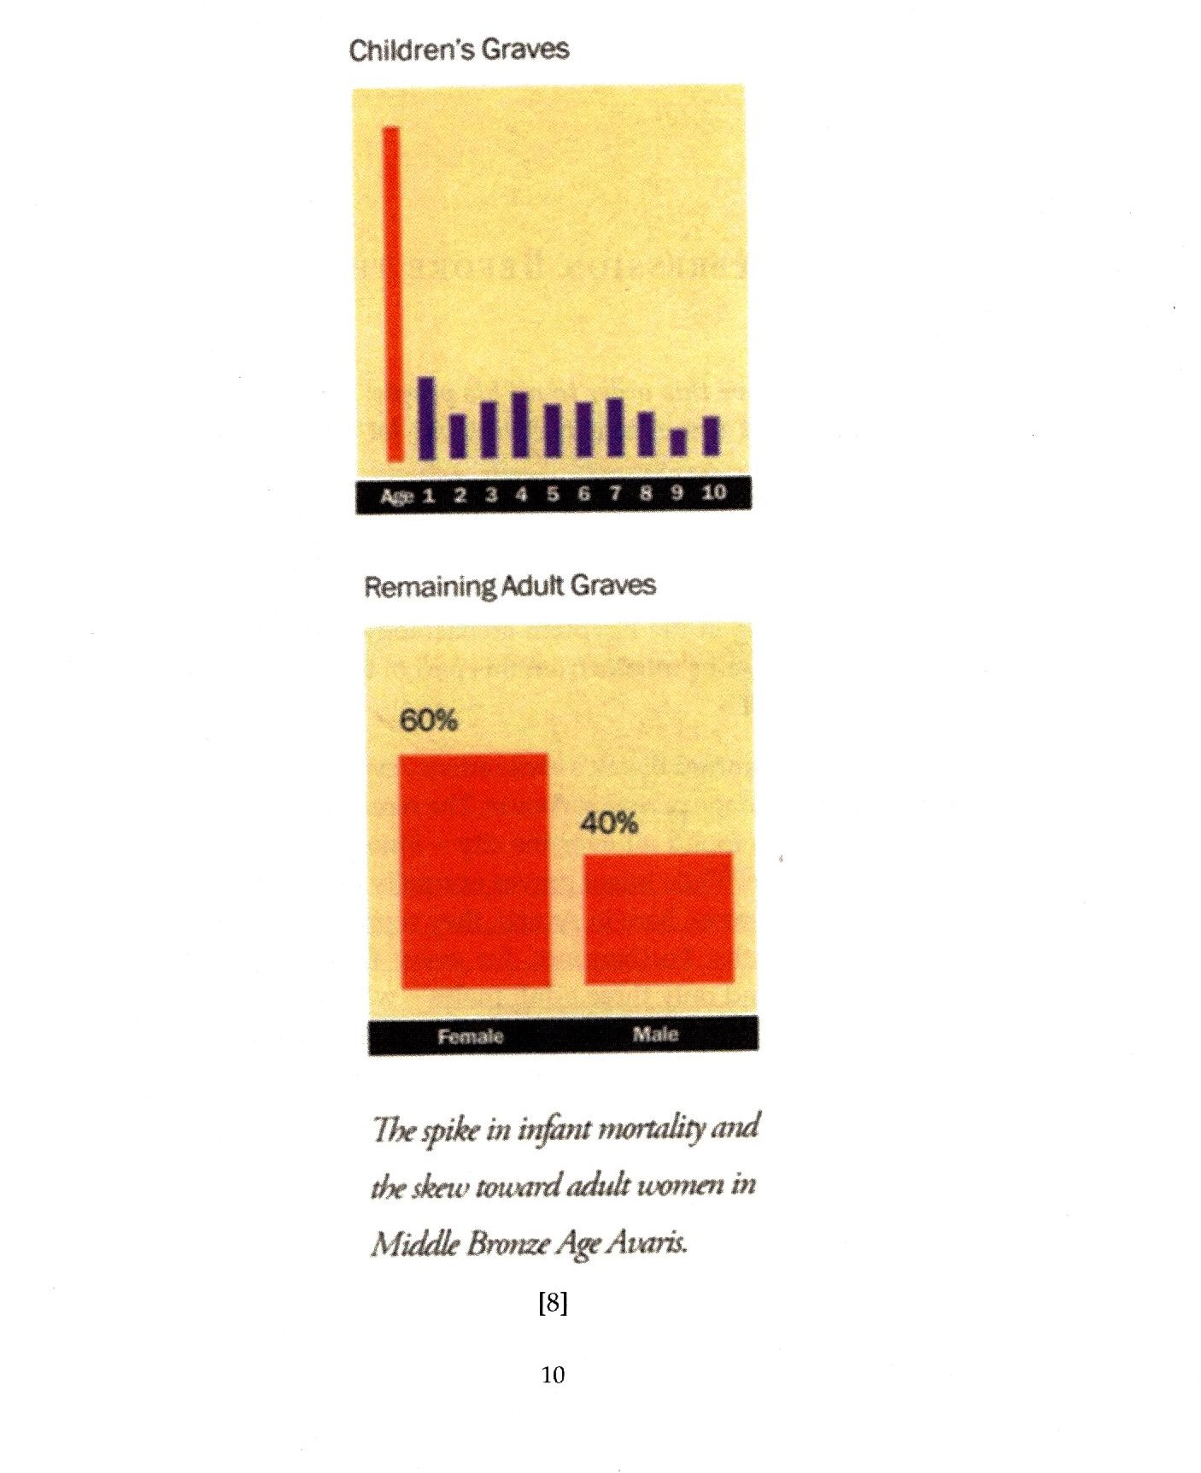

Slide #12 Pharaoh Amenemhat IV of the Exodus
The Egyptians kept detailed records – especially of their Pharaohs. The records are numerous of their reigns, their death and their burial locations. The information is all there – except for one Pharaoh in the 12th Dynasty.
The 12th Dynasty ruled during a very prosperous time, of pyramid building, approximately 1650 – 1450 BC. The capital was Itjawy which was close to the Israelite town of Avaris, where Moses lived. Like all Pharaohs, their exact burial location was noted, except for one, the 7th Pharaoh of the 12th Dynasty, Amenemhat IV, who drowned in the Red Sea.
“The tomb of Amenemhat IV has not been identified.” Some embarrassed ancient Egyptian chroniclers recorded that he never existed!
He was succeeded by his widow, Sobekkare, the last Pharaoh of the 12th Dynasty.
Less than ten years after Amenemhat IV’s death, the 12th Dynasty came to an end and was replaced by a much weaker 13th Dynasty.
In the 13th Dynasty, political instability quickly became prevalent and kings rarely ruled beyond a couple of years.
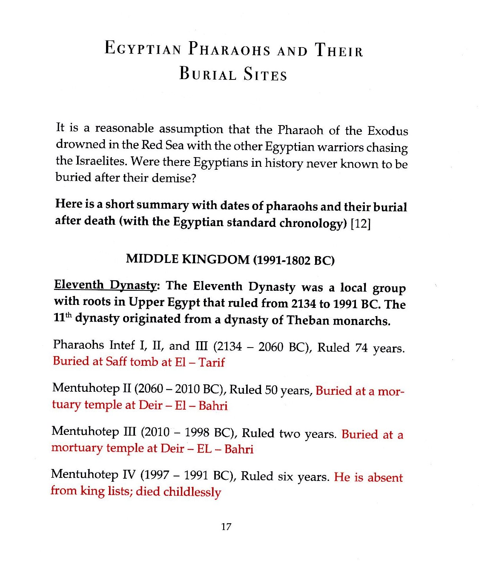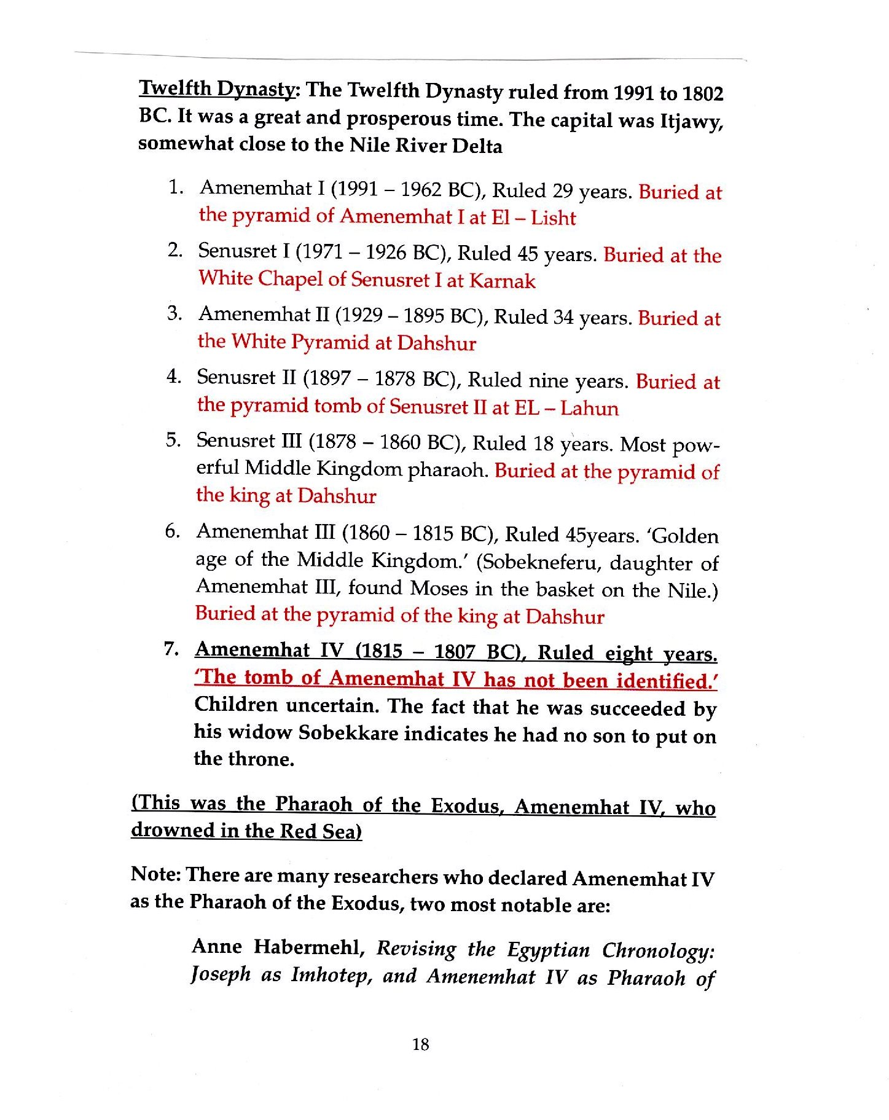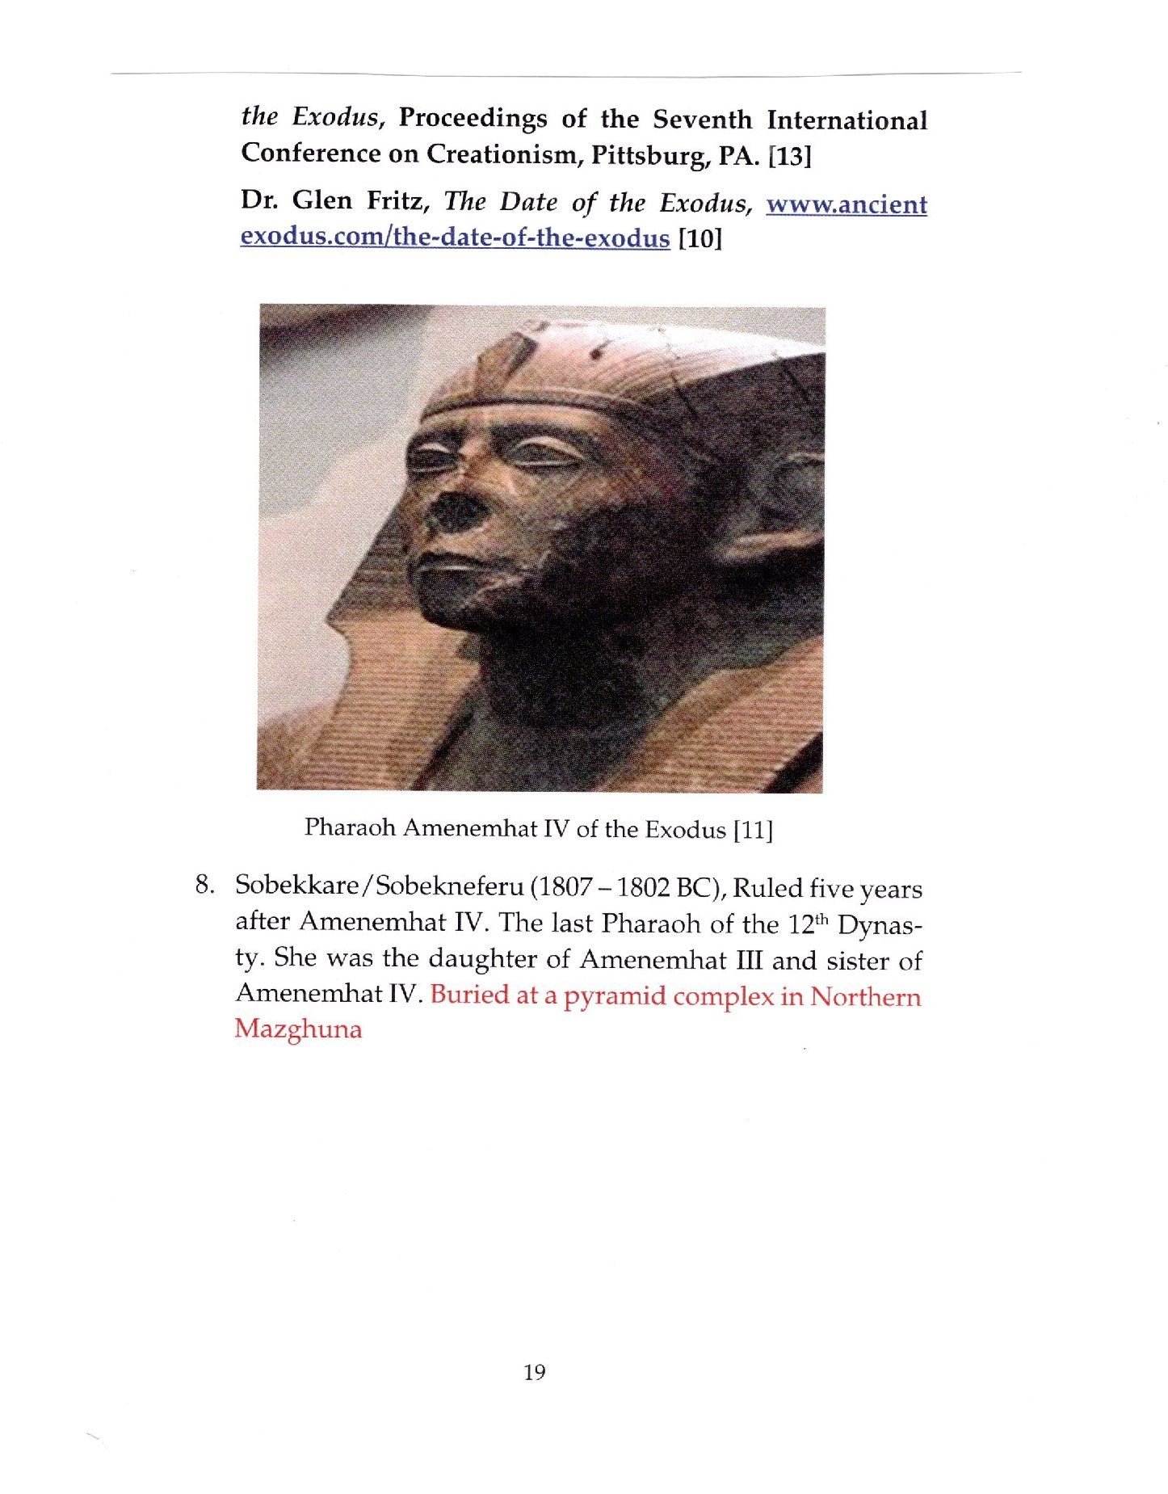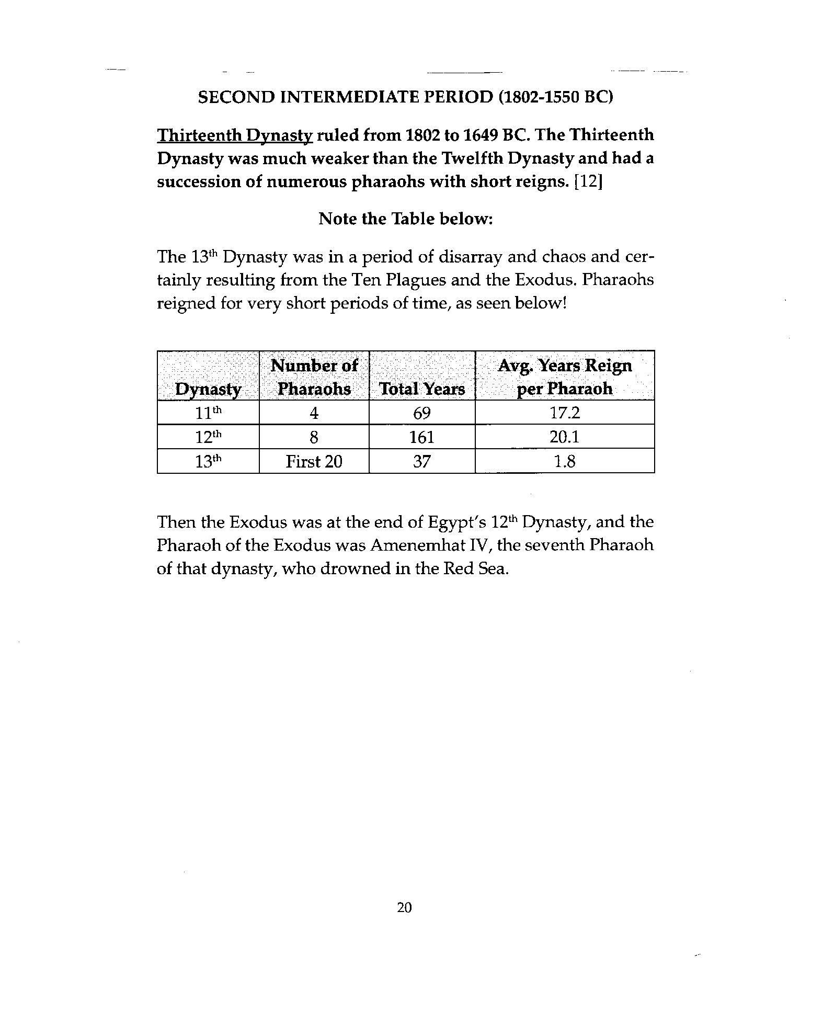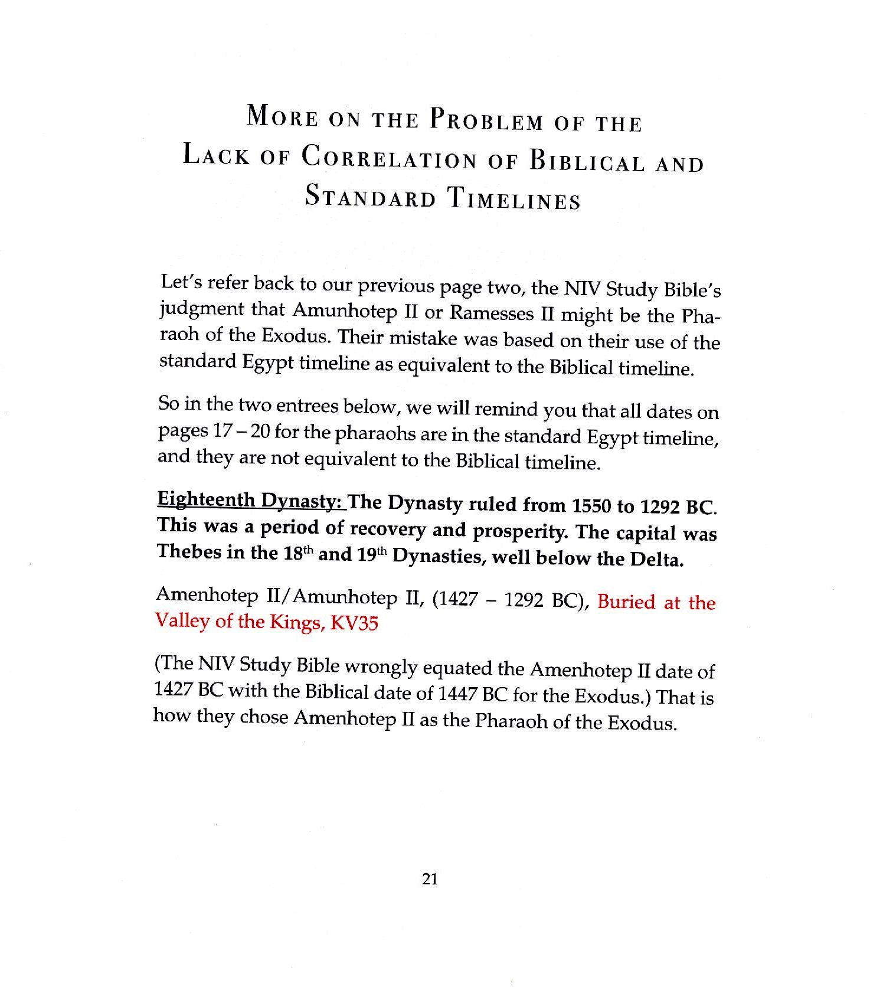
Slide # 13 The Pharaoh of the Exodus, Amenemhat IV

Slide # 14 The Ten Plagues of Egypt

I don’t think I have to remind you that all of this was God’s plan – including the Plagues.
And, our God is a jealous God, and He is the God of all! There will be no other Gods but Him.
I realized, somewhat recently, that the ten plagues were to show up Egypt’s false gods.
Hapi, Heket, Geb, Khepfi, Apis, Sekhmet, Thoth, Nut, Seth, and Ra.
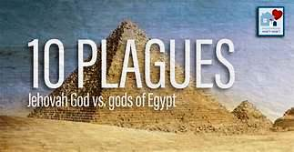

Slide # 15 They will come out with great possessions
As the Israelites left Egypt, they came out with great possessions, just as God told Abraham earlier in Genesis 15:13-16.
They needed the possessions to help sustain them in their 40 years travels.
Their route was not crossing the Gulf of Suez but they left their home Goshen, Avaris, or Succoth traveling east led by the angel of God.
God’s plan was to destroy the Egyptian army and chariots, so he led them to the deep waters of the Gulf of Aqaba at the Arabian border.
They were trapped, but of course God had a plan!
At Neweibe Beech, God parted the water for the Israelites and then returned the waters over the approaching Egyptian chariots.
Note that early Bible scholars got the location of Mt Sinai all wrong – west of the Gulf of Aqaba. It is really, as shown on this map, in Arabia.
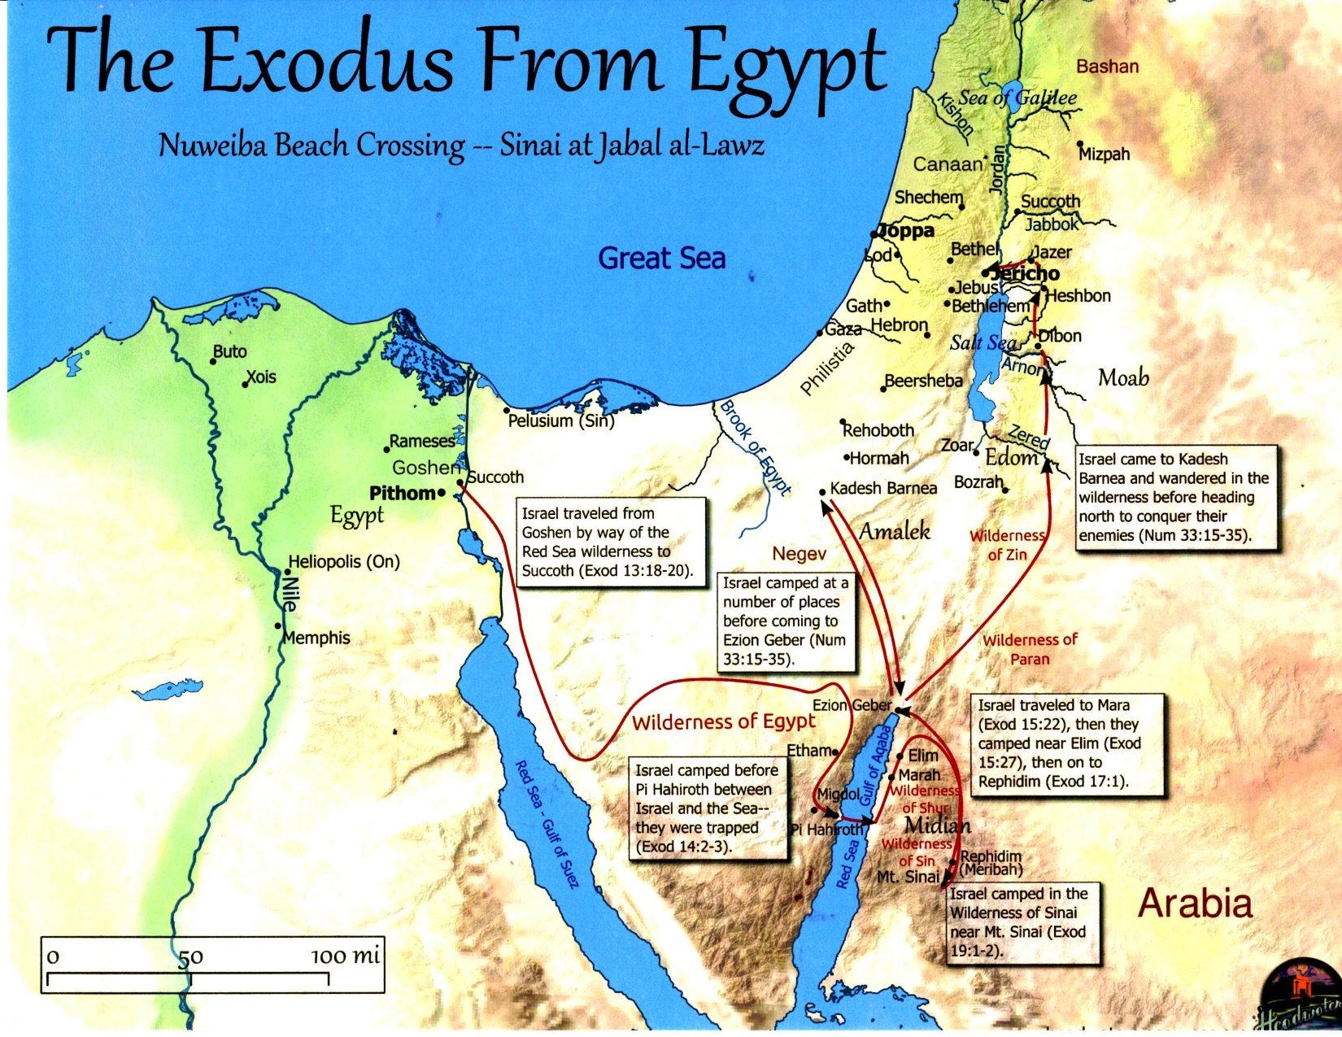
Slide # 16 They were trapped at the beach
This is amazing! The Egyptian army was approaching the Israelites who were trapped at the water’s edge.
Then the angel of God, who had been traveling in front of Israel’s army, withdrew and went behind them. The pillar of cloud also moved from in front and stood behind them, coming between the armies of Egypt and Israel. Throughout the night, the cloud brought darkness to one side (the Egyptian side) and light to the other side (the Israelites), so neither went near the other all night long. Exodus 14:19-20.
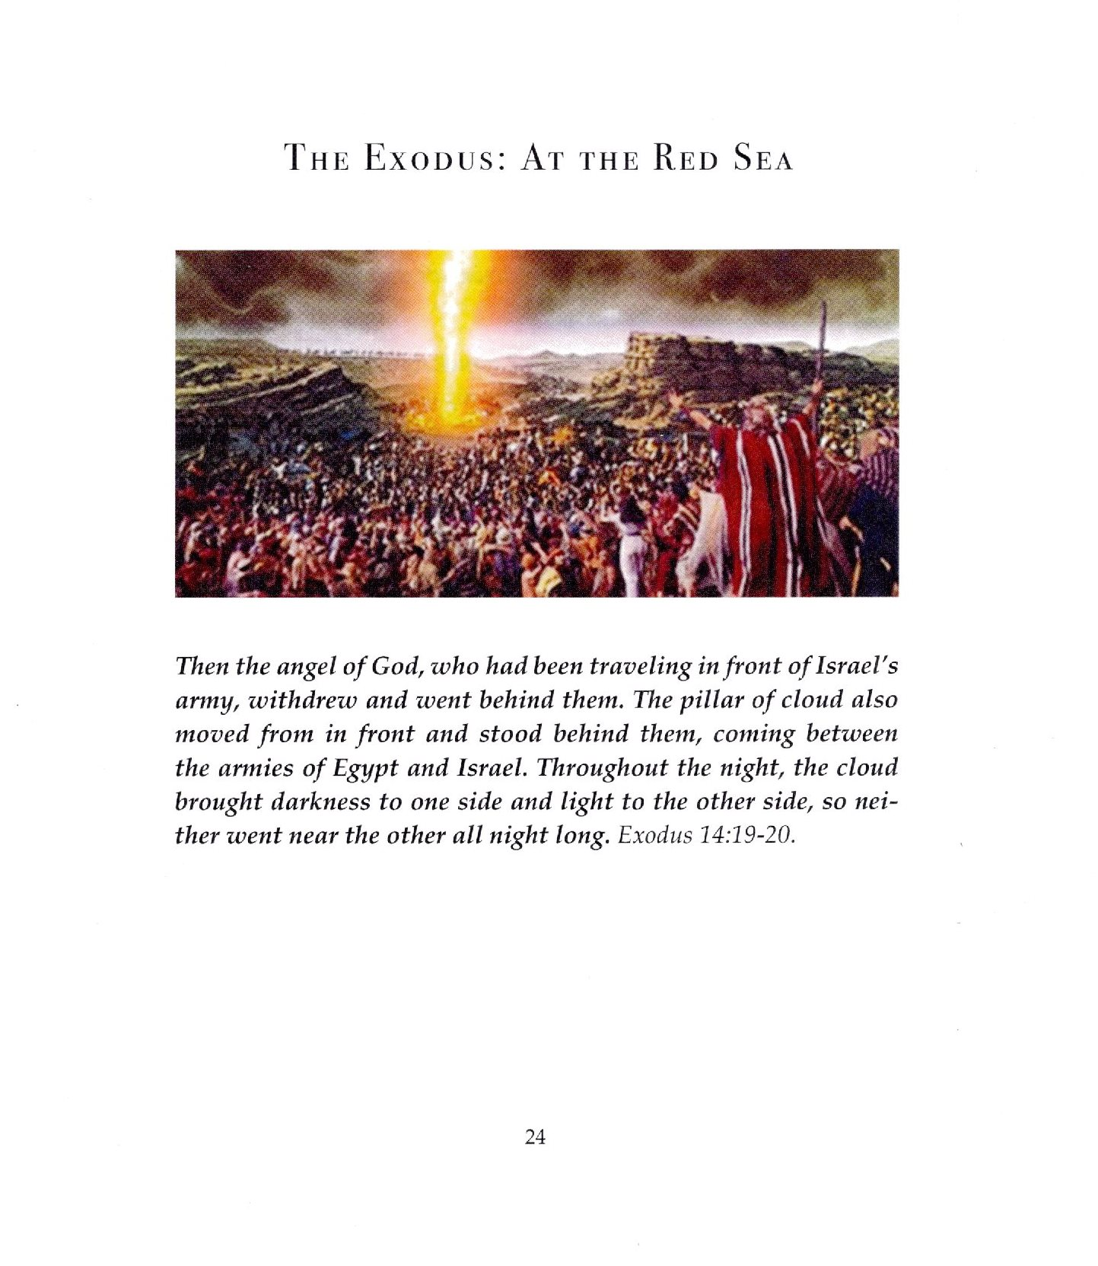

Slide # 17 The Lord swept the Egyptians into the sea
Then the Lord said to Moses, “Stretch out your hand over the sea so that the waters may flow back over the Egyptians and their chariots and horsemen.” Moses stretched out his hand over the sea, and at daybreak, the sea went back to its place. The Egyptians were fleeing toward it, and the Lord swept them into the sea. The water flowed back and covered the chariots and horsemen – the entire army of Pharaoh that had followed the Israelites into the sea. Not one of them survived. Exodus 14:26-28.
Our friend, Pharaoh Amenemhat IV was drowned in the Red Sea!

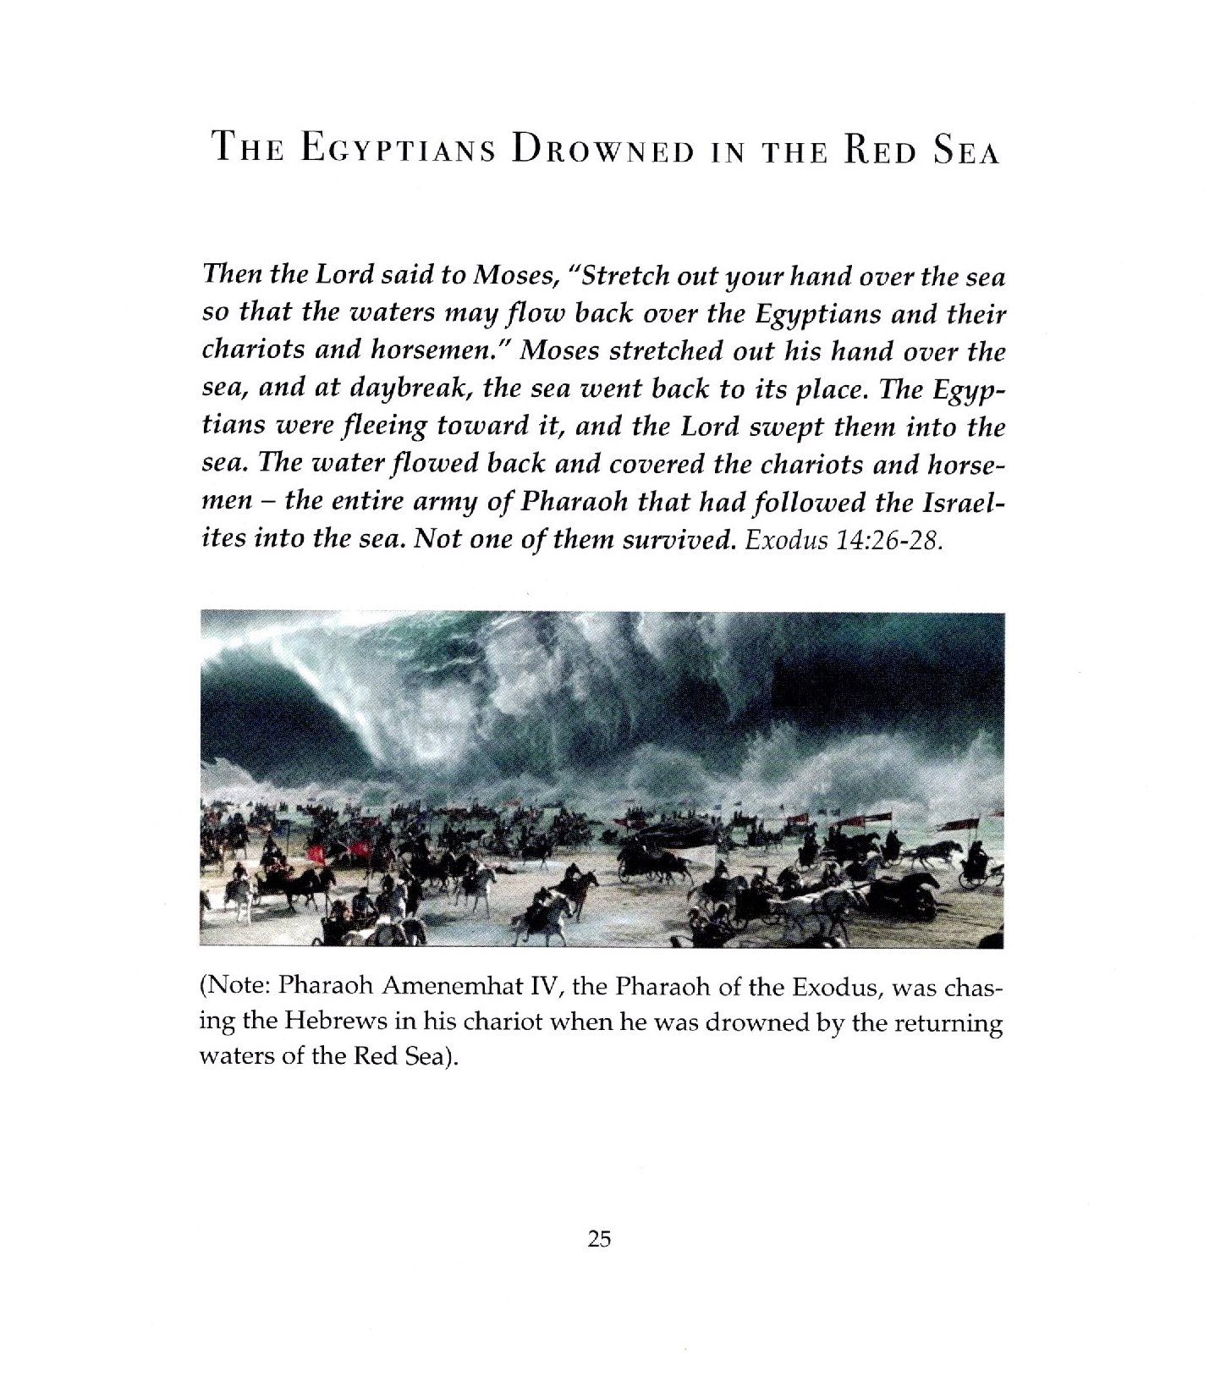
Slide # 18 Chariot wheels in the Red Sea
This has got history wrapped around it by the name of Ron Wyatt who was an archaeologist explorer. He got fame and shame when he ‘discovered’, first in 1977, Noah’s Ark at the Durapinar site in the Ararat Mountains. His fame took a hit when there was found no credible evidence for the claim.
In 1988, Ron explored and found chariot wheels at the bottom of the Red Sea at the Nuweiba Beach.
But, people were skeptical, including the atheists, and because of Ron Wyatt’s other unproved ‘finds’.
Fast forward to now when hundreds of underwater chariot wheel photos can be seen.
Dr. Lennart Moller of Sweden studied the scene extensively and wrote a book, with photos, “The Exodus Case”, in 2008.
There is an article in 2017: www.discovery.global/biblical-discoveries/discovered-red-sea-chariot-wheels/
Also in 2021: www.nationalgeographyc.blogspot.com/2021/08/chariots-found-in-bottom-of-red-sea.html
Ron Wyatt passed away in 1999. He would be glad to know his chariot wheels are truly real!
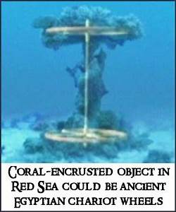

Slide # 19 Underwater divers at the Red Sea, Nuweiba Beach site
There are a lot of divers moving about. Here is just one photo, out of many, of two such divers with their booty.
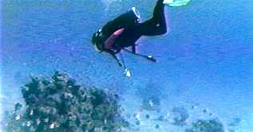

Slide # 20 Gold plated chariot wheel
This is a beautiful gold plated chariot wheel.
It may be from the chariot of Pharaoh Amenemhat IV.
The reason it was so well preserved is that coral does not grow on gold.
The wood inside the gold “veneer” was deteriorated, which made it fragile, and for that reason, divers didn’t attempt to retrieve it from the water.
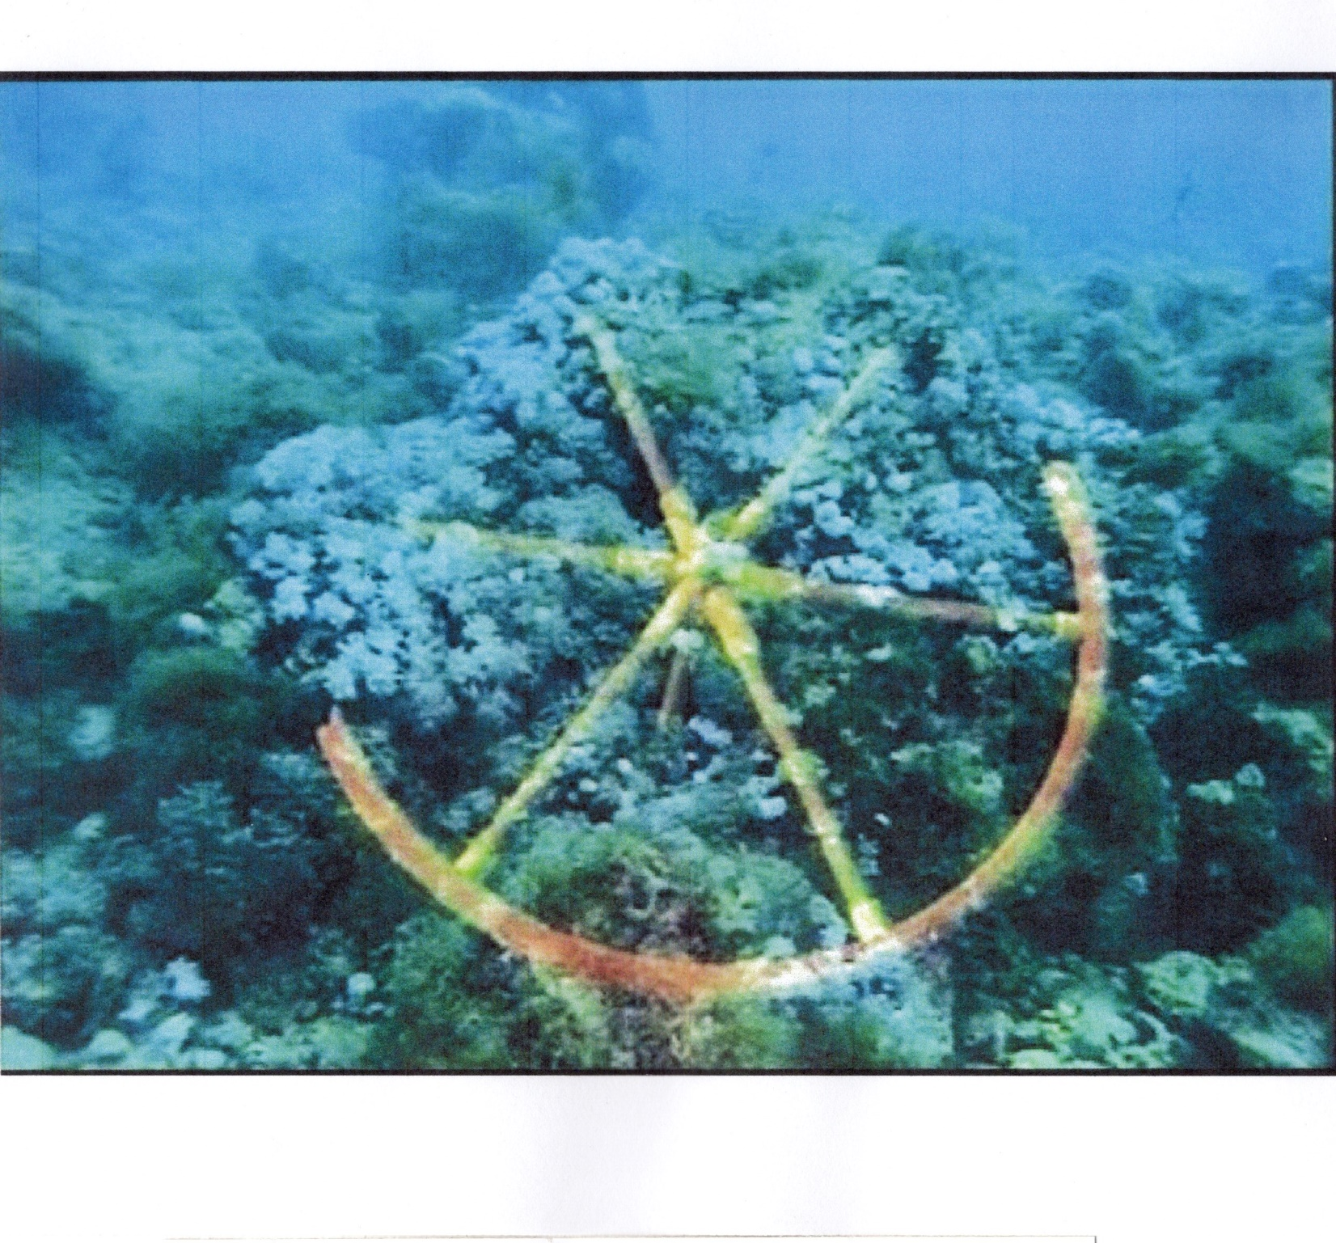
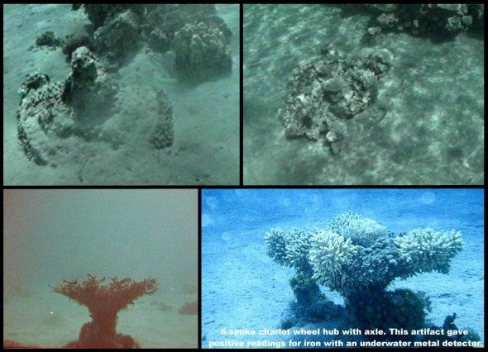

Slide # 21 Bones found at the bottom of the waters
Along with the chariot wheels, a number of bones, human, were found at the bottom of the waters.

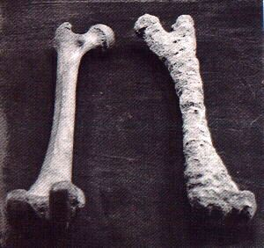
Slide # 22 King Solomon’s two pillars as a memorial to the miracle of the Red Sea crossing
About 480 years after the Exodus (967 BC), King Solomon placed two pillars (one on either side) to memorialize the miracle of the crossing of the Red Sea.
Our friend, Ron Wyatt, first found the pillars.
There was an inscription. In Phoenician letters it contained the words: Mizraim (Egypt); Solomon; Edom; death; Pharaoh; Moses; and Yahweh, indicating that King Solomon had set up these columns as a memorial to the miracle of the crossing of the Red Sea.
On the eastern side, Saudi Arabia does not admit tourists, and perhaps fearing unauthorized visitors, the Saudi Authorities have since removed that column, and replaced it with a flag marker where it once stood.
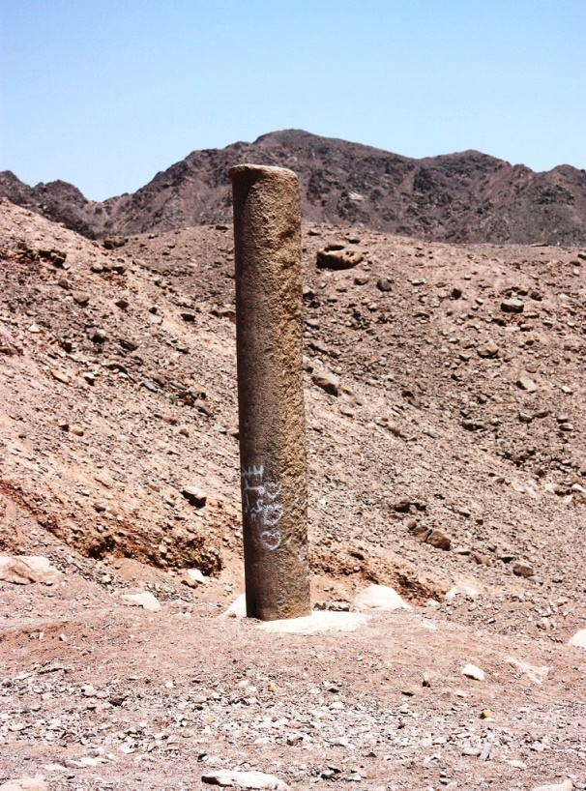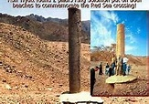

Slide # 23 The Ipuwer Papyrus
People have often asked, “Did the Egyptians actually have something to say about the Plagues and the aftermath of the Exodus?” Thankfully, the answer is yes!
The picture is of a section of the Egyptian Ipuwer Papyrus dated closely after the time of the Egyptian 12th Kingdom and the Exodus.
As one of the Egyptian early historical documents, it is often debated with most saying it describes the chaos caused by the Plagues, and others preferring to label it associated with some other time and event.
Officially designated “Papyrus Leiden I 344”, it is now located in the Dutch National Museum of Antiquities, Leiden, Netherlands.
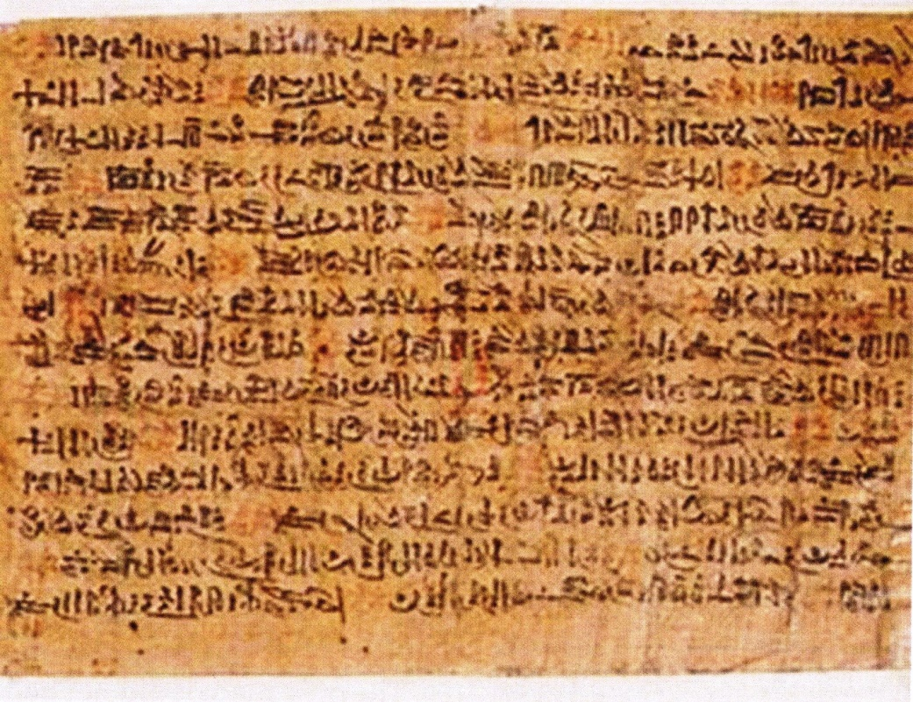
Slide # 24 The Text of the Papyrus vs the Holy Bible
Four examples, out of many:
1.The Papyrus: And every foreign land comes! That is our fate, and that is our happiness! What can we do about it? All is ruin!
Exodus 10:7: Pharaoh’s officials said to him, “How long will this man be a snare to us? Let the people go so that we may worship the Lord their God. Do you not realize that Egypt is ruined?”
2.The Papyrus: Poor men have become owners of wealth, and he who could not make sandals for himself is now a possessor of riches.
Exodus 12:35-36: The Israelites did as Moses instructed and asked the Egyptians for articles of silver and gold and for clothing. The Lord had made the Egyptians favorably disposed toward the people, and they gave them what they asked for, so they plundered the Egyptians.

3.The Papyrus: Pestilence is throughout the land, and blood is everywhere.
Exodus 7:17: . . . I will strike the water of the Nile, and it will be changed to blood.

4.The Papyrus: The river is blood, yet men drink of it.
Exodus 7:24: And all the Egyptians dug along the Nile to get drinking water because they could not drink the water of the river.

Slide # 25 The Merneptah Stele
One more item from ancient Egypt indicating the truth of the Israelites and the Bible.
The Merneptah Stele was found in a funery temple in western Thebes.
Merneptah (the son of Ramesses II) was the fourth Pharaoh of the Egyptian 19th Dynasty (about 1,000 BC). Egypt was strong at this time.
The inscription, shown on the slide, lists Pharaoh’s military victories. The Nation of Israel is on the lists of conquests, which some believe is the earliest reference to Israel outside the Bible. Canaan is also mentioned.
The Merneptah Stele now resides in Egypt’s Cairo Museum.
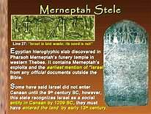
Slide # 26 and # 27 The seven Extra-Biblical discoveries
I believe these are very important because it indicated the Hebrew Exodus truly happened!
I present this study because I am concerned! As I said at the start, it seems that many, if not most, don’t believe in miracles, and so don’t believe fully in God!
Non-belief has set God against us. And He is disciplining us. We can see it in our culture!
I seek to change our thought pattern – and our culture:
The Exodus was true!
The Holy Bible is true!
We can earn God’s favor by our increased Belief and faithfully following His Words and admonitions.

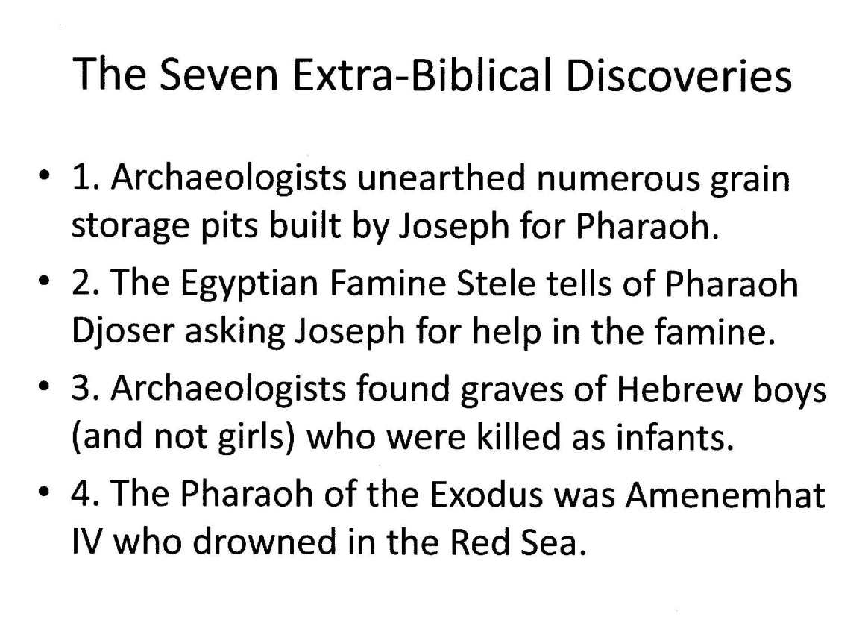
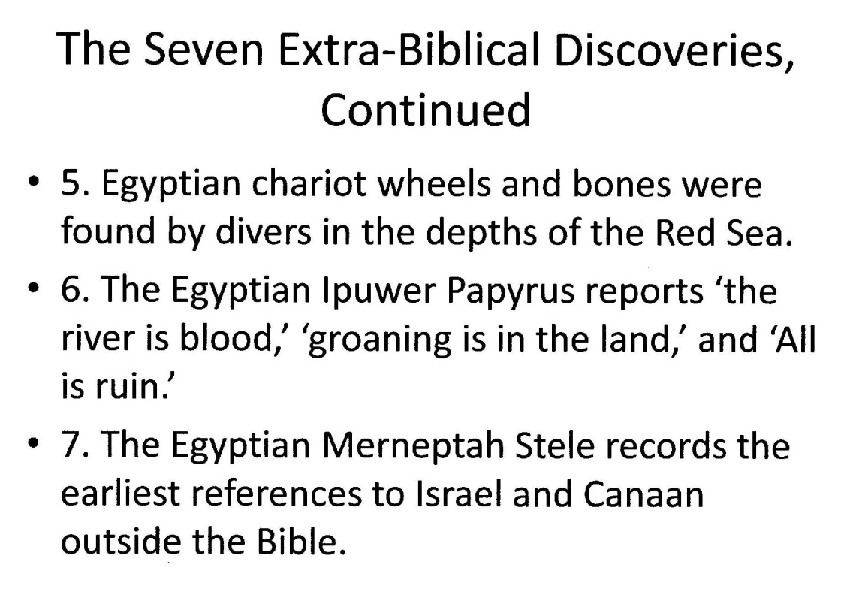
Slide # 28 Epilogue: The Song of Moses and the Israelites
My request: Can we earn God’s favor by our increased belief like Moses, Miriam and the Israelites?
The Song of Moses and the Israelites
Then Moses and the Israelites sang this song to the Lord: “I will sing to the Lord, for he is highly exalted. The horse and the rider he has hurled into the sea. The Lord is my strength and my song; he has become my salvation. He is my God, and I will praise him, my father’s God, and I will exalt him.”
Exodus 15:1-2
