The Hebrew Exodus Truly Did Happen!
Jay Schabacker
It’s time for a reminder. Our Lord God is true, and the truth of His miracles reminds us to follow in His ways.
Let’s refer to God’s remarks to Abraham, 300 years before the actual Exodus from Egypt: Then the Lord said to him (Abraham), “Know for certain that your descendants will be strangers in a country not their own, and they will be enslaved and mistreated for four hundred years. But I will punish the nation they serve as slaves, and afterward, they will come out with great possessions. You, however, will go to your fathers in peace and be buried at a good old age. In the fourth generation, your descendants will come back here (Canaan), for the sin of the Amorites has not reached its full measure.” Genesis 15:13-16.
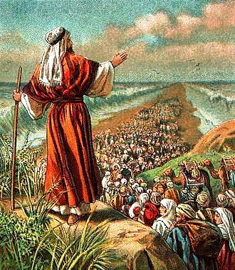
Too many don’t follow and consider all His miracles – including God’s Passover and the Exodus. Can this actually have happened as it says in the Holy Bible?
As it is said in Wikipedia. “The Exodus is the founding myth of the Israelites.” So let’s now research the extra-Biblical truth about the Exodus.

“Strangers in a country not their own.”
The Date of the Exodus
The Holy Bible Old Testament says, In the four hundredth and eightieth year after the Israelites came out of Egypt, in the fourth year of Solomon’s reign of Israel . . . I Kings 6:1. Now, chronologist records fix the fourth year of Solomon’s reign at 966 BC. The above verse tells us that in the fourth year of Solomon’s reign over Israel (966 BC), that was the same as 480 years after the Israelite Exodus from Egypt. So, the Israelites came out of Egypt 966 BC minus 480 years earlier. Then the Exodus was 966 BC plus 480 years earlier or 966 + 480 or 1446 BC.
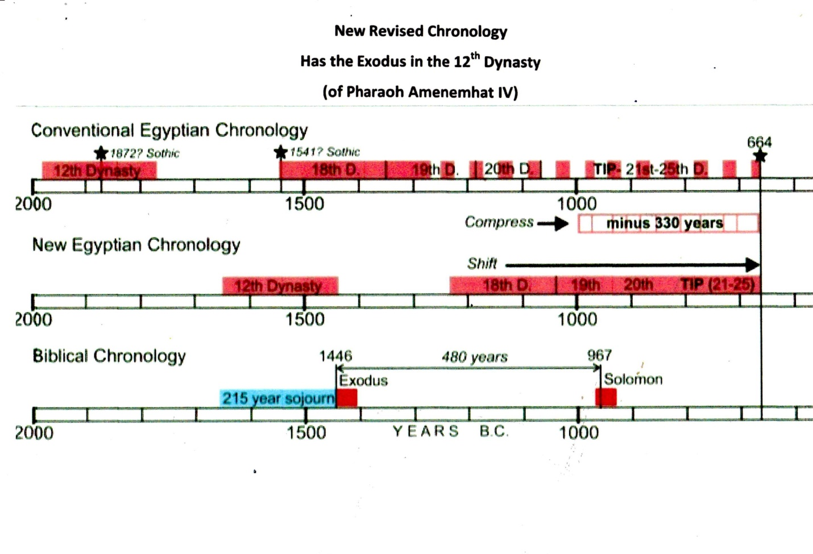
The old Egyptian Conventional Chronology was a problem
For years researchers of the Exodus faced problems because of overlapping pharaohs reigns in Conventional Egyptian Chronology. Their time line was too stretched out and so didn’t jive with the Biblical Chronology. When a match up with the 1446 BC Exodus date was attempted with the Egyptian 18th Dynasty, no Pharaohs seemed plausible, as their bodies were all buried in Egypt. Researchers found a compression was needed (of about 330 years) to make the correction to a New Revised Egyptian Chronology. The date of the Exodus now corresponded with the Egyptian 12th Dynasty instead of the 18th Dynasty!
Let’s go back to where it all got started – with Joseph
God’s plan was to send him (Joseph) to Egypt so he could interpret Pharaoh’s dream. Pharaoh’s dream told of seven years of plenty and seven years of famine. Then Pharaoh Djoser appointed Joseph in charge of all the needed preparations before the upcoming famine.

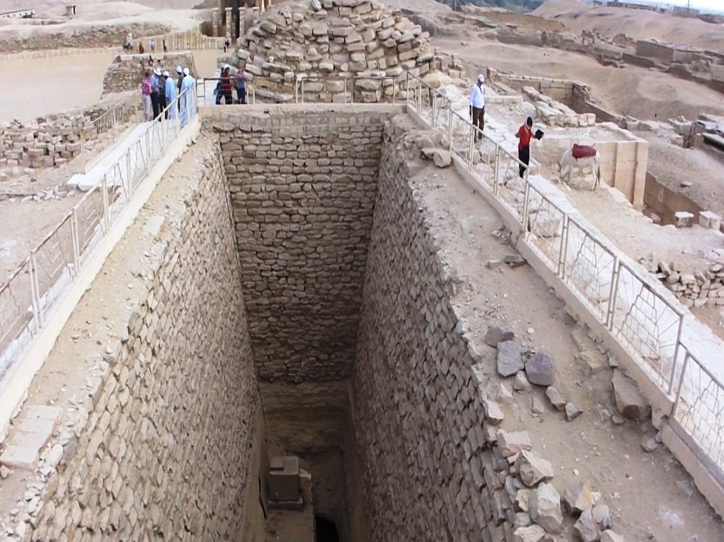

People on top of a huge Egyptian grain pit showing its massive size
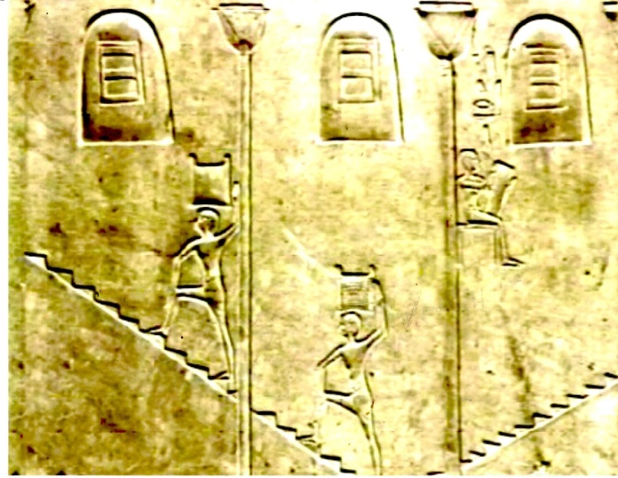
Egyptian hieroglyphs have been found showing workers going up and down the steps transporting the grain. And, indeed, the steps have been uncovered.
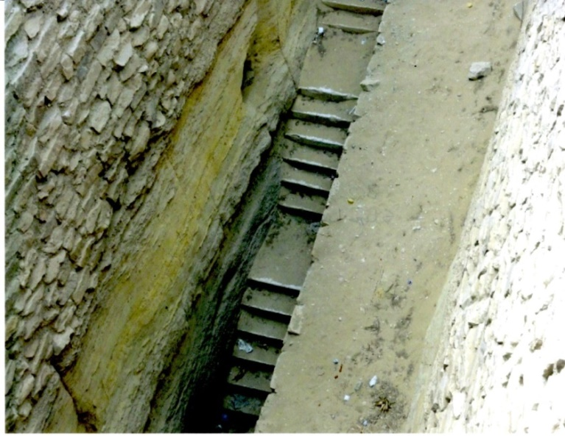
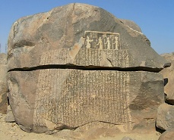
Joseph stored up huge quantities of grain, like the sand of the sea; it was so much that he stopped keeping records because it was beyond measure. Genesis 41:49
On the island of Sihiel, near the first cataract of the Nile, is a great stone (The Famine Stele) with inscriptions on it which mentions Joseph. It tells of Pharaoh Djoser. The inscription states ‘seven meagre years and seven rich years’. “Pharaoh Djoser asks Joseph to help him with the coming seven years of famine.” The Famine Stele
“They will be enslaved and mistreated”
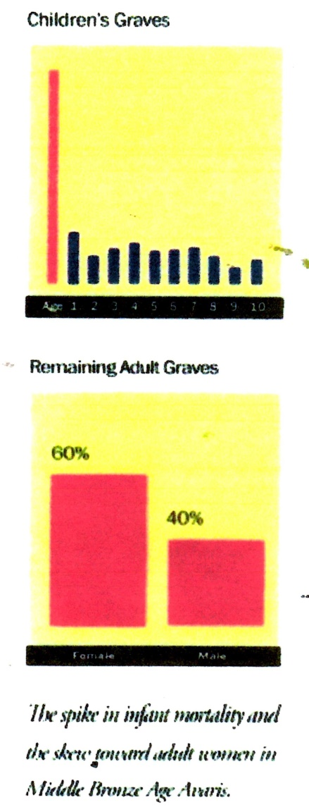
Then a new king that did not know about Joseph came to power in Egypt. Exodus 1:8.
So they set slave masters over them to oppress them with forced labor. Exodus 1:11.
Then Pharaoh gave this order to all his people: “Every boy that is born you must throw into the Nile, but let every girl live.” Exodus 1:22.
Graves of young boys killed by Pharaoh have been unearthed
Archaeologists have something recently that they found amazing – Hebrew boys did indeed die at an early age.
Is there anything in the Egyptian archaeology that reflects the death of male Israelite infants in this part of the slave story? The answer is “Yes.”
Archaeologist Manfred Bietak’s excavations revealed that during the Israelites bondage period, about 1530 BC, at Avaris, the remains of numerous tiny graves were found all over the city – innocent victims of a vicious slaughter.
While children’s graves normally make up a quarter of all graves, here at Avaris, they represent about two thirds of all deaths. (See top chart.) Furthermore, for every five adult female burials, they found only three adult males. The males died earlier as infants. (See bottom chart).
Who was the Pharaoh of the Exodus?
The Egyptians kept detailed records – especially of their Pharaohs. The records are numerous of their reigns, their death and their burial location. The information is all there – except for one Pharaoh in the 12th Dynasty.
The 12th Dynasty ruled during a very prosperous time, approximately (1650-1450 BC. The capital was Itjawy which was close to the Israelite town of Avaris, where Moses lived. Like all Pharaohs, their exact location of burial was noted, except for one, the seventh Pharaoh, Amenemhat IV, who drowned in the Red Sea.
“The tomb of Amenemhat IV has not been identified.” The fact that he was succeeded by his widow, Sobekkare, the last Pharaoh of the 12th Dynasty, he had no son (alive) to be put on the throne. Less than ten years after Amenemhat IV’s death, the 12th Dynasty came to an end and was replaced by a much weaker 13th Dynasty. In the 13th Dynasty, political instability quickly became prevalent and kings rarely ruled beyond a couple of years.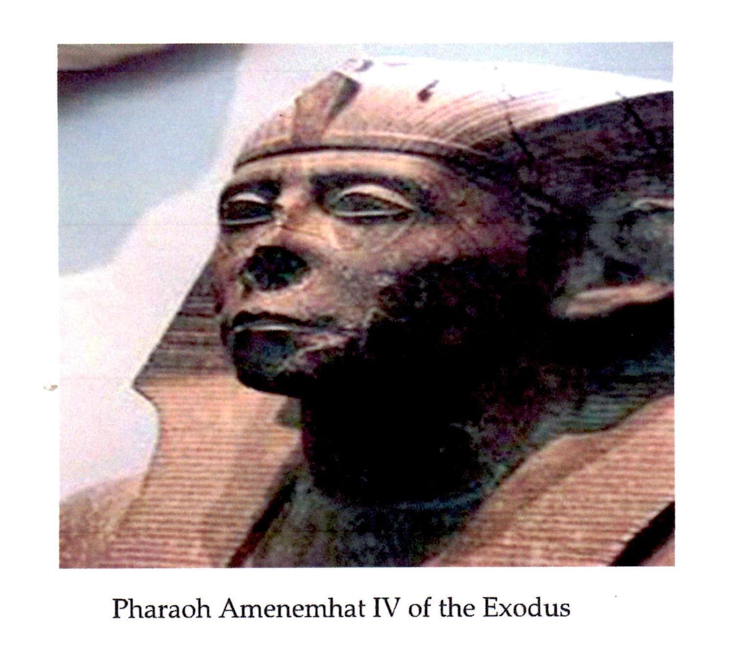

“I will punish the nation they serve as slaves”
The Ten Plagues of Egypt
Our God is a jealous God. Then the Lord God threw the Ten Plagues at the Egyptians to emphasize that their gods were of no effect when needed.
- Their god of the Nile, Hapi, lacked power as the water was turned to blood
- The god, Heket, had no control of Egypt’s sacred frogs
- Geb, the god of dust and land, had no control of the dust and gnats
- Khepfi, the god of insects, had no control when God called out the flies
- Apis, the god of the bull, had no effect when God struck down the livestock
- Sekhmet and Thoth couldn’t prevent the Plague of Boils in Egypt
- Nut controlled the weather, but had no effect from the destructive hail
- Seth, the god of the crops had no effect over the destructive locusts
- Ra, the sun god, saw no sun and no light for the extent of three days
- It was God’s plan to destroy Pharaoh, so the death of the first-born, set off the victorious Passover of the Israelites and their trip to the Promised land

Our God is a jealous God and He is the God of all! There will be no other Gods but Him.

Exodus 12:7 and 12:11
Then they are to take some of the blood and put it on the sides and the tops of the doorframes of the houses where they eat the lambs. Exodus 12:7.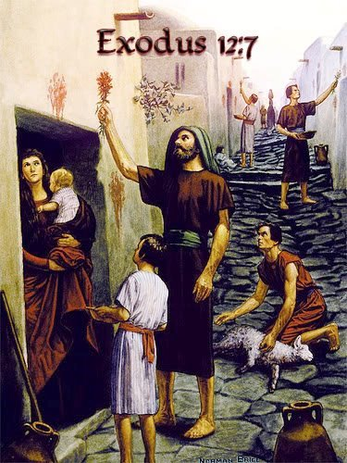

This is how you are to eat it: with your cloak tucked into your belt, your sandals on your feet and your staff in your hand. Eat it in haste; it is the Lord’s Passover. Exodus 12:11.

“They will come out with great possessions”

The Israelites did as Moses instructed and asked the Egyptians for articles of silver and gold and for clothing. The Lord had made the Egyptians favorably disposed. Exodus 12:35-36.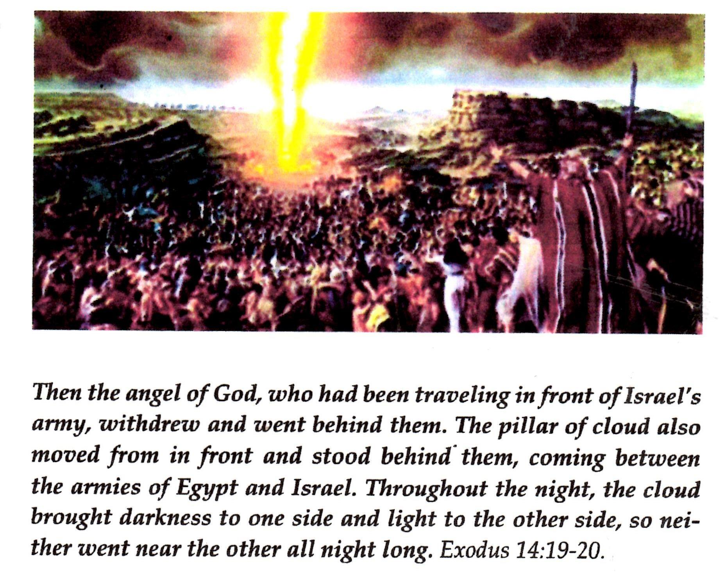

The Chariot Wheels
Researchers over many years have been gathering information of the Israelite’s crossing of the Red Sea at the Gulf of Aqaba – and the destruction of the Egyptian army in their waters. There have been numerous photos taken of chariot wheels and even of human bones. Here is just one of a chariot wheel and one of the bones.
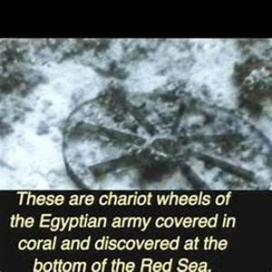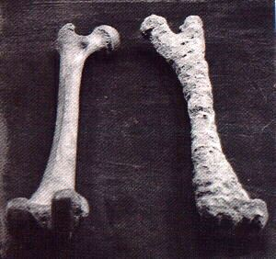

Statements from the Egyptian Ipuwer Papyrus
People have often asked, “Did the Egyptians actually have something to say about the Plagues and the Exodus?” The answer is thankfully – Yes!

The Egyptian Ipuwer Papyrus was written at the end of the 12th Dynasty. It is largely a conversation, in poem form, by an Egyptian called Ipuwer, who is talking to someone called ‘The Lord of All.’ It refers to the complete collapse of Egypt at the end of the Old Kingdom because of God’s Ten Plagues and the Exodus. Many of the calamities mentioned are identical to the calamities mentioned in the Holy Bible. Some of the text refers to ‘the river is blood,’ ‘the grain is lacking,’ ‘groaning is through the land,’ and ‘All
Is ruin.’
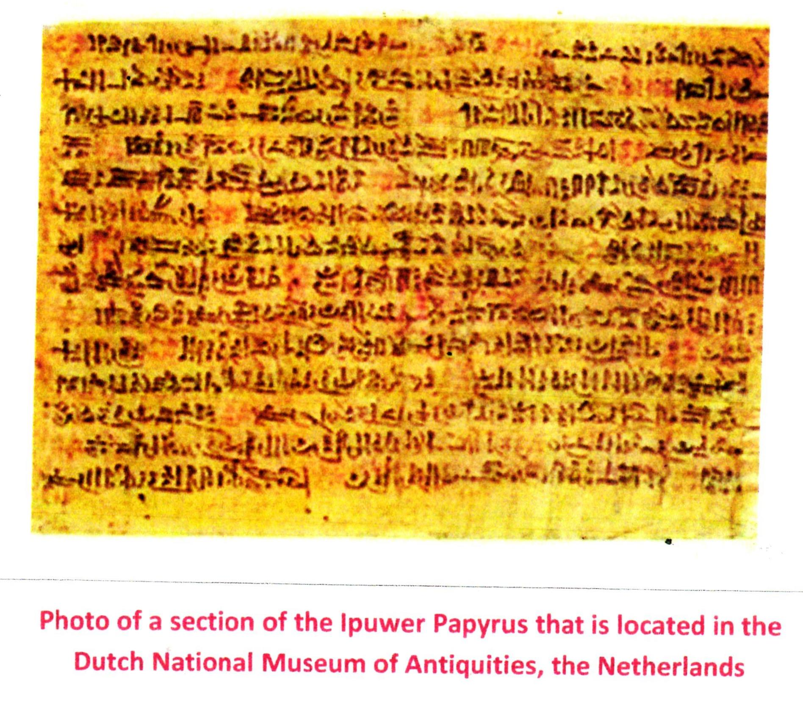

Some quotes from the Ipuwer Papyrus

Pestilence is throughout the land, and blood is everywhere.
The river is blood, yet men drink it.
All animals, their hearts weep; cattle moan because of the state of the land.
Trees are felled and branches are stripped off.
Men no more because of the condition of the land.

Conclusion

- Revising the Egyptian chronology is key: Joseph as Imhotep, the vizier of Pharaoh Djoser, who built the Stepped Pyramid, with the help of Joseph.
- Archaeologists have unearthed numerous Egyptian grain storage silos built by Joseph.
- The Pharaoh of the Exodus was Amenemhat IV, who drowned in the Red Sea.
- Archaeologists have found, at about 1530 BC, Hebrew boys (and not girls) died as infants at an early age.
- Numerous Egyptian chariot wheels and bones have been found and photographed deep in the Red Sea at the Gulf of Aqaba.
- The Egyptian Ipuwer Papyrus chronicles ‘the river is blood’, ‘the grain is lacking’, ‘groaning is throughout the land’, and ‘All is ruin.’
- Extra –Biblical research finds – the Hebrew Exodus truly did happen!

Epilogue
The Song of Moses and Miriam
Then Moses and the Israelites sang this song to the Lord: “I will sing to the Lord, for he is highly exalted. The horse and the rider he has hurled into the sea. The Lord is my strength and my song; he has become my salvation. He is my God, and I will praise him, my father’s God, and I will exalt. The Lord is a warrior; the Lord is his name. Pharaoh’s chariots and his army he has hurled into the sea. The best of Pharaoh’s officers are drowned in the Red Sea. The deep waters have covered them; they sank to the depths like a stone. Your right hand, O Lord, was majestic in power. Your right hand, O Lord, shattered the enemy. In the greatness of your majesty you threw down those who opposed you. You unleashed your burning anger; it consumed them like stubble. By the blast of your nostrils the waters piled up. The surging waters stood firm like a wall; the deep waters congealed in the heart of the sea.” Exodus 15:1-8.

