BESPOKE ARCHED STONE BRIDGE

by Harry
This follows on from my previous article about building a stone abutment. This time it is a bridge to span a 210mm gap (105' in N) with height to trackbed of 119mm.(60' in N).
In this case the layout already has a 12 arch (Metcalfe) stone viaduct further along the line, so following prototype practice this bridge will be built of stone from the same local quarry.
The first step is to design the bridge. Whatever its' size or gauge the design aim is to match the number of arches, their size and the dimensions of the legs to achieve a bridge that looks balanced and blends into the scenic setting. In short it should look 'right', if not go back to the drawing board.
I am using 3.6mm cork flooring tiles but a good quality card or thin ply would be alternatives. PVA glue is used throughout as it allows time to ease things into place and is very strong when set.
The photos show the sequence of construction as follows:
1 Draw the profile of the chosen design full size to finalise the general appearance. No other drawings are necessary as this bridge is a uniform width throughout. Draw 2 x bridge sides accurately on cork tile/cardboard/ply. Cut them out and laying them back to back, check for uniformity. Trim as necessary to make them identical.
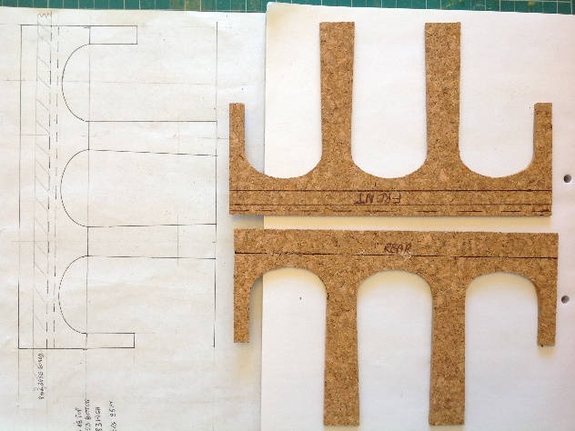

2 Draw and cut out the transverse leg faces and the trackbed. Lay one bridge side down and glue the trackbed and transverse leg faces. An engineer's square or similar is a necessity at this stage.
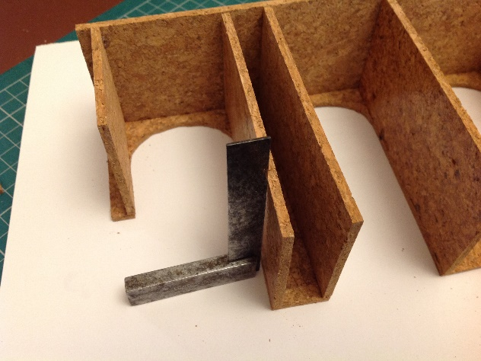

3 Glue on the other bridge side and use pins or small pieces of masking tape to hold everything square until the glue sets. Then tidy up all cut edges.
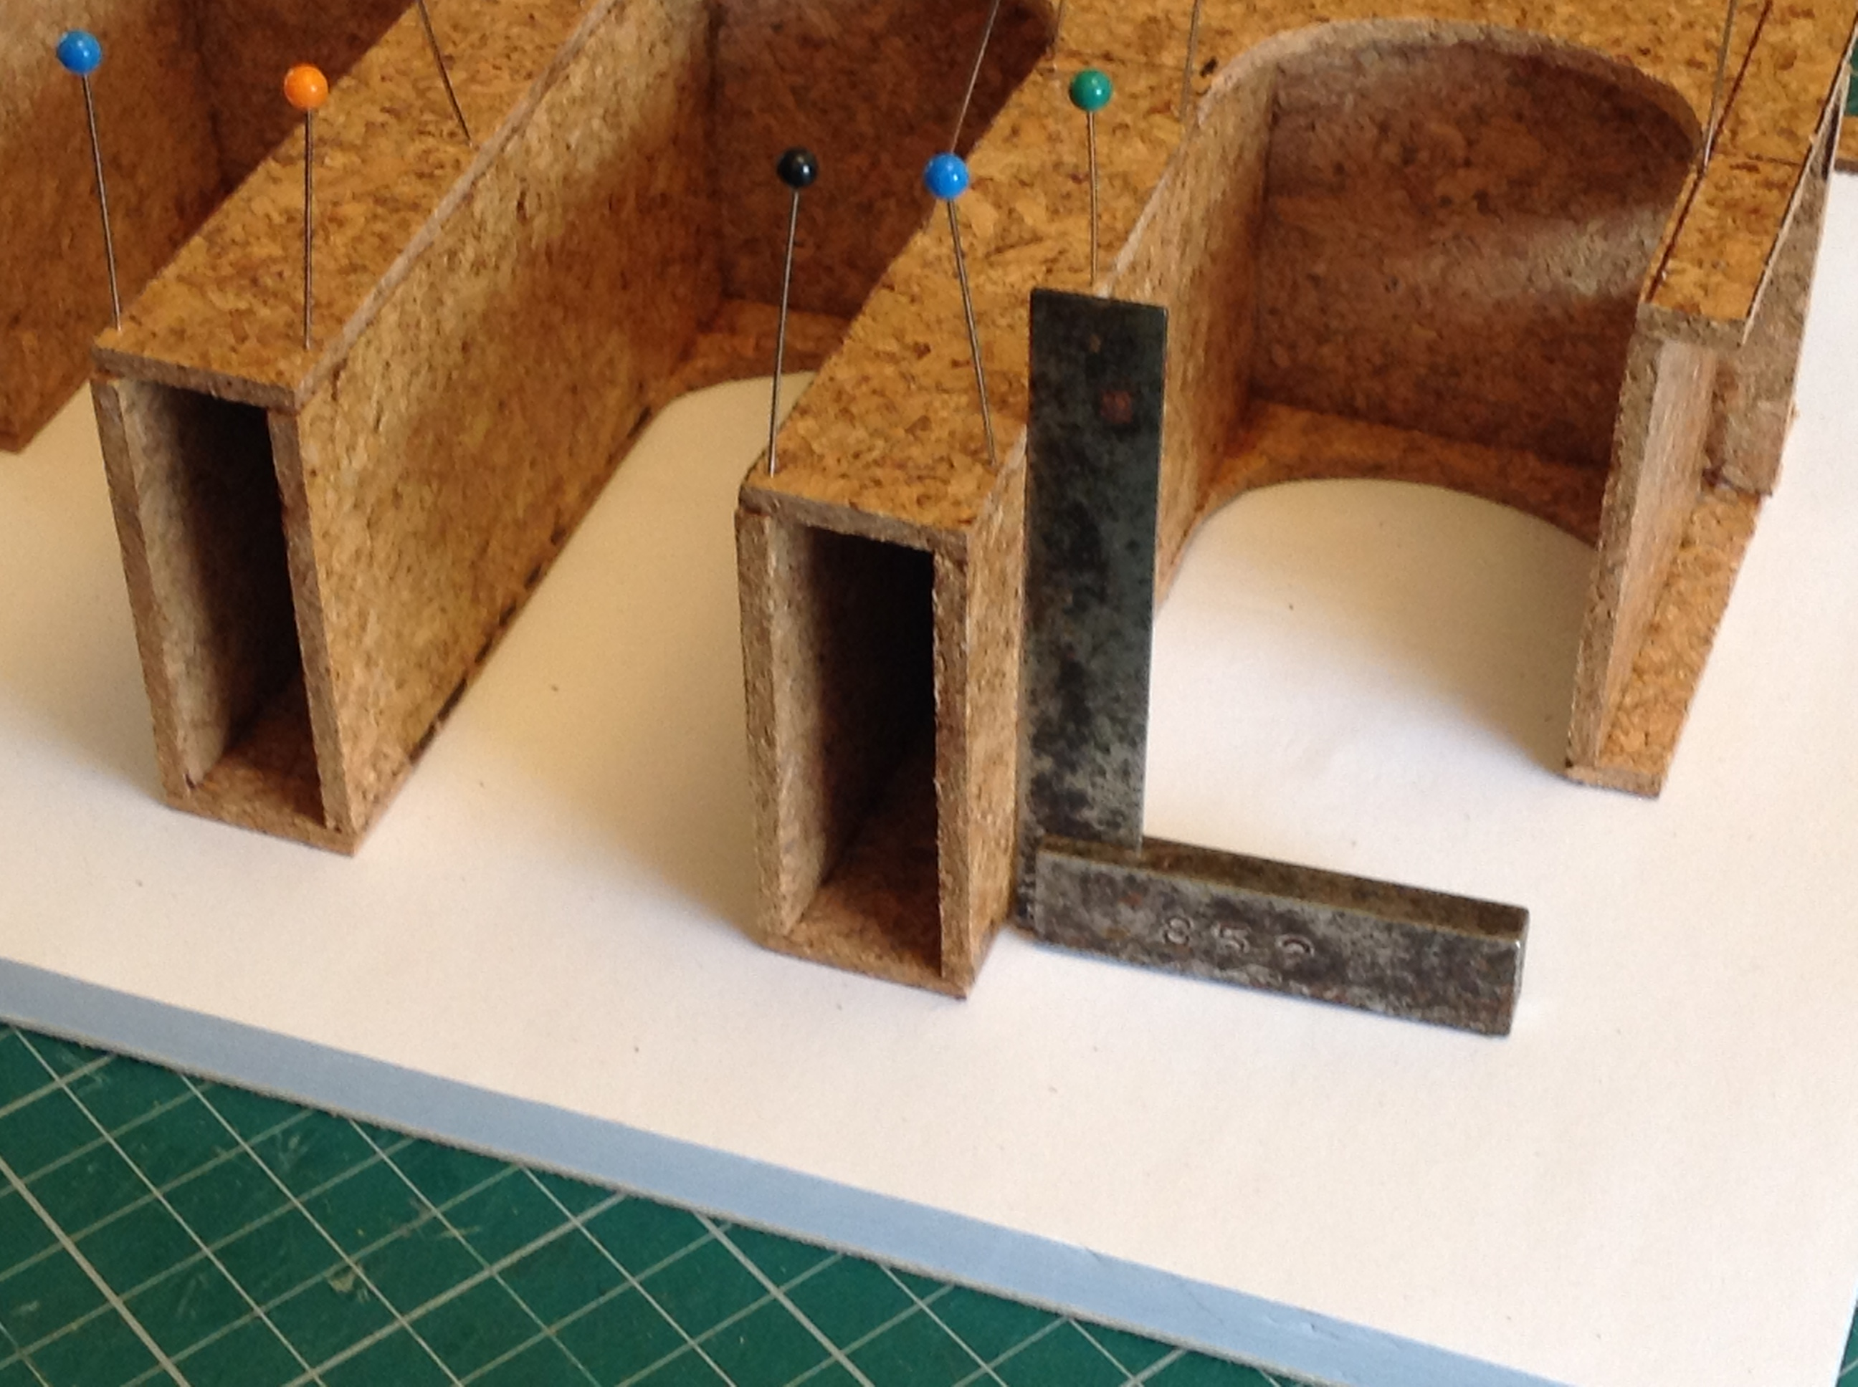
4. The curved arches come next. Cut out enough for all 4 arches from thin card in one long strip, drawing transverse lines to show the ends of each arch. Roll it around a cylinder of slightly smaller diameter than the bridge arches and keep it tight with elastic bands. Holding it over a steaming kettle to dampen the card will help it achieve a smooth curve as it dries overnight. When dry release the curved card and cut across the marked lines to create the individual curved arches. Glue each one in place. A mix of pins and elastic bands should hold the arch to the curved edges of the bridge while the glue sets.
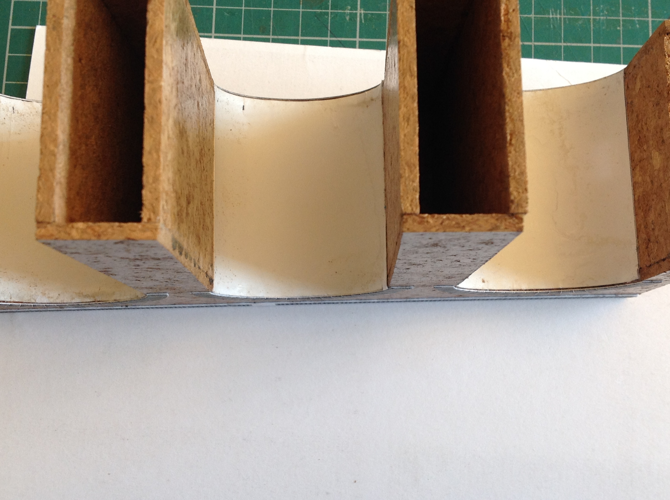
5. "PAWS" for thought and dress up for 🇬🇧'VE DAY🇬🇧
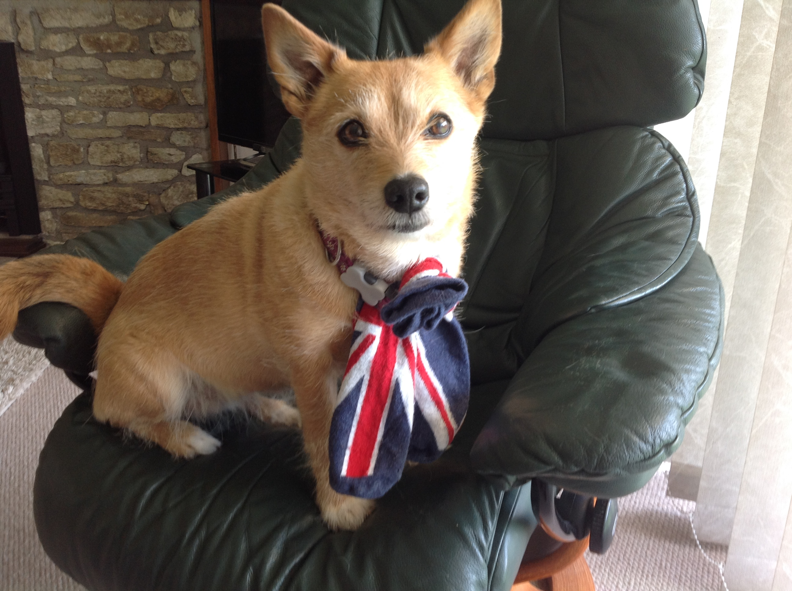
6 Making the arch diameter the same as those on the long Metcalfe bridge looked OK and allowed me to use the left over Metcalfe card arch facings. These, plus other card bits to represent other raised stonework were then glued on. You can add as much embellishment as you want at this stage - ornate, functional, lettering, sequins or whatever floats your boat.
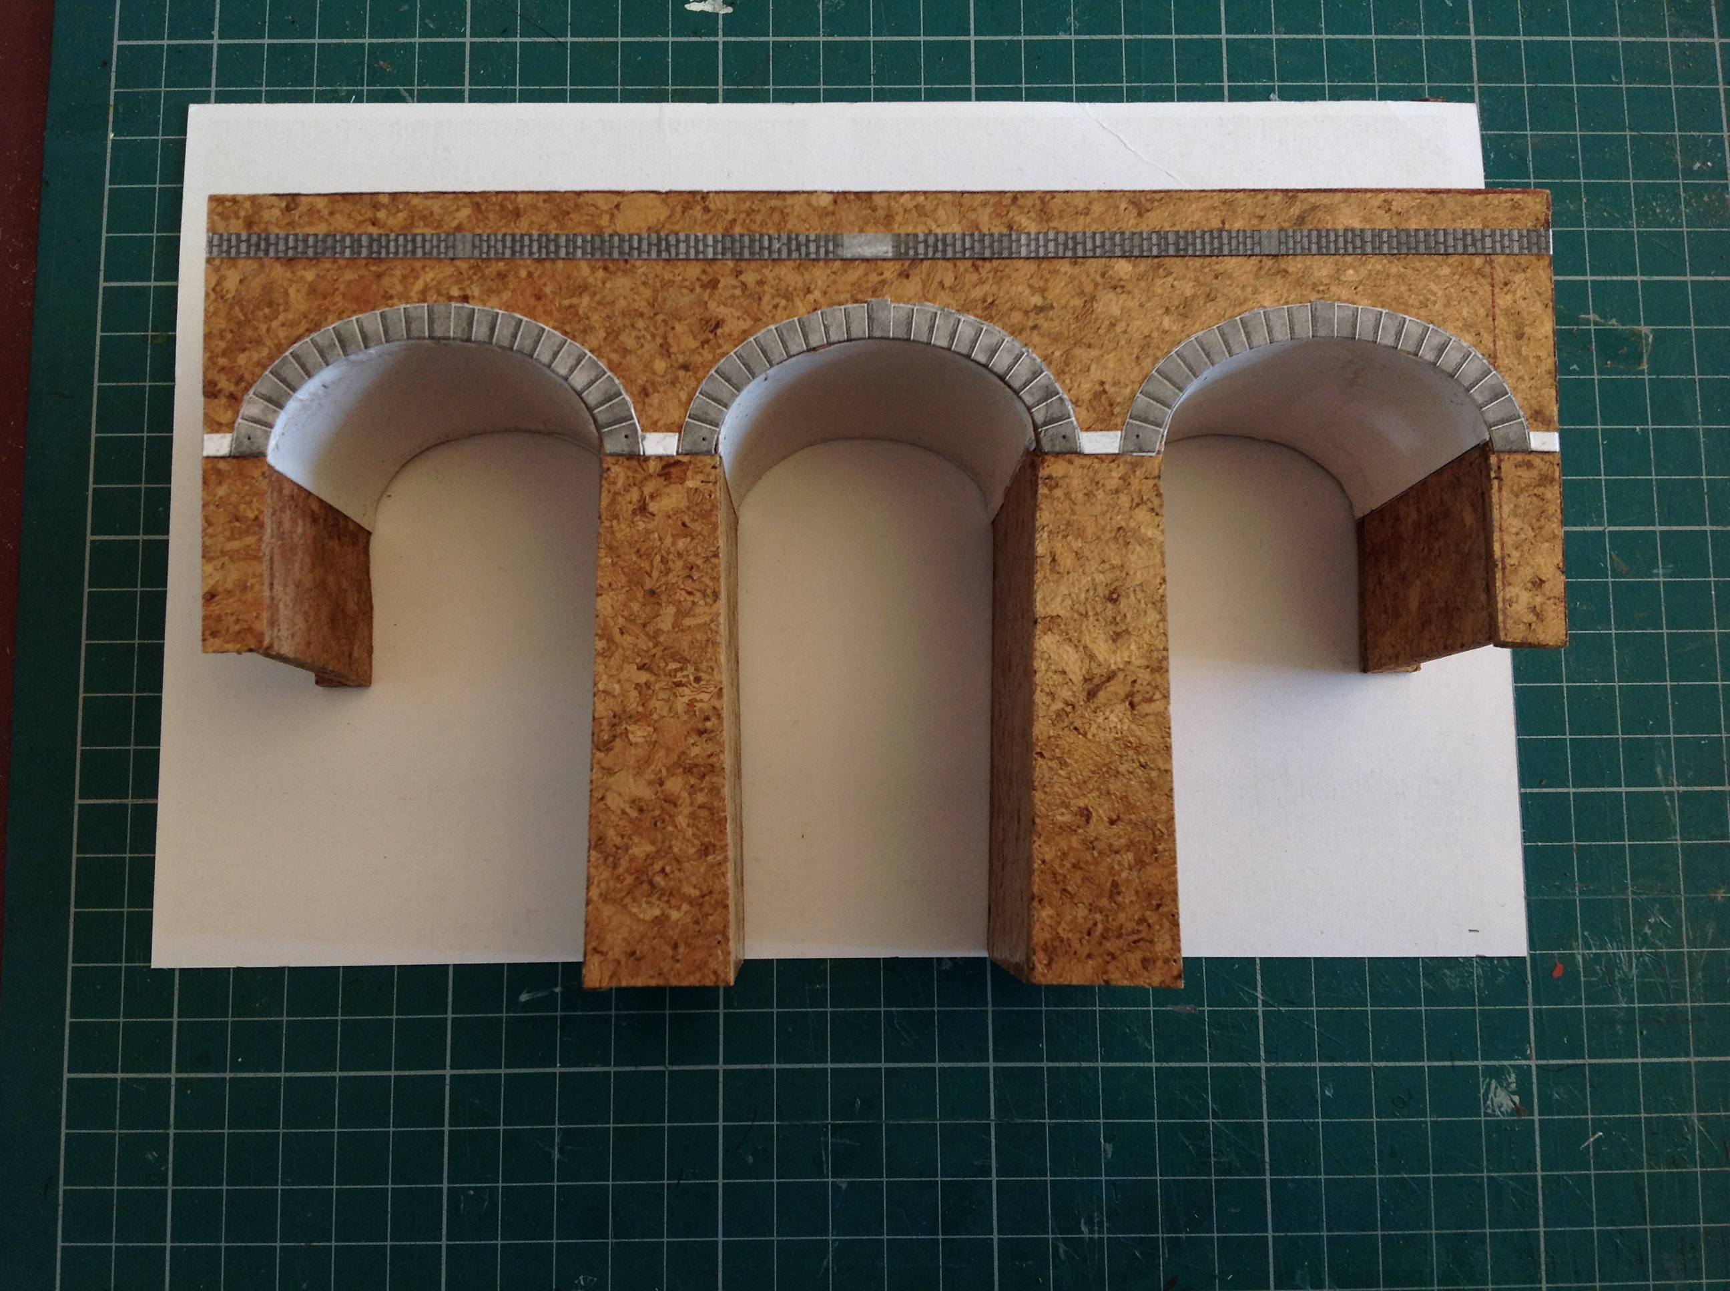
7 A quick splash of grey undercoat with some weathering would more or less finish the job if you were going for a reinforced concrete Glenfinnan Viaduct type of finish, but in this case it is purely a base coat.
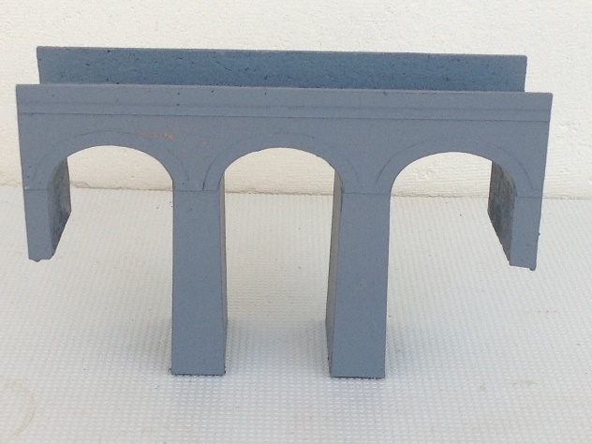
8. The stonework on the front face of the bridge is scribed into a thin skin of no-nails adhesive or pollyfilla (the tube version is ready mixed). When dry this will benefit from light sanding down in places to remove blemishes or excess thickness. In hot weather things dry quicker so experiment to establish the area that can be safely scribed before the coating becomes unworkable. These arches are too narrow for successful scribing of stonework within them so an alternative approach was used. A coat of spray stone finish paint (Wilkinsons) inside the arches gives a rough texture which can then be overpainted. The rear face of this bridge is out of sight so it is finished in grey undercoat.
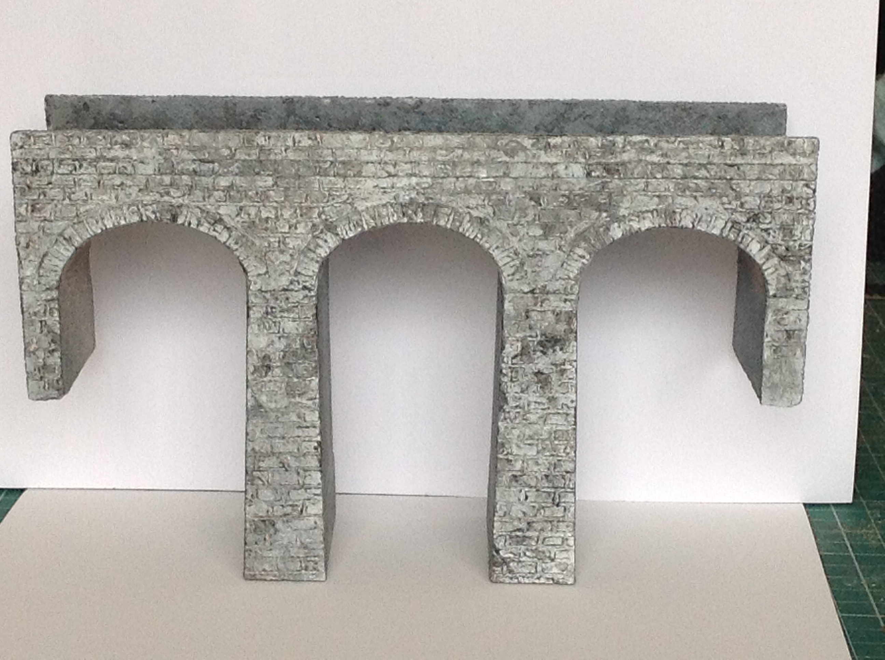
9. As the trackbed and track are already in place on the layout this bridge will have to be put in place from underneath. To achieve this the bottom of each leg is removable and will be slid in after securing the main part of the bridge.

