Safety Plan
Warning Signs:
Thoughts:
Feelings:
More warning signs:
The Pain is talking. Feelings are NOT facts.

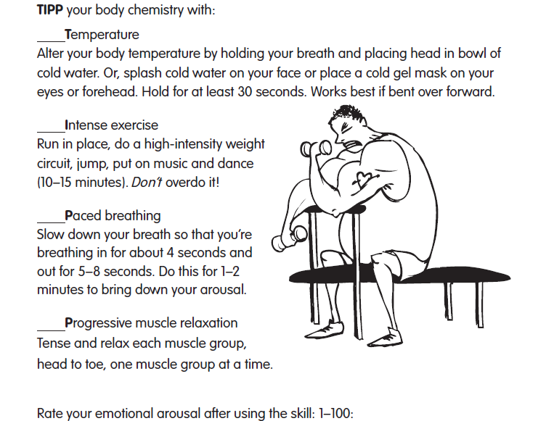
- What to do when things get intense: IT DOES GET BETTER.
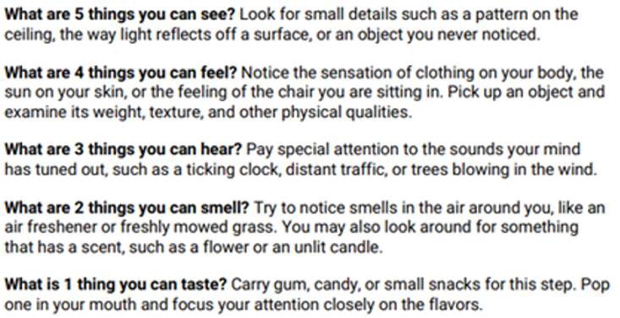

Reasons to stay alive: (paste pictures here in addition to writing things down)

CALL These People *before doing anything*:
- Kermit the Frog 555-5555
- Fozzy Bear 555-5555
- Sam Eagle Facebook messenger
- Gonzo Discord
Therapist: Simone (435) 523-4641 Crisis Text Line: 741741 Crisis Lifeline: 988

