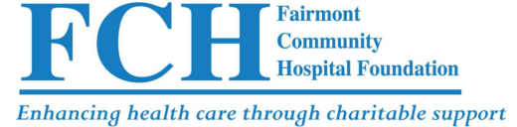
THERESA C. SMITCH RADIOLOGY SCHOLARSHIP
SCHOLARSHIP APPLICATION PROCESS
Applicants for the theresa c. Smith radiology scholarship must have completed one full year of an accredited joint review committee on education in radiologic technology (jrcert) program and be entering their second year. The applicant must be a full time student and preference is given to students who graduated from a high school in Martin, Jackson or Faribault County or surrounding areas.
February
Scholarship information regarding the Theresa C. Smith Radiology Scholarship is sent to area Colleges and Universities that offer a 2 or 4-year JRCERT program. This will include application information and how to contact FCH Foundation for additional information.

April
Scholarship applications are due April 15th to Kayla Caven, Executive Assistant. A log of applications will be maintained.

May
All applications will be reviewed by the Scholarship Committee of FCH Foundation. Recommendation will be forwarded to the full board for approval/disapproval at the next regular meeting.

Scholarship awardee will be notified. He/she will be asked to forward documentation of tuition costs and course work completed to the Executive Assistant.

Scholarship, in the amount of $500, will be awarded to one applicant.

August
A check will be sent to the scholarship recipient(s) college or university.

