 ST. LOUIS GATEWAY DISTRICT AREA LOCAL, apwu, AFL-CIO
1705 South Broadway, St. Louis, Mo. 63104-4050 (314) 231-7665

2025 BARBARA PROTHRO SCHOLARSHIP PROGRAM

INTRODUCTION

In 1979, the APWU Postal Office Women for Equal Rights (POWER) was created at their 1st Biennial POWER Convention in St. Louis, Missouri. The APWU POWER Sisters would like to acknowledge the woman pioneer who came before us within our local. Sis. Barbara Prothro was a true pioneer of the Women’s Movement in APWU. Sis. Prothro held several positions at the local and national level of the APWU organization. In 2024, the Barbara Prothro scholarship program was created, this will provide educational and technical assistance to the children of the St. Louis Gateway District Area Local members and dues paying retirees. It will award $500.00 (one male and one female) to apply towards their four-year college tuition or vocational training.

**This is a separate scholarship from the National APWU**
**Apply for Both**

ELIGIBILITY REQUIREMENTS

- A senior attending high school or other corresponding secondary school.
- Child or grandchild, including stepchild or legally adopted child of an active member, retiree
member, or deceased member of the American Postal Workers Union.

- Parent or grandparent must be a full dues paying member or retiree member [as defined in the APWU National Constitution and Bylaws, reference Article 3, Section 1, Section 4(d)] in good standing or must have been a member immediately preceding death.
- Barbara Prothro scholarship recipient must attend a university, college, or vocational school.

  - Must maintain: “B” average, or
  - “Pass” if Pass/Fail system.
EXCLUSIONS

- Children/grandchildren of all Elected National Officers.
- Sponsor is currently a postal manager.
- Scholarship will be discontinued if the sponsor becomes a postal manager.
- Applicants from other Postal Unions (NALC, NRLCA, NMPHU)

INSTRUCTIONS AND DEADLINES

- Application form with instructions must be obtained from the St. Louis Gateway District Area
Local website (St. Louis APWU (stlouisapwu.org)
- Applicant is responsible for submitting a COMPLETED APPLICATION and required materials.
- All application materials must be submitted in ONE ENVELOPE.
- Transcripts and teacher/community leader assessment must be in separate sealed envelope or emailed by a school official.

Send envelope to: POWER SCHOLARSHIP PROGRAM
St. Louis Gateway District Area Local
1705 S. Broadway
St. Louis, MO 63104

Send email to: scholarship@stlouisapwu.org

DEADLINE: June 30, 2025
Winners will receive notice by July 15, 2025
Posted in August/September Press On

SELECTION

The Scholarship Selection Committee [qualified persons in the education field who have no personal ties to the applicants] will select two Prothro winners, one male and one female.

In making the selections, the Scholarship Selection Committee places primary emphasis upon knowledge and understanding of the importance of unions as displayed in the essay. Decisions of the Selection Committee will be final.

DISBURSEMENT OF FUNDS AND ACCOUNTABILITY

- Once the student recipient is accepted into the academic program of their choice, St. Louis Gateway District Area Local POWER committee will disburse the scholarship amount specified to the Student Financial Aid Office of the college and/or to the Student (full-ride scholarship).
- The student recipient is responsible for providing the St. Louis Gateway District Area Local POWER with the disbursement request form and the official original student transcript, for the prior academic year, prior to APWU making its disbursement.
- Scholarship funds will be disbursed directly to the school for payment of tuition, room, board, books, or fees.

STUDENT CHECKLIST

Please use this section to assure you have included the necessary documents.

  - Applicant and Union Membership Profile
  - Educational Profile
  - Student Essay
  - Transcript
  - Teacher/Community Leader Assessment

Please retain these two pages for your personal files.
DO NOT RETURN WITH SCHOLARSHIP APPLICATION

ST. LOUIS GATEWAY DISTRICT AREA LOCAL, APWU, afl-cio
1705 South Broadway, St. Louis, Mo. 63104-4050 (314) 231-7665
BARBARA PROTHRO SCHOLARSHIP APPLICATION FOR 2025

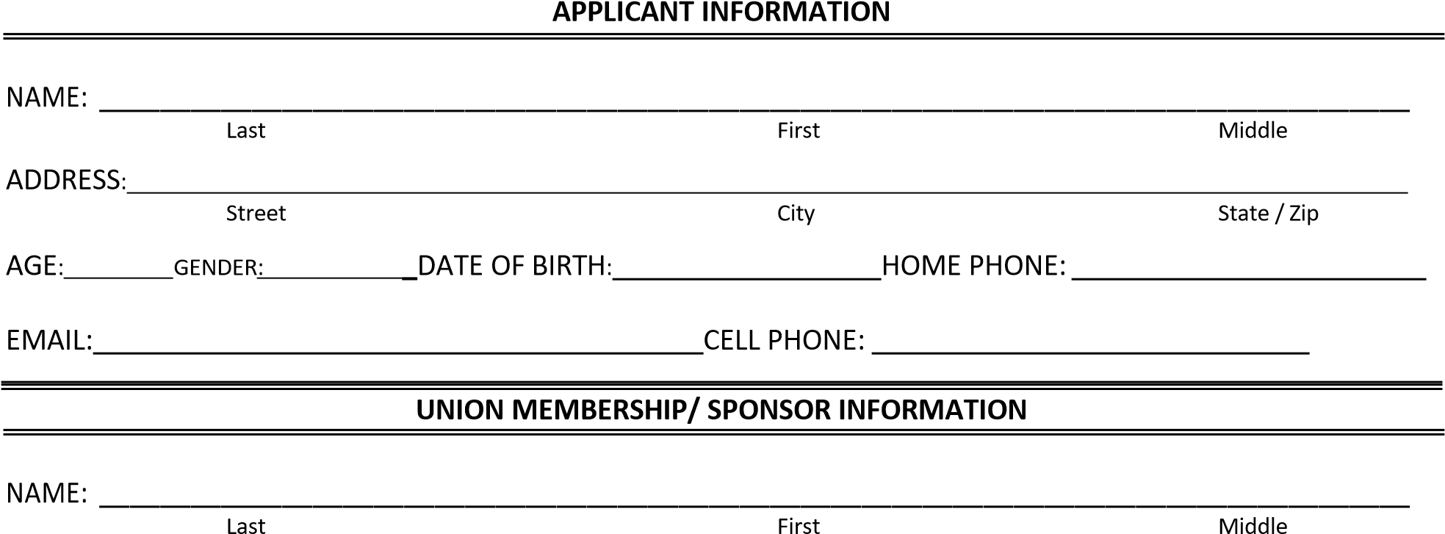

ADDRESS:
Street City State / Zip
APWU Member still employed? Yes No If no, are they living: Yes No
Member of APWU Retirees Department? Yes No If no, are they living: Yes
No

EID or Social Security No: Relationship to Applicant:
Local

Union

Name:

_ Local

#:

City State Zip

Applicant must include proof of a deceased sponsor’s membership in the Local. The St. Louis Gateway District Area Local, APWU, AFL-CIO does not keep records of deceased retirees.

For Official Use - Do no Write in this Box Sponsor Membership Verified? □Yes □ No
File No.:

Student must return ALL FORMS AND MATERIALS to STLGDAL by June 30, 2025
ST. LOUIS GATEWAY DISTRICT AREA LOCAL, APWU, afl-cio
1705 South Broadway, St. Louis, Mo. 63104-4050 (314) 231-7665
BARBARA PROTHRO SCHOLARSHIP APPLICATION FOR 2025
EDUCATIONAL PROFILE

High School
City/ State

_ Class Year

List Colleges / Universities that you plan to attend:

Name
_ City/

State

_ City/

State

Future fields you plan

to

Pursue_____

_

Name

High School/Community Activities  List school and/or community activities (exclude paid jobs).  Examples: student government, athletics, drama club, volunteering | Positions Held  Include position or leadership roles held, if any | YEAR

High School Awards  List no more than five of your academic awards or accomplishments and year received. Include honors won, awards. Example: National Merit Scholar | YEAR

Current GPA:

REQUIRED SIGNATURE

I hereby affirm that the information included in this application is true and accurate:

Student Applicant Signature:

Date:

ST. LOUIS GATEWAY DISTRICT AREA LOCAL, APWU, afl-cio
1705 South Broadway, St. Louis, Mo. 63104-4050 (314) 231-7665
BARBARA PROTHRO SCHOLARSHIP APPLICATION FOR 2025

STUDENT ESSAY

Submit a 350-to-500-word essay on ONE of these topics:
- How would you use social media to organize an APWU rally (at the main branch of your local post office) with the theme “U.S. Mail is Not for Sale”?
- What is the current and future impact of computer technology on postal service work? Discuss the pros and cons of collective bargaining to protect traditional postal work (e.g. mail collection, sorting, processing and delivery).

- For future employment, what will be the benefits for you to work for a company where workers have a union, as opposed to a company where no union exists?

[The essay will provide the most points in the evaluation of your application]

Applicants are expected to use encyclopedias, textbooks, and the Internet, but do not cut and paste text from the Internet without crediting your source(s). Use of biographies, bulletins, newspaper articles, the APWU newsletter, reports from private organizations or governmental agencies, personal interviews with union personnel (other than their parents) and other research materials deemed appropriate as sources of information. All research materials must be properly cited and documented.
Student must return ALL FORMS AND MATERIALS TO STLGDAL by June 30, 2025

ST. LOUIS GATEWAY DISTRICT AREA LOCAL, APWU, afl-cio
1705 South Broadway, St. Louis, Mo. 63104-4050 (314) 231-7665
BARBARA PROTHRO SCHOLARSHIP APPLICATION FOR 2025

SCHOLASTIC RELEASE OF INFORMATION

Student Applicant Name: _______________________________________________________________________________________________________

Parent/Guardian Name: _________________________________________________________________________________________________________

REQUIRED SIGNATURES

Permission is hereby given to school officials to release the high school record and other reque
sted information

for consideration in the APWU POWER Barbara Prothro Scholarship

Student Applicant Signature

Date

Parent/Guardian Signature

_ Date

OFFICIAL TRANSCRIPT

THIS PAGE WITH ORIGINAL TRANSCRIPT must be placed in a sealed envelope and given to the student to submit or emailed by a school official to scholarship@stlouisapwu.org
Student’s transcript in a sealed

envelope:

(
initials of High School Principal or Guidance Counselor
)

THIS IS THE LAST PAGE TO BE COMPLETED BY THE STUDENT APPLICANT

Student must return ALL FORMS AND MATERIALS to STLGDAL by June 30, 2025

ST. LOUIS GATEWAY DISTRICT AREA LOCAL, APWU, afl-cio
1705 South Broadway, St. Louis, Mo. 63104-4050 (314) 231-7665
BARBARA PROTHRO SCHOLARSHIP APPLICATION FOR 2025
TEACHER OR COMMUNITY LEADER ASSESSMENT

Student Applicant Name:
APWU Sponsor’s Name:

On a separate sheet of paper, please evaluate this student in relation to receiving this scholarship, leadership ability, or volunteerism. Please specify dates of activities and the length of involvement in said program. If there are special circumstances that the Selection Committee July consider, please add them to your statement. Please label at the top of the page “Teacher or Community Leader Assessment”.

Student’s assessment in a sealed

envelope:

(
initials of Teacher or Community Leader
)

THIS PAGE WITH ASSESSMENT must be placed in a sealed envelope and given to the student to submit or emailed by a school official to scholarship@stlouisapwu.org

REQUIRED SIGNATURE

The information provided is true and accurate to the best of my knowledge.

Teacher or Community Leader Signature:

Print Name:

_

Date

Student must return ALL FORMS AND MATERIALS to STLGDAL by June 30, 2025

