﻿
﻿
VMF IN-SERVICE REGISTER SIGN-UP
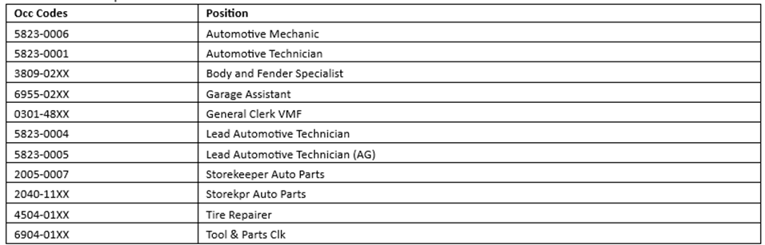
Dates: July 1st-July 15th 2026
For all eligible crafts wishing to transfer to the vehicle maintenance craft this is the only opportunity to sign-up and test for skilled positions.
NOTE: This does not necessarily indicate we currently have positions to actively fill within your Installation, this is your chance to become qualified for when vacancies are available:
If you wish to be considered for vacancies outside of your current Installation/Bid Cluster, you must use eReassign to request a transfer you must be qualified for the position at the time you would be considered.

No requests for skilled positions will be accepted before 7/1/26
No requests for skilled positions will be accepted after 7/15/26
You must use the standardized EDC sheet provided with this posting.
CRAFTS NOT ELIGIBLE: Postal Police, Nurses, IT/ASC, Rural, non-bargaining employees, pre-career employees
Local Management: Keep physical copy of EDC sheet in the employee’s file. Email a copy of completed EDC sheets to:
William.M.Sidwell@USPS.gov, please make sure “EDC” is in the subject line. This will ensure your employee’s request is not missed.

