In-Service VMF Qualification Opportunity
Employee Data Collection Form

PRINT BOTH LEGIBLY AND NEATLY. This information will be entered into TAS (Test Administration System) from which the exam instructions will be emailed to you.

All fields below are Required:

Employee Full Name:
Employee ID Number (8 Digits):__________________________________________________________
Current Craft (APWU, NALC, NPMHU) & Office:
Daytime Phone Number:

Valid Non-Postal Email Address:
(PRINT CLEARLY)
Current Mailing Address: ______________________________________________________________
City – State – Zip Code:
Signature and Date: ___________________________________________________________

Mark the position(s) you wish to be considered for. NOTE: Not all positions shown are available at every VMF facility.



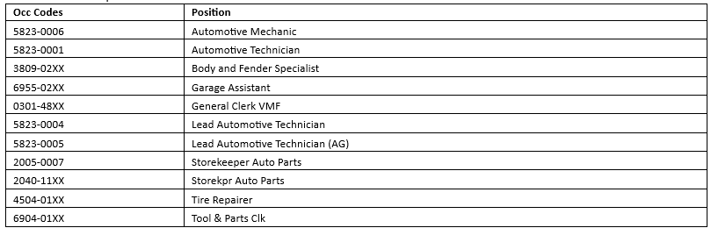
This completed EDC form must be received by Local Services by the deadline below. *LATE APPLICATIONS WILL NOT BE ACCEPTED FOR ANY REASON*
SUBMIT COMPLETED FORMS TO: ____William.M.Sidwell@usps.gov____
Please make sure to use “EDC” in the subject line. This will ensure that your submission is not missed.

RETURN BY JULY 15, 2026 11:59PM EST

