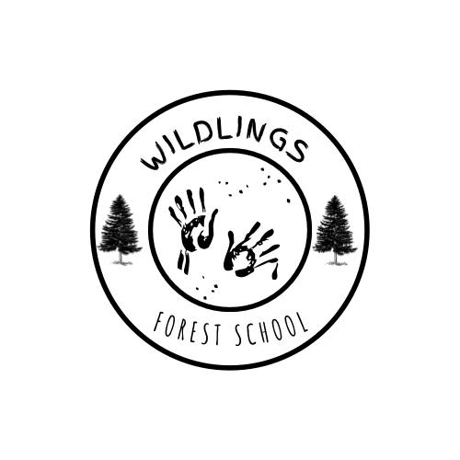

**Terms of Conditions and Waiver of liability**

Thank you for allowing your child to join WILDLINGS FOREST SCHOOL. Please read the following points below prior to your child starting the sessions.

**1. Express Voluntary Assumption of Risk**

Participation in the activities with WILDLINGS FOREST SCHOOL carry risks that cannot be eliminated regardless of the care taken to avoid injuries. The risks are activity dependent and can vary from minor injuries such as scratches, bruises and sprains to major injuries as well as paralysis and death. I acknowledge the risks involved in the activities conducted at WILDLINGS FOREST SCHOOL. These risks or dangers may be caused by other participants, by accidents, forces of nature or other causes. I acknowledge that WILDLINGS FOREST SCHOOL will do everything they can to keep my child safe with safety checks, risk assessments and class rules in place.

**2. Permission to receive first aid**  
I understand that participation in activities can create a risk for injury ( these risks are addressed and managed in the company risk assessments). I understand that there is a qualified First Aid attendant on site and hereby consent for my child to receive medical treatment, including transportation to a doctor or hospital if necessary. I will provide medical information for my child so that the leader is aware of any illnesses, conditions or allergies that they need to be aware of.

[ ] I agree to my child having a pre measured calpol/paracetamol sachet as a form of pain relief in the case of an injury. (please tick if you consent)

**3. Appropriate clothing**  
I understand that it is my responsibility to ensure that my child is dressed appropriately for the sessions. PE kit or old clothing is ideal for the sessions. Wet weather requires wellies, waterproof pants and coat/ all in one. Hot days requite a sun hat and sun cream applied prior to the school day.

**4. Extreme weather**  
Due to the nature of our forest learning sessions being outdoors, the weather has the potential to impact participants’ safety. I recognise that WILDLINGS FOREST SCHOOL reserves the right to cancel/provide alternative activities in the event of extreme weather conditions.

**5. Photographs and social media**   
I consent to my child having their photographs used for WILDLINGS FOREST SCHOOLS’ social media and website purposes. Children will not be named and the nature of the photograph is to be used for advertisement purposes only.

Parent name _______________________________ Child name _____________________________________

Signed ____________________________________

**6. Release of liability**  
I release, waive, and fully discharge WILDLINGS FOREST SCHOOL from any claims, demands, obligations and liabilities which were to arise from children taking part in the sessions. I understand that the leader is qualified to deliver lessons to my child, is first aid trained and has all of the relevant risk assessments and policies and procedures in place to care for and look after my child with their interests and welfare at heart. Risk assessments and policies can be found on our website at www.wildlingsforestschools.com

I have read this waiver of liability and assumption of risk document and fully understand its terms and I understand that by initialling and signing this document I hereby release WILDLINGS FOREST SCHOOL from any and all liability associated with the program my child is attending.

Parent name___________________________________________________________

Signed ________________________________________________________________ Date ________________