Our mission is to initiate, conduct, implement, and/or participate in activities or programs which are intended to assist in the recovery and rehabilitation of persons suffering from the disease of alcoholism, and to aid in the prevention and retardation of the progression of such disease. We are privileged to serve those in the recovery community in Southeastern Wisconsin by providing facilities for AA and Al-Anon meetings as well as related social events.

Life Line

INSIDE THIS MONTH:
- Out & About Happenings
- Financial Update
- Meeting Schedule & Contact Information

August 2020

Grove Club Board of Directors
President … Katie M
Treasurer … Linda L
Secretary … Rochelle S
Manager … Chad O
Facilitator … Grant E
Activities … Holly W
Coordinator … Stacy W

Grove Club Meetings Schedule

As of August 9, 2020
Meeting | Reopening Information
Alcoholics Anonymous
Sunday 10:00 A.M. | NO In-Person Meeting
Sunday 4:30 P.M. | In-Person Meeting Available
Sunday 7:30 P.M. | In-Person Meeting Available
5
Monday 10:00 A.M. | In-Person Meeting Available
Monday 4:30 P.M. | In-Person Meeting Available
Monday 6:00 P.M. | In-Person Meeting Available
Monday 7:30 P.M. | In-Person Meeting Available
5
Tuesday 10:00 A.M. | In-Person Meeting Available
Tuesday 4:30 P.M. | In-Person Meeting Available
Tuesday 8:00 P.M. | In-Person Meeting Available
5
Wednesday 10:00 A.M. | NO In-Person Meeting
Wednesday 4:30 P.M. | In-Person Meeting Available
Wednesday 6:30 P.M. | In-Person Meeting Available
Wednesday 8:00 P.M. | In-Person Meeting Available
5
Thursday 10:00 A.M. | NO In-Person Meeting
Thursday 4:30 P.M. | NO In-Person Meeting  **Contact a Board member to reopen*
Thursday 8:00 P.M. | NO In-Person Meeting  **Contact a Board member to reopen*
5
Friday 10:00 A.M. | NO In-Person Meeting
Friday 5:30 P.M. | In-Person Meeting Available
Friday 8:00 P.M. | In-Person Meeting Available
5
Saturday 8:00 A.M. | In-Person Meeting Available
Saturday 10:00 A.M. | In-Person Meeting Available
Saturday 3:00 P.M. | In-Person Meeting Available
Saturday 7:00 P.M. | NO In-Person Meeting  **Contact a Board member to reopen**
Al-Anon Family Group
Tuesday 9:30 A.M. | In-Person Meeting Available
Wednesday 8:00 P.M. | In-Person Meeting Available
Thursday, 8:00 P.M. | NO In-Person Meeting

Recovery Around Racine

24 Hour Hotline 262-554-7788

For additional information about what’s happening in our recovery community, visit RACO website, or obtain a copy of the “Monthly Reprieve” newsletter.
RACO info:
Racine Area Central Office
3701 Durand Avenue, #225 Racine WI
Phone: (262) 554-6611 Hotline: (262) 554-7788
www.racinecentraloffice.org
Email & Newsletter – raconewsletter@gmail.com

Benjamin House 4848 County Road H, Franksville WI 53126
Phone: (262) 886-9611 http://benjaminhouseracine.org
AA, Alanon, and Dual-Addicted Groups, Sunday thru Saturday
Kenosha Alano Club
630 56th Street , Kenosha WI
Phone: (262) 654-8246
AA & Al-Anon Groups, Sunday thru Saturday
Racine Alano Club
1140 Doulas Avenue, Racine WI
Phone: (262) 634-9902
AA & Al-Anon Groups, Sunday thru Saturday

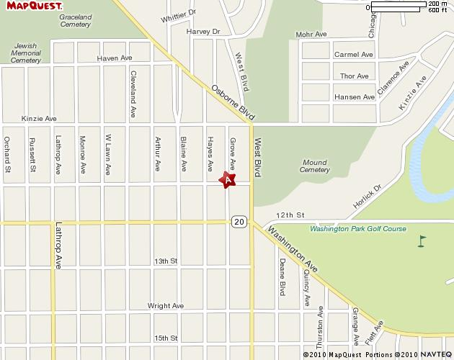
Mailing Address:
The Grove, Inc.
1037 Grove Avenue
Racine, WI 53405

...For it is by self-forgetting that one finds…

Membership Rates

Individual $ 80.00 paid in full or $8.00 per month
Family $120.00 paid in full or $11.00 per month
Locker Rental $12.00 Key Deposit $10.00 Members Only

Check out our new website!
Thegroveclub.com
1037 Grove Avenue, Racine, WI, 53405 (262) 634-9656 grove.clubinc@yahoo.com

Financials July 2020:

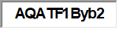
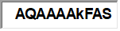
Ordinary Income/Expense
 |  | Income
 |  |  | 46499 · Merchandise |  | 20.10
 |  |  | 47200 · Program Income
 |  |  |  | 47232 · Sobriety Tree | 21.00
 |  |  | Total 47200 · Program Income |  | 21.00
 |  |  | 47230 · Membership Dues
 |  |  |  | 47235 · Key Deposit | 30.00
 |  |  |  | 47230 · Membership Dues - Other | 604.54
 |  |  | Total 47230 · Membership Dues |  | 634.54
 |  |  | 47280 · Group Rents |  | 902.77
 |  |  | 60000 · Donations |  | 4,051.00
 |  | Total Income |  |  | 5,629.41
 | Gross Profit |  |  |  | 5,629.41
 |  | Expense
 |  |  | 60901 · Bank Fees |  | 7.35
 |  |  | 62160 · Cleaning Service |  | 640.00
 |  |  | 62890 · Utilities |  | 476.97
 |  |  | 65000 · Supplies
 |  |  |  | 65040 · Supplies/General | 367.38
 |  |  | Total 65000 · Supplies |  | 367.38
 |  |  | 65044 · Office Expense |  | 135.90
 |  |  | 65045 · Concessions Stock |  | 0.00
 |  | Total Expense |  |  | 1,627.60
Net Ordinary Income |  |  |  |  | 4,001.81
 |  |  |  |  | 4,001.81

