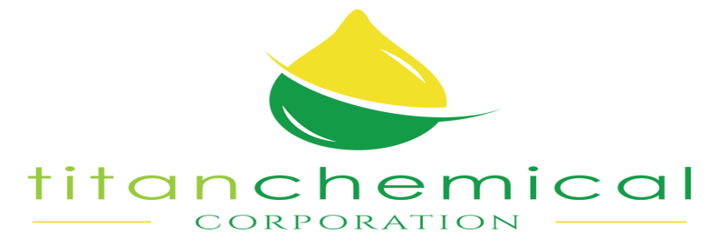

SPECIAL RIG WASH

Product Data
This product is a combination of selected surfactants, penetrants and fast acting oil emulsifiers. It easily penetrates, absorbs, and emulsifies to float away grease and oil but leaves no greasy film or residue. SPECIAL RIG WASH is not harmful to aluminum and other soft metals when used in dilution. This product is recommended for cleaning and degreasing of rigs and rig floors.

Typical Properties

Appearance Blue, Sassafras Odor
Pour Point 20 Degrees
Flash Point >250°F
pH (5% Solution) 11.0-11.5
Specific Gravity, 72 Degrees F 1.129
Density, Lbs./Gal. 72 Degrees F 9.1
Viscosity, 72 Degrees F 15-20 cps
Solubility, 10%
Water Complete
Isopropanol Dispersible
Kerosene No
Xylene No
Heavy Aromatic Naptha No
Acid No. (MG.KOH/G)
pH 5.5 N/A
pH 9.5 N/A
Application

May be sprayed, mopped or wiped on. If used through pressure washer or steam cleaner, dilute with water. Dilute up to 30-1 with water.

Titan Chemical Corp.
6710 Cadillac St.
Houston, Texas 77021
713-747-3134

