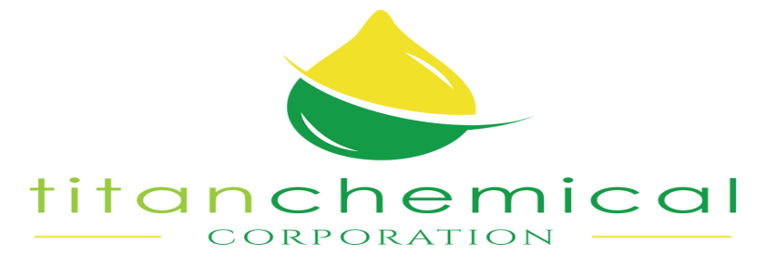

870 Cleaner

Product Description

Titans’ “870” Cleaner is a truly concentrated product that contains over 40% active ingredients. It handles the really tough degreasing and cleaning jobs on all types of surfaces in all types of cleaning operations. Its powerful cleaning agents will quickly penetrate, loosen and wash away harder deposits and mild soils. “870” is a non-flammable, biodegradable water soluble cleaner.

This is a uniquely effective all-purpose, highly concentrated cleaner that is safe for all types of cleaning operations. It reduces clean-up time, costly scraping and shipping operations and helps prevents surface damage. Because of its high degree of concentration, “870” will prove to be very cost effective.

Directions

This product can be used manually or applied through an automatic machine.

For regular cleaning: 1 to 100 parts water
Heavily soiled areas: 1 to 10 parts water

Product Data

This first true liquid concentrate is 40% active. “870” is a uniquely effective all purpose, highly concentrated, biodegradable cleaner for the toughest degreasing to mild soil removal. USDA approved.

870 Cleaner Cont.

Typical Properties

Appearance Blue
Pour Point 25 deg. F
Flash Point, TCC F None
pH (1% Solution) >12
Specific Gravity, 72 deg. F 1.14
Density, Lbs./Gal. 72 deg. F 9.5 Lbs./Gal.
Viscosity, 72 deg. F 10-15 cps
Solubility, 10%

Water Complete
Isopropanol Yes
Kerosene No
Xylene No
Heavy Aromatic Naphtha No

Acid No. (MG. Koh/G)

pH 5.5 NA
pH 9.5 NA

Application

Can be used in dip tanks, steam cleaners and manual cleaning of oils and grease. May be sprayed, wiped or brushed on.

Titan Chemical Corp.
6710 Cadillac St.
Houston, Texas 77021
713-747-3134

