Reliability 101 – Introduction to Reliability
Introduction
Reliability is a topic in which there are many misconceptions due to a misunderstanding or misuse of the basic language. It is therefore important to get an understanding of the basic concepts and terminology in order to communicate its concepts more clearly.

A practical definition of reliability is “the probability that a piece of equipment operating under specified conditions perform its basic function for a stated period of time”. The reliability is a statistical probability defined as a number between 0 and 1 representing the chances of a successful outcome.

Failure rate
All products have a failure rate, which is simply the number of units failing per unit time. The failure rate is usually represented in reliability mathematics by the Greek symbol Lambda (λ).

The failure rate of a product may change throughout the life of the product. This is what gives us the familiar Reliability bathtub curve shown in figure 1, which shows the failure rate vs. operating time for a product. The bathtub curve is widely used in reliability engineering. It describes a particular form of the hazard function which comprises three parts:

- The first part is a decreasing failure rate, known as early failures.
- The second part is a constant failure rate, known as random failures.
- The third part is an increasing failure rate, known as wear-out failures.

Figure 1 – Bathtub curve: Source: http://en.wikipedia.org/wiki/Bathtub_curve

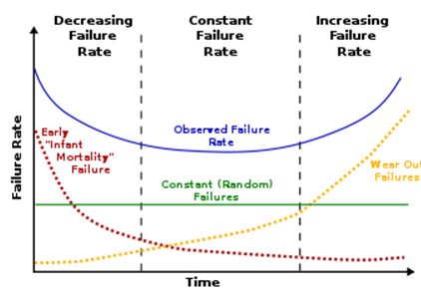

MTBF vs. MTTF
It is commonly misunderstood and wrongly assumed that the MTBF (mean time between failures) indicates a minimum, guaranteed, time before failure occurs. Technically, MTBF (mean operating time between failures) applies to equipment that is going to be repaired and returned to service, MTTF (mean time to failure) applies to equipment that will not be repaired but discarded after failure. For simple systems these terms are often used interchangeably and only in very complex systems is the distinction significant.

Constant Failure Rate
During the constant failure rate portion of the Reliability bathtub curve, MTBF is the inverse of the failure rate, i.e.
$\text{MTBF}=\frac{1}{λ}$

If the failures occur randomly as in the constant failure rate portion of the curve then they can be described by the exponential distribution and the reliability equation can be written as:
$R(t)=e^{−λ⋅t}=e^{\frac{−t}{\text{MTBF}}}$

When the operating time equils the MTBF the reliability becomes;

$R(t)=e^{−1}=0\text{.}\text{37}$

This can be stated in several ways:
- For a single unit, the probability that it will work for as long as its MTBF, is 37%.
- It can be said that the unit will work at least as long as its MTBF figure with a 37% Confidence Level.
- If a population of units is considered, then 37% of them will be functioning at the MTBF.

Non-Constant Failure Rate
During the decreasing failure rate and the increasing failure rate, or wear-out portions of the Reliability bathtub curve the failure rate is not constant. The reliability of these times in a system’s life requires different analysis tools than the simple concept of MTBF / MTTF.

For the exponential failure distribution, the hazard rate is a constant with respect to time (that is, the distribution is "memory-less"). For other distributions, such as a Weibull distribution or a log-normal distribution, the hazard functions are not constant with respect to time.

A continuous failure rate depends on the existence of a failure distribution, which is a cumulative distribution function that describes the probability of failure up to and including the time of failure. A widely used failure distribution in reliability engineering is the Weibull distribution because of its ability to describe either an increasing or decreasing failure rate.

Conclusion
The reliability engineer has many tools and techniques for predicting, measuring and communication of reliability statistics. The most basic and important of these are the meaning of the reliability number and the type of distribution being described.

