Reliability 103 – Derating

Derating is a technique employed in electrical and electronic devices, where the devices are operated at less than their rated maximum specifications. This is done in order to reduce the rate at which they deteriorate over time and the reliability and life expectancy are improved. That derating is a practical means of reducing failures is supported by much literature including multiple standards as well as suppliers of components.

Conceptually, if a component or system is operated under its design limit, it will be more reliable than if it is operated at or above the design limit. While a component may be specified to operate at high voltage and high temperature, applying those conditions simultaneously would probably be worse than applying either one or the other independently. Derating increases the margin of safety between part design limits and applied stresses, thereby providing extra protection for the part. Also given that reactions are known to proceed at higher speeds at higher temperatures (Arrhenius), we would expect reduced degradation, and hence extended life, by running a component at lower than its maximum temperature.

Simple Example

All the derating standards call for reduced levels of power for resistors in order to enhance reliability. A typical number from these standards is 50% application power to rated power, referred to as a Power Stress Ratio.

$\text{PowerStressRatio}=\text{100}\text{\%}×\frac{\text{ApplicationPower}}{\text{RatedPower}}$

Give a 1 Watt resister and that its measured power dissipation in the application circuit is 0.35 Watts the stress ratio would be calculated as follows:

$\text{PowerStressRatio}=\text{100}\text{\%}×\frac{0\text{.}\text{35}W}{1\text{.}0W}=\text{35}\text{\%}$

If our standard calls for 50% derating and our measured stress ration is 35% we conclude that this component for this parameter meet the derating guidelines. However, resistors power ratings are also derated for component temperature in the application. Below is a manufacturer’s derating curve and an example derating curve for a Carbon Film Power resistor:

Note that the derating cure tracks the manufacture’s curve but at a lower level. Next to demonstrate the multidimensional nature of derating two scenarios are superimposed onto the curve. In both cases we will use our 35% stress ration from before, however in case “A” the measured temperature of the resistor is 60°C and the other Case “B” it is 100°C.

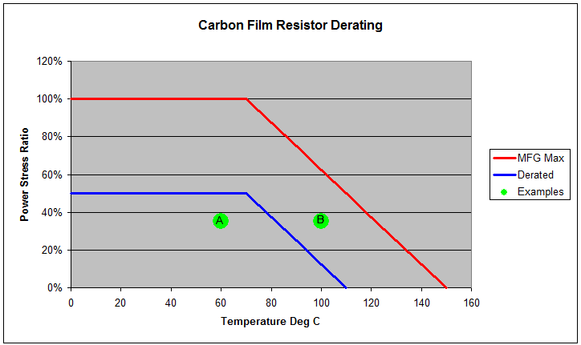

In the chart above the green dots shows the resistors working temperature and power ratio under the defined working condition. For the cases shown, the resistor is properly derated in scenario “A” since the power ratio is below the derating line for the resistors working temperature. However, for scenario “B” the dot is above the derating curve, the stress under the working condition would not meet the derating requirement. This would imply that the resistor would be likely to fail; therefore, changing to a higher-rated resistor or adjusting the operating condition might be needed.

Derating Standards
Several derating guidelines have been issued by military or other agencies, and the following are some examples:

RAC Reliability Engineering toolkit, The "Reliability Toolkit" series originated in 1988 when the Rome Air Development Center (RADC), the DoD's Center of Expertise in Reliability and Maintainability for more that 40 years.

MIL-STD-975, published by NASA, focuses on selection of parts used in the design and construction of space flight hardware as well as mission-essential ground support equipment.

MIL-STD-1547, published by the Department of Defense, is targeted to aid in the design, development and fabrication of electronic systems with long life and/or high reliability requirements while operating under the extreme conditions of space and launch vehicles.

AS4613, published by the U.S. Navy, sets forth derating requirements for the reliable application of electronic and electromechanical parts.

NAVSEA TE000-AB-GTP-010, published by the U.S. Navy, contains derating requirements and part selection and application information on the ten most commonly used electrical and electronic parts.

ECSS-Q-30-11A, prepared and maintained under the authority of the Space Components Steering Board in partnership with the European Space Agency, contains derating requirements applicable to electronic, electrical and electromechanical components.

MSFC-STD-3012, prepared by NASA's Marshall Space Flight Center, sets requirements for electrical, electronic and electromechanical parts selection, management and control for space flight and mission-essential ground support equipment for Marshall Space Flight Center programs.

