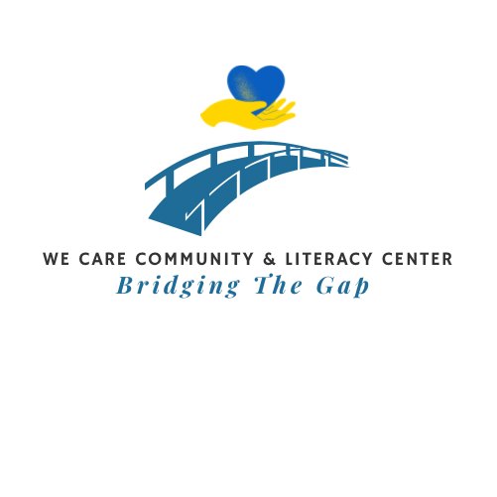

***Media Kit***

***Mission***

We Care Community & Literacy Center’s mission is to work together with students, residents, their families, and outstanding professionals to bring hope and change to young people and adults who face tough challenges. Serve all members of the community. Foster creativity, collaboration, and interaction across generations and disciplines. Support the physical, mental, and spiritual health of the community. Demonstrate community values of stewardship, interdependence, and independence. Create a coalition of partner organizations for greater efficiency and broader offerings.

***Immediate Goals***

* Assuring the Center remains open and programs are fully supported.
* Building community involvement and support.
* Creating long-term financial sustainability.
* Broad community representation and effective non-profit management.
* Tutoring and Literacy
* Expand outreach in the community and scope of activities leading to increased use of the facilities, an increase in revenues, and additional employment opportunities.
* Create a coalition of local organizations and nonprofits that would result in a wider range of classes, events, community building opportunities, entertainment and sports activities.
* Develop transparent governance with a board composed of participating community members dedicated to meeting the needs and desires of the community.
* Develop core Volunteer Program and In-Kind Support Program to support community center needs and build community involvement.

***Strategic Objectives***

Develop Sustainable Revenue Sources

* Planned Giving Program.
* Affiliate and Member support.
* In-kind support program.
* Create strong local leadership.
* Support the health of the community through health and sports-related programming, special events, and community services for all ages.
* Provide growing grounds for Next Generation Leaders through community service projects, internships, and teaching opportunities.

***Services***

We Care Literacy & Community Center will offer organized instructional programs for physical fitness activities, entertainment & game room, dining area, mentorship/self-esteem building program, resume writing, professional development & Life Application. Unstructured activities such as indoor craft activities, outdoor play & sports, socializing, and club meetings. We will plan community events such as: Fundraisers (Water Ice Stand, Fish Fry/Dinner Sales, Skate Party, Bowling Party, Trips (Casino, Amusement/Water Park). Offer a daily feeding program.

We also offer resources such as meals, clothing, enrichment, and tutoring. We offer a less intimidating approach to learning while encouraging kids to see how math and reading can be fun, by providing fun interactive lessons for non-school and school‐aged children, between the ages of 3 to 17. The student-to-student approach allows students to feel comfortable. The community center will be located in Philadelphia, PA, and provide services to residents located in Philadelphia and surrounding areas.

***Marketing***

We Care Community & Literacy Center will use flyers as the primary resource to market our services. After getting permission from the school principals we will hang flyers at local schools and provide additional flyers to the guidance offices. We will also advertise our services during school announcements. Flyers will also be located on the community bulletin boards.

***Media***

[***Click here to view our media and upcoming events.***](http://www.wccliteractcenter.org/events)

**Leadership**

[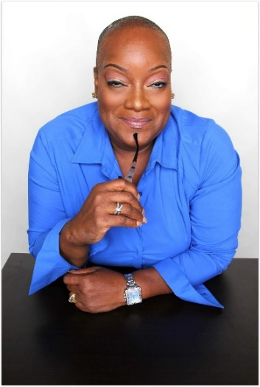](http://www.wccliteracy.org)Rochelle R. Singleton, President of WCCLC, was born and raised in the City of Brotherly Love (Philadelphia), the middle child of five children. She accepted Christ at the age of eleven, grew up in the church, and did not abandon Him as she became an adult.When Rochelle was a younger single woman, she learned that there was a standard to holiness. Holiness was not about religion but relationship, which caused her to pursue more of God.

Through the years, Rochelle found herself sharing her testimony of singleness, marriage, family, and life trials, with others she met along her journey. With wit, wisdom, and honesty, she would openly share the stories of her life. Through these stories, others would be encouraged to go and walk with the Lord in their lives, because in her life, God has proven He is faithful, and He honors vows!

## Family Life

In her spare time, Rochelle puts on her backpack and escapes into a world of her own to roller skate. The roller-skating rink was where she experienced “Love at First Sight” and today she is married to him: Marc A. Singleton, Sr. She is a wife, mommy/stepmom, and grandmom “Meme”, but above all, her daughter, Ires Renae Singleton, is the apple of her eye. Besides skating she has always loved dancing and is a member of the Chantel Price Dance Studio where she takes adult ballet classes.

## The Lord Provided A New Vision

Eight years ago, while sitting during a prayer breakfast, the Lord spoke to Rochelle regarding ministry through a song. God asked her, *“How many of my people need me to hurry up their way again? How many need a new start?”*

Today Rochelle has a new vision and mission: to be a modern-day Pope wherein she will cross religious and cultural boundaries, bringing the men and women of God together in love, respect, and unity. Passionate about the vision, Rochelle says, “I want to see Christian, Muslim, Jehovah's Witness, Catholic, Buddhist, and even the atheist come together. I want to love on the men and women of God and allow the love they feel to make them rethink their decisions and live life on purpose according to the Word of God.”

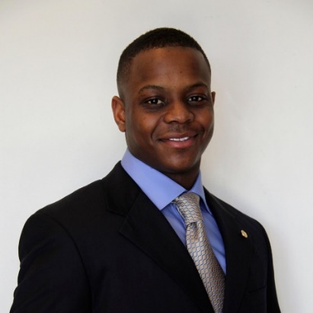J. Demetrius Barker is the Chief Advisor to WCCLC. J is an American businessman and author. As the Owner and President of The Network, LLC he has assisted 100+ startups in securing legalization and business funding. In 2006, at the age of 16, he started a non-profit organization called Urban Entrepreneurs which serviced inner-city youth in the tri-state area. During his time as Co-founder and Chancellor, he raised hundreds of thousands of dollars to provide resources to assist with programs and special events. This organization gained public and political recognition for its success in connecting and equipping youth with the resources and training necessary to pursue their goals of starting their own business. Over the last ten years, J has assisted several private companies and government agencies such as Citeron Wine, Nate Jackson Global, Jim Smith Jr International, The Philadelphia Police Department Cheers program, Youth for Change, etc. J has worked with political officials and severed as a panelist for youth prevention. J is the recipient of numerous prestigious awards such as The Good Citizenship Award of The Union League of Philadelphia, Certificate of Partnership from The Philadelphia Police Department, Reserve Officers Association of The United States, and The William H. Gray Jr. Service Award. J is the Author of The Access Code, “How to Unlock Your Success”.

**Literacy Plan**

**Moto**

“TOGETHER We Can”

**Slogan**

Bridging the Gap

**Mission**

The purpose of We Care Community & Literacy Center is to provide and cultivate the skills of reading, writing, thinking, speaking, and listening for all ages. To provide EXCELLENT EDUCATION in an environment where everyone feels free and safe so they can learn and to secure a successful future.

**Vision**

Community empowerment through culture, engagement, academic achievement and excellence. Anyone can be a student when willing to learn and are expected to learn. The education of a student is a shared task of schools, families, and our community, focusing on the pursuit of excellence in learning.

|  |
| --- |
| **Week 1** |
| ABCs |
| **Learning & Chanting the ABCs** Each day, all children chant "A, a, apple, B, b, balloon…". After we chant our ABCs, we do a special activity with the ABC using songs, flashcards, letter tracing, etc.  ***Purpose***   * Upper- and lower-case letter recognition * Associating letters to beginning sounds * alphabetical order * left to right progression |
| **Week 2** |
| **Letter Identification**   * + Find the letter in the alphabet: lowercase   + Find the letter in the alphabet: uppercase   + Choose the letter that you hear: lowercase   + Choose the letter that you hear: uppercase   + Frequently confused letters: find the letter   + Frequently confused letters: find all the letters |
| **Week 3** |
| **Lowercase and uppercase letters**   * Choose the lowercase letter that matches: easier letters * Choose the lowercase letter that matches: harder letters * Find all the lowercase letters * Choose the uppercase letter that matches: easier letters * Choose the uppercase letter that matches: harder letters * Find all the uppercase letters   **Word Recognition**   * Choose the two words that are the same * Choose the sentence that is spaced correctly * Find a word in a sentence |
| **Week 4** |
| **Rhyming**   * New! Which word has the same ending? * Which two words have the same ending? * Choose the picture that rhymes with the word |
| **Week 5** |
| **Blending And Segmenting**   * Blend each sound in a word together * Identify the first sound in a word * Put the sounds in order |
| **Week 6** |
| **Consonant Sounds & Letters**   * Which two words start with the same sound? * Find the word that begins with a given sound * Which two words end with the same sound? * Choose the letter that matches the consonant sound |
| **Week 7** |
| **Short Vowels**   * Find the short a word * Find the short e word * Find the short i word * Find the short o word * Find the short u word |
| **Week 8** |
| **Sight Words**   * Choose the two sight words that are the same * Choose the sight word that you hear |
| **Weeks 9 & 10** |
| Reading Strategies |
| **Text Features**   * Identify book parts and features   Front Cover  Back Cover  Last Page  Last Word on Page  **Reality vs. Fiction**   * Which could happen in real life?   Example: Turtle Driving a Car vs. Man Driving a car    **Inference and Analysis**   * Which feeling matches the picture? * What will happen next? |
| **Weeks 11 & 12** |
| **Speech & Vocabulary Development** |
| **Color And Number Words**   * Use color words (ex. Chose a picture. What color is/are the object(s)) * Use number words: one to five (ex. How many objects in the picture) * Use number words: six to ten * Use number words: one to ten   **Nouns**   * Choose the singular or plural noun that matches the picture   **Verbs**   * Find the picture that matches the action verb   **Adjectives**   * Compare pictures using adjectives |
|  |
| **Senior & Adult Services** |
| * **Adult Day Care** * **Exercise Classes:** Zumba, Line Dancing * **Home Health Care Partnership** * **Food Dispensary** * **Resource Center:** Home Improvement, Taxes, Health Care, Food * **GED Program** * **Literacy & Basic Life Skills Program** |

