Craig Thompson – CPA

3770 Bridgewater Drive – St. James, Southport, North Carolina

952-292-5694 Craig.thompson@outlook.com
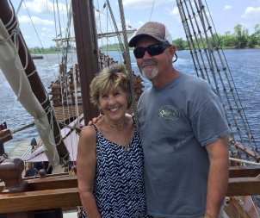

Retired CFO seeking to continue as a Director of the St. James Marina Owners Association (MOA) Board. My current term ends on December 31, 2022. As a current incumbent of the MOA Board, I have served as Treasurer since 2020 and am now seeking re-election to the MOA Board.

Since joining the MOA Board, I have assisted with several marina association key initiatives and policy updates related to the marinas operations and the related 16 acres of property under the jurisdiction of the MOA. I am an owner of five dry stacks and wet slips at marina.

My wife (Debra) and I moved to St. James in 2016, and since that time have been actively involved with the marina operations and personnel via two of my passions - boating and fishing. As a lifetime boater, I understand the value of providing strong consistent marina operations management and direction setting via the Board of Directors as well as keeping slip and condo owners informed consistent running a quality operation.

Professional experience: Chief Financial Officer and change agent with strong track record of delivering results in a fast-paced international environment. Pro-active leadership qualities proven in many complex challenging situations and cultures. Commercially focused with a broad background in Finance and General Management in the Consumer Goods / Healthcare industries. Employers included: Bristol-Myers Squibb, Novartis Corporation and Nestle - geographic locations included the U.S, Canada, and Europe.

Retirement Activities: Retirement responsibilities include: various voluntary organizations including:
- St. James Marina - MOA Treasurer and Board Member
- St. James Fishing Club - Current Vice President and Board Member
- Southport Sailing and Boat Club: - Previous Commodore (2016 to 2019) and current Board Member
- Brunswick County Sheriff’s office – Marine Patrol Volunteer
- WARM - Wilmington Area Rebuilding Ministries – Constriction lead
- Town of St. James Fire Department - firefighter
- Southport Maritime Museum - Construction volunteer
- Town of St. James Emergency Management Committee (Risk Assessment Manager) (2017 to July 2019

Qualifications / Professional Affiliations

Professional Affiliations :
American Institute of Certified Public Accountants
Academic:
Bachelor of Business Administration – Accounting - Hofstra University - June 1975

