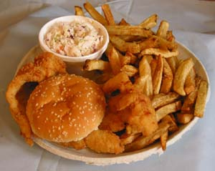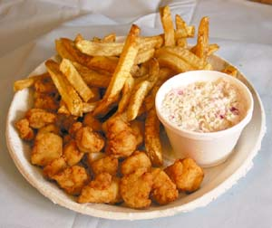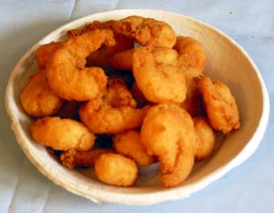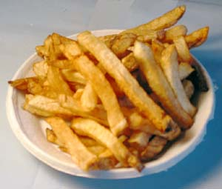

**Newsletter Subscription/Membership Form 2022**

584 E. Genesee St., Fayetteville, NY 13066

** Please complete the entire form and return to the Center**

**\*\*\*Must Answer\*\*\***

**\*Registrant #1:** ___________________________________________________________

**\*Date of Birth (M/D):** __________

**Registrant #2: __________________________________________**

**Date of Birth (M/D):** __________

**\*Email:________________________________________________________________________**

**\*Address:** _______________________________________________________________

**\*City:** ___________________________________________________________________

**\*State: ____________ *Zipcode:_____________ *Phone #:_____________________**

**Winter Address:________________________________________________________________**

**______________________________________________________________________________**

**Newsletter to be delivered to winter address from: ___________to ____________**

**We offer a variety of activities, please check any you may be interested in:**

Art Classes____ Tech Classes ____ Exercise Classes____

Book Club____ AARP Classes____ Card Games____

Board Games____ Movies____ Suggestions____________________________

**Are you interested in volunteering and helping out the center? Yes ____ No _____**

**\*If yes, please list what your interests are (ex: Kitchen, Newsletter, Fundrasiers, ect.):**

**______________________________________________________________________________**

**______________________________________________________________________________**

**______________________________________________________________________________**

**\*Emergency Contact and Phone#: _________________________________________________**

**\*Registrant #1 Signature:** ___________________________________________________________

**Registrant #2 Signature:_________________________________________________________**

**$20 Per Household**

“Providing meals, smiles, and activities to the Senior community in the greater Fayetteville area”

Fish Dinner

Scallop Dinner

Shrimp Only

French Fries

“Providing meals, smiles, and activities to the Senior community in the greater Fayetteville area”