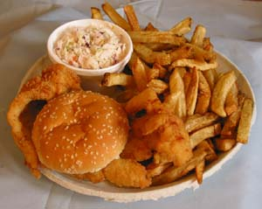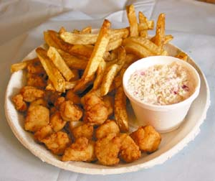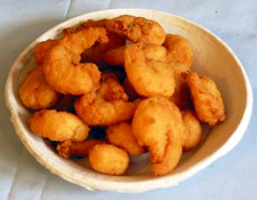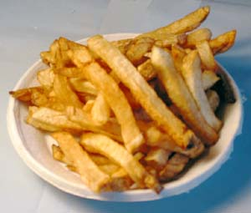

**Newsletter Subscription/Membership Form 2023**

584 E. Genesee St., Fayetteville, NY 13066

** Please complete the entire form and return to the Center**

**\*\*\*Must Answer\*\*\***

**\*Registrant #1:** ___________________________________________________________

**\*Date of Birth (M/D):** __________

**Registrant #2: __________________________________________**

**Date of Birth (M/D):** __________

**\*Address:** _______________________________________________________________

**\*City:** ___________________________________________________________________

**\*State: ____________ *Zipcode:_____________ *Phone #:_____________________**

**Are you interested in volunteering and helping out the center? Yes ____ No _____**

**\*If yes, please list what your interests are (ex: Kitchen, Newsletter, Fundrasiers, ect.):**

**______________________________________________________________________________**

**______________________________________________________________________________**

**\*Emergency Contact and Phone#: _________________________________________________**

**I have read and understand the Fayetteville Senior Centers Code of Conduct. I agree to abide by the rules described above for as long as I am an active member of the center. I also understand that I may be removed as a participant if I violate any of these rules.**

**\*Registrant #1 Signature:** ___________________________________________________________

**Registrant #2 Signature:_________________________________________________________**

**$25 Per Household (January-January)**

“Providing meals, smiles, and activities to the Senior community in the greater Fayetteville area”

Fish Dinner

Scallop Dinner

Shrimp Only

French Fries

“Providing meals, smiles, and activities to the Senior community in the greater Fayetteville area”