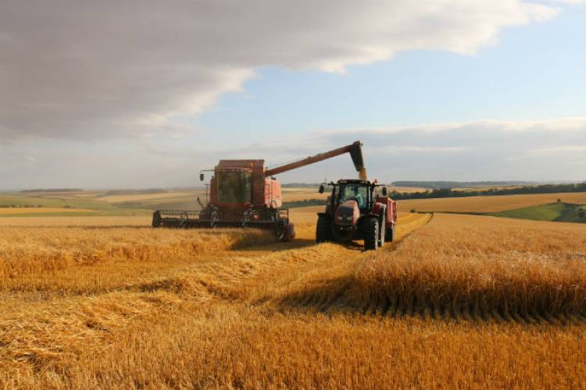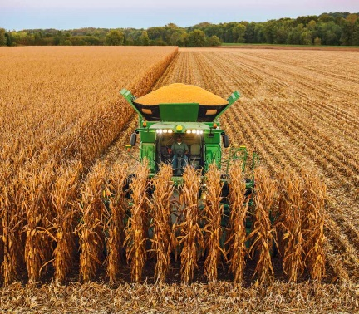

OCTOBER 2025

Strahan United Methodist Church

“Growing Disciples for

Jesus Christ!”

|  |  |  |  |  |  |  |
| --- | --- | --- | --- | --- | --- | --- |
| *Sunday* | *Monday* | *Tuesday* | *Wednesday* | *Thursday* | *Friday* | *Saturday* |
|  |  |  |  |  |  |  |
|  |  |  | **1**  **United**  **Women in Faith**  **7:00** | **2** | **3** | **4**  UWFaith Iowa Annual Meeting at Algona  9:00 – 3:00 |
| 5  **Worship Service**  **9:45 am**  **Sunday School 10:45 am**  Happy Birthday  Jun Caole | 6  Happy Birthday  Joni Hickey  Dusty Goodman | 7 | 8 | **9**  Happy Birthday  Abigail Moen | **10**  Happy Birthday  Ava Grindle  & Nathan Bowen | **11** |  |
| **12**  **Worship Service**  **9:45 am**  **Sunday School 10:45 am**  Happy Anniversary John & Jill Wade | 13 | 14 | 15 |  | **17**  Happy Birthday  Nathan Stouder & Dusty Smiley | 18 |
| 19  **Worship Service**  **9:45 am**  **Sunday School 10:45 am** | 20 | 21 | 22  Happy Birthday  Ella Spurgiss | 23 | 24  Happy Birthday  Candi Morrical & Katie Pollock | 25  Happy Birthday  Gregg Christensen |
| 26  **Worship Service**  **9:45 am**  ***Ingathering Sunday***  **Kids in costumes get treats after church** | 27  Happy Birthday  Haiden Olerich,  Jenn Gee,  & Bianka Honeyman | 28 | 29  November Board Meetings  **Trustees 6:30 pm**  **Ad Board**  **7:00 pm** | 30  Happy Birthday  Noah Hillyer &  Carol Spicer Weeks | 31 |  |