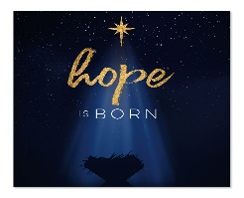

December 2025
Strahan United Methodist Church
“Growing Disciples for Jesus Christ!”
Sunday | Monday | Tuesday | Wednesday | Thursday | Friday | Saturday
 | 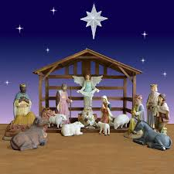  1 | 2 | 3  United Women in Faith 6:00  Red Oak | 4 | 5  Set up Christmas Shoppe  3:30 | 6  Christmas Shoppe  1:00 – 3:00  Malvern Library  Happy Birthday  Pam Auerbach & Connie Jones
7 2nd Sunday of Advent  Worship Service  9:45 am  Communion  Program Practice 10:45 am  SS ZOO Trip | 8  Happy Birthday Wyatt Grindle | 9  Happy Birthday  Price Schroeder | 10  Happy Anniversary James & Harva Paul | 11 | 12  Happy Birthday Makayla McGrew  &  Vera Weeks | 13
14 3r^{d} Sunday of Advent  Worship Service  9:45 am  Program Practice 10:45 am  Christmas Program  6:00 p.m. | 15  Happy Birthday Natalie Goodman | 16 | 17  All Church Caroling 6:00 with food after  Happy Anniversary Charles & Marilyn Kayton | 18 | 19   | 20
21 4th Sunday of Advent  Worship Service  9:45 am | 22  Happy Birthday  Dave York | 23 | 24  Christmas Eve Worship  8:00 p.m. | 25  Happy Birthday  Brian Hillyer  Donald Angus  Hayden Pollock | 26  Happy Birthday  Nole Bowen | 27  News due for January 2026 newsletter
28  Worship Service  9:45 am | 29  Happy Anniversary Dusty & Tara Goodman | 30  On the 29th  Happy Birthday  Vera Stephens & Bill Pollock | 31  New Year’s Eve Party 7:00 | 

