
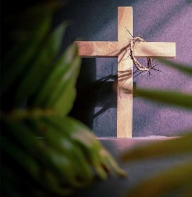
April 2022
Strahan United Methodist Church
“Growing Disciples for Jesus Christ!”

Sunday | Monday | Tuesday | Wednesday | Thursday | Friday | Saturday
 |  |  |  | On the 1st:  Happy Anniversary Jeff & Kelsey Spicer | 1  Happy Birthday Brooke Johnston  & Lillian Irvin | 2  Church Clean-up  9:00 a.m.
3  Adult SS 8:45  Worship 9:45  Communion  Children SS  10:45  VBS planning  4:45  Movie SABINA  6:00 | 4  Happy Birthday Sharon McCall  On the 3rd:  Happy Birthday Jayce Wade | 5  Happy Birthday Jennifer Frazee | 6  UWF  7:00 | 7  Happy Birthday Nathan Paul  & Steve McKinney  Happy Anniversary Curt & Jennifer Frazee | 8 | 9  Church  Clean-up  9:00 a.m.  Rain date
10  PALM SUNDAY  Adult SS 8:45  Worship 9:45  Children SS  10:45  Happy Birthday Luci Olerich | 11 | 12 | 13  Happy Birthday William Angus &  Gabi Pollock | 14  Happy Birthday Bryce Christensen | 15  Good Friday  Service  7:00 pm | 16
17  Easter  Sunrise Service 6:00  Adult SS 8:45  Worship 9:45  Easter Egg Hunt  10:45 | 18  Happy Birthday  Tara Goodman | 19 | 20  Happy Birthday Cathy S. Pollock | 21  Happy Birthday James Paul | 22  Earth Day! | 23
24  Adult SS 8:45  Worship 9:45  Special Offering  Children SS  10:45 | 25  News due for May newsletter | 26 | 27 | 28 | 29 | 30

