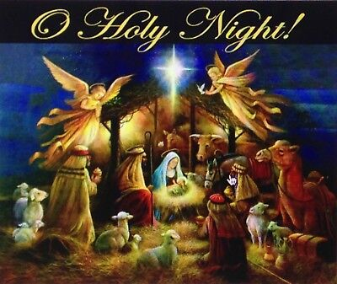

December 2022
Strahan United Methodist Church
“Growing Disciples for Jesus Christ!”
Sunday | Monday | Tuesday | Wednesday | Thursday | Friday | Saturday
 |  |  |  | 1 | 2  Set up Christmas Shoppe  5:00  Malvern UMC | 3  Christmas Shoppe  1:00 – 4:00  Malvern UMC
4  Adult SS 8:45 Worship Service  9:45 am  Communion  Program Practice 10:45 am | 5 | 6  Happy Birthday Connie Jones | 7  United Women in Faith  6:30  Classic Cafe | 8  Happy Birthday Wyatt Grindle | 9  Happy Birthday Price Schroeder | 10  Happy Anniversary James & Harva Paul
11  Adult SS 8:45 Worship Service  9:45 am  Program Practice 10:45 am  Christmas Program  6:00 p.m. | 12  Happy Birthday Makayla McGrew  &  Vera Weeks | 13 | 14 | 15  Happy Birthday Natalie Goodman | 16 | 17  Happy Anniversary Charles & Marilyn Kayton  Happy Birthday Connr Gray
18  Worship Service  9:45 am | 19 | 20 | 21  All Church Caroling  4:00  with food to follow | 22  Happy Birthday Dave York | 23 | 24  Christmas Eve Worship  8:00 p.m.
  25  Happy Birthday  Brian Hillyer  Donald Angus  Hayden Pollock | 26  News due for January 2023 newsletter | 27 | 28  Happy Birthday  Emalie Hogan  & Jerrod Wilson | 29  Happy Anniversary Dusty & Tara Goodman  Happy Birthday  Bill Pollock | 30 |   31  New Year’s Eve Party  7:00

