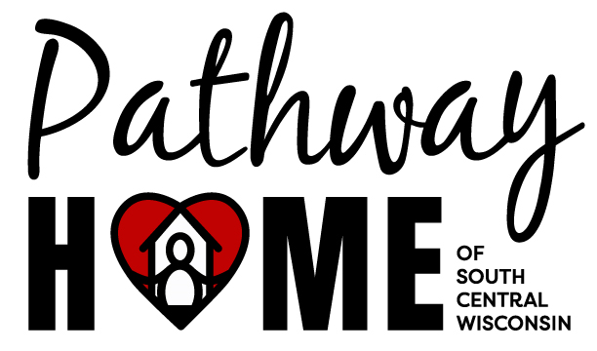

1200 Silver Circle

Baraboo, WI 53913

PHONE: 608-356-3069

Email: jessica@pathwayhomewi.org

**Background Check Authorization Form**

I authorize Pathway Home of South Central Wisconsin, Inc. to conduct a criminal background screening.

I authorize and consent, without reservation, to the retrieval of information from CCAP and any other form of Public Records Search.

I certify that all of the statements and answers set forth on the application form are true and complete to the best of my knowledge. I understand that if any statements or answers are found to be false or information has been omitted, such false statements or omissions will be just cause for termination of my employment/volunteer term.

I further acknowledge that this authorization and consent will remain in effect throughout my employment/volunteer term.

______________________________________________ _________________________

Signature/Volunteer Date

______________________________________________ _________________________

Print Name Date of Birth

If I am under 18 years of age, a parent or guardian must read, agree to statements and sign and date below:

______________________________________________ ___________________________

Signature – Parent or Guardian Date