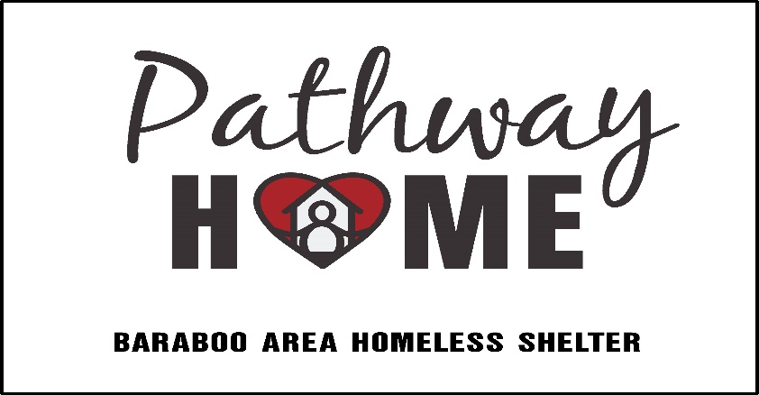
Last name (write legibly!):

__________________________

Release and Waiver of Liability and Indemnity

This Release and Waiver of Liability and Indemnity (the release) dated this _________ day of ____________(month), 20______, by the volunteer in favor of Pathway Home of Baraboo Area Homeless Shelter, a non-profit corporation, their directors, officers, employees, and agents.

Release and Waiver: The volunteer does hereby release and forever discharge Pathway and its successors from any and all liability, claims, causes of action, and demands of whatever kind or nature, either in law or in equity, which arise or may hereafter arise from the Volunteer's participation with and for Pathway.

Awareness and Assumption of Risk Involved: The volunteer desires to work as a volunteer for Pathway without compensation and engage in the activities related to being a volunteer. The volunteer understands that activities may include but are not limited to the following: working at Pathway Home offices and worksites; working in or for Pathway Home ReStore operations; loading and unloading materials; constructing and rehabilitating residential buildings; other construction-related activities; and other volunteer activities. The volunteer understands that activities may include work that may be hazardous, including, but not limited to, exposure to lead, asbestos, and mold, which may cause or worsen certain illnesses, especially if the volunteer does not wear protective equipment, is exposed for extended periods of time, or has a pre-existing immune system deficiency. The volunteer understands that the food, accommodations, and medical facilities may be donated to Pathway and be beyond the control of Pathway. The volunteer also understands that Pathway does not assume any responsibility for or obligation to provide financial or other assistance to the volunteer, including, but not limited to, medical, health, or disability insurance. The volunteer acknowledges they have been given the opportunity to read the Pathway Home policies and procedures manual, as well as all confidentiality and crisisdocuments. They further understand this information and agree to Practice these safety measures.

Consent to Transportation and Medical Treatment: The volunteer consents to the use of first aid treatment and the use of generic and over the counter medications and treatments as directed by manufacturer labels, whether administered by Pathway employee or first aid personnel. In an emergency, the volunteer understands Pathway employees may try to contact the individual listed as an emergency contact. If an emergency contact cannot be reached promptly, the volunteer hereby authorizes Pathway employees to act as an agent for the volunteer to consent to any examination, testing, x-rays, medical, dental or surgical treatment for the volunteer as advised by a physician, dentist or other health care provider. This includes, but is not limited to, the volunteer’s assessment, evaluation, medical care and treatment, anesthesia, hospitalization, or other health care treatment or procedure as advised by a physician, dentist or other health care provider. The volunteer also authorizes Pathway to arrange medical transportation as deemed necessary and appropriate in their discretion. I, the Volunteer, do hereby release, forever discharge and hold harmless Pathway from any liability, claim, demand, and action whatsoever brought by me or on my behalf which arises or may hereafter arise on account of any transportation, first aid, assessment, care, treatment, response or service rendered in connection with my Activities with any of the Pathway employees, personnel, or agents.

Insurance: The volunteer understands that, unless specifically agreed to by Pathway in writing, Pathway does not carry or maintain health, medical, or disability insurance coverage for any volunteer. Each volunteer is expected and encouraged to obtain his or her own medical or health insurance coverage. The volunteer understands that they are and remain responsible for payment of such hospital, physician, ambulance, dental, medical or other services obtained for them or their child. The volunteer agrees that Pathway does not assume any responsibility for the payment of such fees or expenses which may be incurred. If the volunteer has health insurance, their personal health insurance is their primary coverage.

Photographic Releases and Consent to Contact: The volunteer does hereby grant and convey unto Pathway all right, title, and interest in any and all photographic images, video, and audio recordings made by Pathway during the Pathway program, including, but not limited to any royalties, proceeds, and other benefits derived from such photographs or recordings. The volunteer grants Pathway the right to use photographs in future advertisement and informational materials. In the event of inclement weather or emergency conditions, the volunteer consents to text message notification when stores are closed for the day.

Independent Legal Advice: The volunteer acknowledges that he or she has been encouraged to obtain independent legal advice prior to the execution of this Release and Waiver of Liability and Indemnity and has either obtained same or chosen to waive such independent legal advice.

Other: This release shall be governed by and interpreted in accordance with the laws of the United States of America and the state of Wisconsin within which it is executed. The volunteer agrees that in the event that any clause or provision of this Release and Waiver of Liability and Indemnity shall be held to be invalid by any court of competent jurisdiction, the invalidity of such clause or provision shall not otherwise affect the remaining provision of this release which shall continue to be enforceable. The volunteer has fully considered their decision, the benefits and risks involved and hereby give their informed consent to participate in all volunteer Activities. The volunteer has read and understood this Release and Waiver of Liability, any questions have been answered, and they voluntarily agree to the above provisions. It is the volunteer’s intent to bind their heirs, next of kin, assigns and legal representative.

In witness whereof the volunteer has executed this Release and Waiver of Liability and Indemnity as of the day and year first written above.

VOLUNTEER: _____________________________________________________________________________
(signature)

Print name:___________________________________________________________ Date: _________________
(print name – legibly, please!)

____________________________________________________________________________________________________
Address City State Zip

Email: __________________________________________________ Phone: ____________________________

Emergency Contact (name and phone): ________________________________

*******************************************************

Areas of Interest: (please circle any areas where you’d like to volunteer!)

Construction Mentoring Food Donation Building Services/Supp

Support/Office Services Other: ________________________

