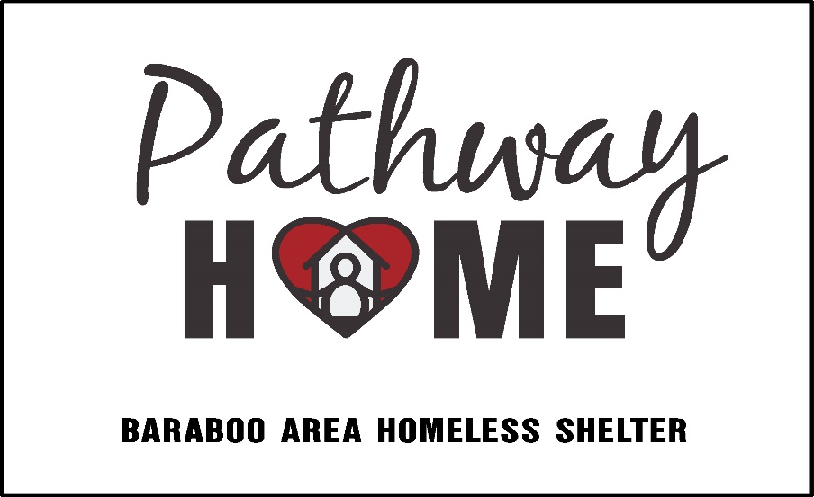
Last name (write legibly!):

__________________________

Release and Waiver of Liability and Indemnity for Minors

This Release and Waiver of Liability and Indemnity (the Release) dated this _____ day of __________, 20___, by a minor child (Volunteer), and a parent having legal custody or having the status of legal guardian of the Volunteer (Parent/Guardian), in favor of Pathway Home of Baraboo Area Homeless Shelter and Pathway Home International (Pathway), a non-profit corporation, their directors, officers, employees and agents.

Release and Waiver: Volunteer and Parent/Guardian expressly and specifically assume the risk of any injury, harm, and loss/damage of personal property that may result from the Volunteer’s participation with and for Pathway and forever release and discharge Pathway and it’s successors from any and all liability claims, causes of action, and demands of whatever kind or nature, either in law or in equity, which arise or may hereafter arise from the Volunteer's participation with and for Pathway.

Awareness of and Assumption of Risks Involved: The volunteer desires to work as a volunteer for Pathway without compensation and engage in the activities related to being a volunteer. The volunteer understands that my activities may include but are not limited to the following: working at Pathway Home offices and worksites; working in or for Pathway Home ReStore operations; loading and unloading materials; constructing and rehabilitating residential buildings; other construction-related activities; and other volunteer activities. The Volunteer understands that the Pathway Program may include activities that may be hazardous to the Volunteer and that food, accommodations, and medical facilities may be donated to Pathway and beyond the control of Pathway. The Volunteer and the Parent/Guardian understand that the Pathway Program involves work that may be hazardous to the Volunteer. The Volunteer and Parent/ Guardian also understand that Pathway does not assume any responsibility for or obligation to provide financial or other assistance to the volunteer, including but not limited to medical, health, or disability insurance in the event of injury illness, death, or property damage. The volunteer acknowledges they have been given the opportunity to read the Pathway Home Policies and procedures, crisis protocol and procedures, and confidentiality documents. They further understand this information and agree to practice these safety measures.

Medical Treatment: Volunteer and Parent/Guardian hereby release and forever discharge Pathway from any claim whatsoever which arises or may hereafter arise on account of any first aid, treatment, or service rendered in connection with the Volunteer’s Activities with Pathway or with the decision by any representative or agent of Pathway to exercise the power to consent to medical or dental treatment as such power may be granted and authorized in the Parental Authorization for Treatment of a Minor/ Child.

Insurance: The Volunteer and the Parent/Guardian understand that, unless specifically agreed to by Pathway in writing, Pathway does not carry or maintain health, medical, or disability insurance coverage for any Volunteer. Each Volunteer is expected and encouraged to obtain his or her own medical or health insurance coverage. The volunteer understands that they are and remain responsible for payment of such hospital, physician, ambulance, dental, medical or other services obtained for them or their child. The volunteer agrees that Pathway does not assume any responsibility for the payment of such fees or expenses which may be incurred. If the volunteer has health insurance, their personal health insurance is their primary coverage.

Photographic Release and Consent: The Volunteer and Parent/Guardian does hereby grant and convey unto Pathway all right, title, and interest in any and all photographic images and video or audio recordings made by Pathway during the Pathway Program, including, but not limited to any royalties, proceeds or other benefits derived from such photographs or recordings. The Volunteer and Parent/Guardian do also agree to the use of these images for HFHWRA advertising.

Independent Legal Advice: The Volunteer and Parent/Guardian acknowledge that they been encouraged to obtain independent legal advice prior to the execution of this Release and Waiver of Liability and Indemnity and has either obtained same or chosen to waive such independent legal advice.

Other: The Volunteer and Parent/Guardian expressly agree that this Release is intended to be as broad and inclusive as permitted by the laws of the State of Wisconsin, and that this Release shall be governed by and interpreted in accordance with the laws of the State of Wisconsin. The Volunteer and Parent/Guardian agree that in the event that any clause or provision of this Release is held to be invalid by any court of competent jurisdiction, the invalidity of such clause or provision shall not otherwise affect the remaining provisions of this Release which shall continue to be enforceable.
The volunteer and Parent/Guardian have carefully considered their decision, the benefits and risks involved and hereby give their informed consent for the Volunteer to participate in all volunteer Activities. The volunteer and Parent/Guardian have read and understand this Release and Waiver of Liability, any questions have been answered, and they voluntarily agree to the above provisions. It is the intent of the volunteer and Parent/Guardian to bind their heirs, next of kin, assigns and legal representative.

IN WITNESS WHEREOF, Volunteer and Parent/Guardian have executed this Release as of the day and year written above.

____________________________________ _____________________________________________
Volunteer’s Name Volunteer’s Signature

_______________________________________________________________________________________
Address City State Zip code

____________________________________ _______________________________________________
Parent/Guardian Name Parent/Guardian Signature

_______________________________________________________________________________________
Address City State Zip code

____________________________________ _____________________________________________
Preferred phone of Guardian Secondary phone of Guardian

Date Signed__________________________

