Installation Instructions for Can Am Maverick X3

Make sure your box contains the following:
- X3 stereo
- Mounting kit
- 2 L base clamps
- 2 bent clamps
- 4 screws
- Zipties

Installation:
- Make sure to test fit your stereo to your roll cage before any holes are drilled into the box.

- Hold stereo up in cage and push as far forward as possible.

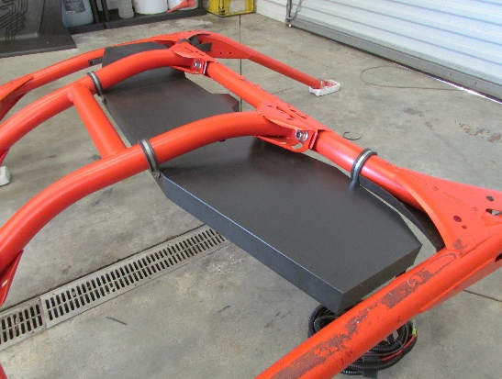

- Place the 2 L base clamps around the front roll bar with the L base on the outside of the bar.
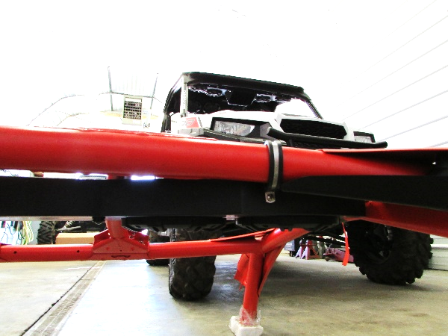

-Run a screw through both holes on the clamp and directly into the plastic box for both of the front mounted clamps.

-Place a flat bent clamp around both center bars in the middle of the cage.

-Squeeze the clamp together until the holes line up and run a screw through the conjoined holes and directly into the plastic box.

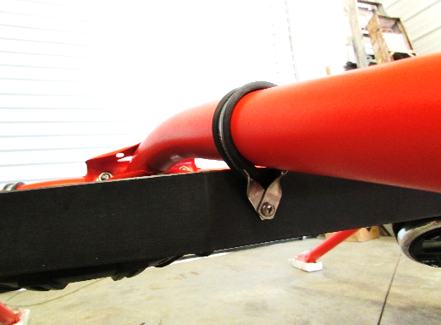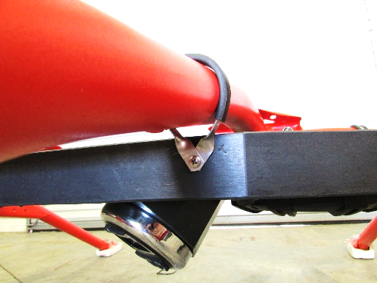

-Your stereo is now mounted and in place.

Wiring:
-Run the loomed paired wire towards the back of the roll cage on the passenger side and drop it down behind the passenger seat securing in place with provided zipties.
-Secure ring terminals to battery making sure the positive and negative wires correspond with the battery’s positive and negative posts.
-Make sure the switch is in the on position and your stereo will be powered up and ready to go!

*****NOTE***** If you have a boss radio in your swampdonkey stereo there is a power button on the head unit itself located right beside the volume knob make sure this button is pushed the first time you power up you radio after that the master switch on the box with turn it on and off and retain its memory.

