Stereo Assembly Instructions
For Technical Support Call: (740)858-0707

- Arrange clamps on roll bars (flat feet inside)
- One clamp on driver/passenger side
- 2 clamps on the front

- Position stereo overhead inside the perimeter of the roll cage and push all the way forward
until box touches the clamps on the front most bar of the roll cage.

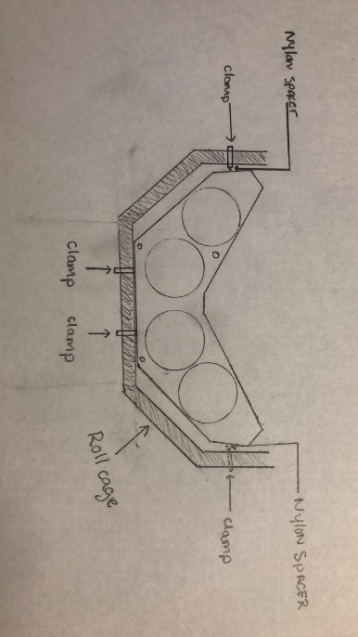

- Make sure box is level with roof or top of the roll cage.

- Fasten the front of the box to the roll cage using the screws provided (Do NOT tighten fully)

- Position existing screws into the clamps on driver and passenger side and slide the provided Nylon spacers between the clamps and the box.
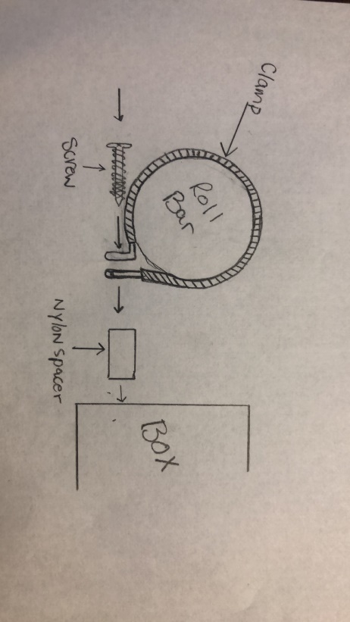
- Once all 4 screws are started into the box you may proceed to tighten up the screws until secure.

- Run wires however you like and enjoy stereo!

