Install Instructions
RZR Trubo S System

- Arrange clamps on roll bars (Flat feet inside)
- One clamp on driver/passenger side
- 2 clamps on the front

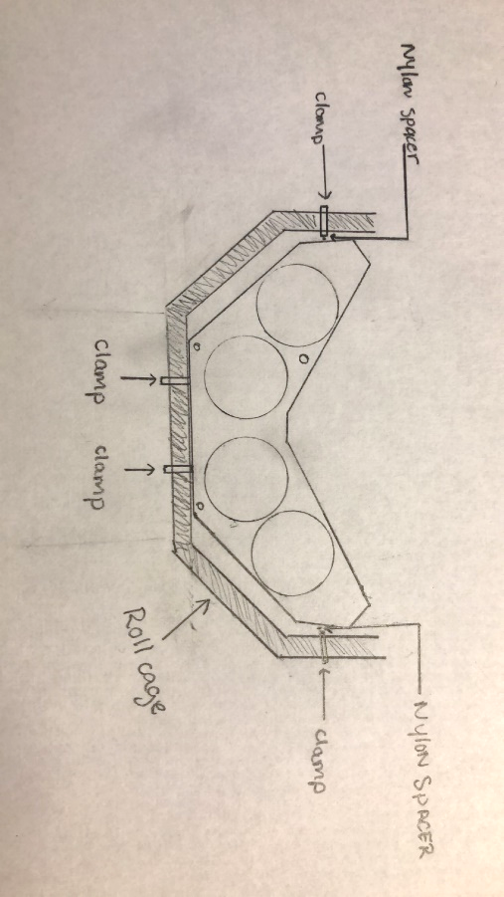

- Position stereo overhead inside the perimeter of the roll cage and push all the way forward until box touches the clamps on the front most bar of the roll cage.

- Make sure box is level with roof or top of roll cage.

- Fasten the front of the box to the roll cage using the screws provided.
Note: Do not tighten fully

- Position existing screw into the clamps on driver and passenger side and slide the provided Nylon spacer between the clamps and the box.

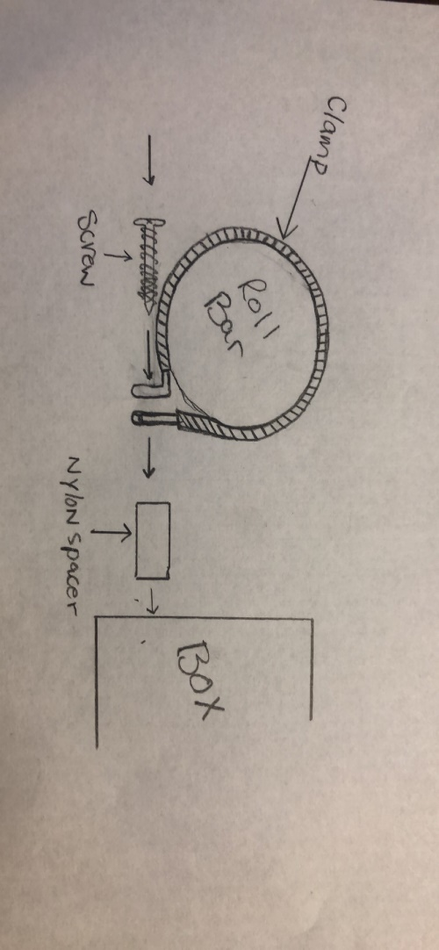
- Once all 4 screws are started into the box you may proceed to tighten up the screws until secure.
- Run wires however you like and enjoy your new system.

