Can am Trail/Sport
Install Instructions

Things you will need:
- Phillips head Screwdriver
- Wire cutter
- 10 mm
Sony Tuning
Band1: -3
Band2: -2
Band3: 0
Band4: 5
Band5: 9

- Tape Measure

Step 1: Remove Roof (if applicable)

Step 2: Obtain L brackets and self-drilling screws and your tape measure.

Step 3: Measure and mark 6” inches back from the inside of the front most roll bar.

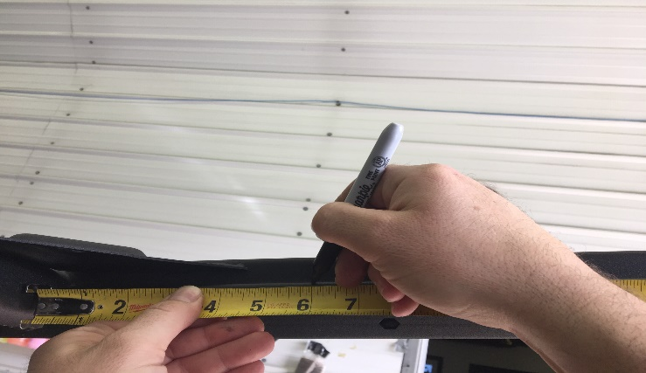

Step 4: Align “L” bracket with the 6” mark you have made on your cage with the longer side facing downward.
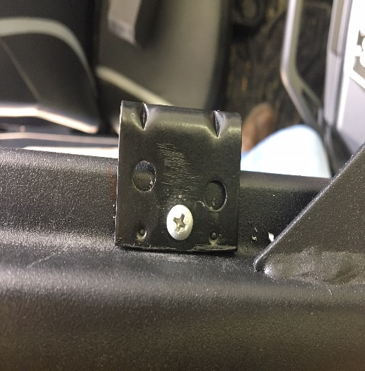

Step 5: Secure short side of bracket with supplied screw. (See image 2) Repeat for both sides.
Note: Bracket holes may very use the one that is best for your application.

Step 6: Once brackets are mounted reinstall roof if applicable.

Step 7: Place round clamps on frontmost roll bar with the flat foot in towards the cab.

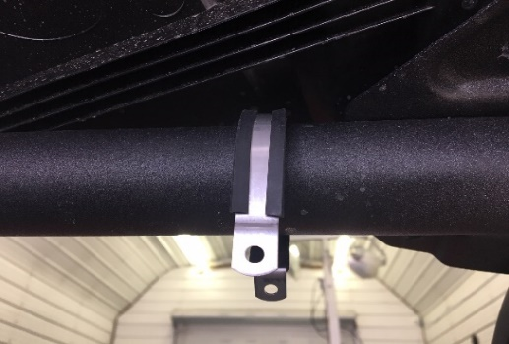

Step 8: Place your stereo overhead to the roll bar and push all the way to the front of the bar until it touches the clamps. (Make sure it keep it level)

Step 9: Screw through both holes of the round clamps and directly into the stereo box.

Step 10: Adjust stereo so that it is level in your machine and attach it to the mounted “L” bracket with supplied screws in the center of the bracket directly into the stereo box.

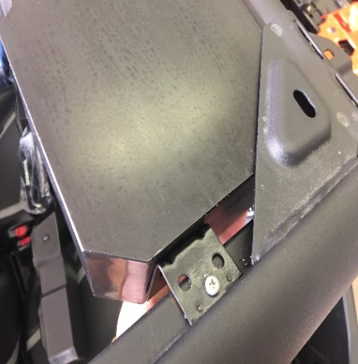

Step 11: Now that your stereo is mounted run your wires directly to the battery.
(There are supplied zip ties for running wire)
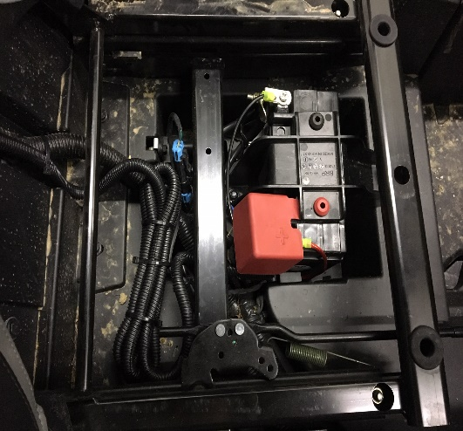
Step 12: Enjoy your system, if you have any questions, concerns, or comments feel free to call us at 740-858-0707!
Note: Use supplied screw spacers of necessary.

