Stereo Assembly Instructions
For Technical Support Call: (740)858-0707
- Place straps around bars like shown. Two on each side.
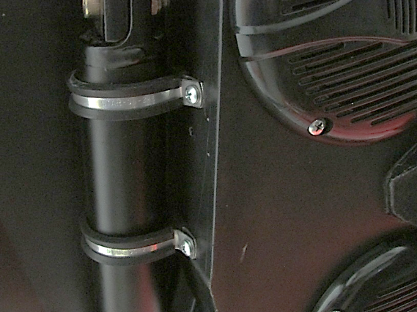
- Hold stereo box against the roof, all the way to the very front. (this is easier with someone to help)
- Screw clamps to box with self-drilling screws, DO NOT tighten until all clamps are installed with screws. SCREWS CAN STRIP OUT!
- Run wire across driver cage bar to battery. Keep wire on inside of cage, secure with zip ties. (see photos)
IMPORTANT: wire needs to be under the seat bar!
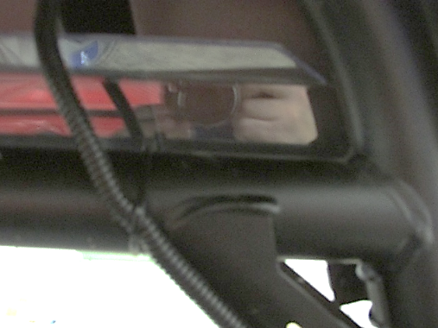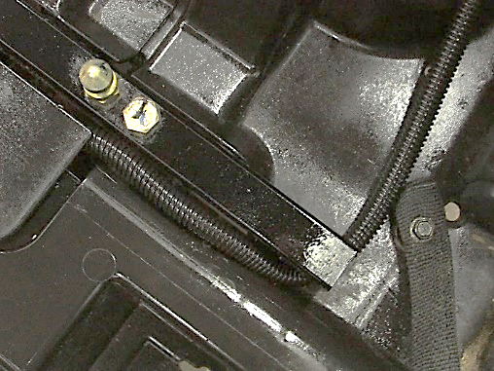

- Make the battery connections (this has to be done last!).
IMPORTANT: The fuse goes to +12V red side! (see photo)
*IF CONNECTED BACKWARDS IT WILL BLOW FUSE IN HEAD UNIT!!!!!!
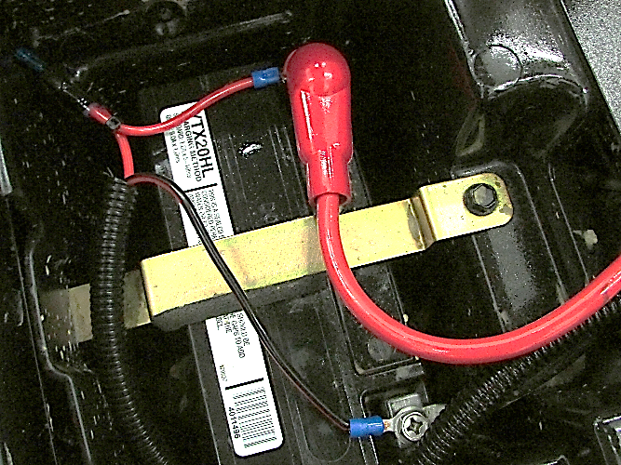
Sony Tuning
Band1: -3
Band2: -2
Band3: 0
Band4: 5
Band5: 9

- Enjoy your new stereo!!
Note: Use supplied screw spacers if necessary.

