- Make sure your box contains the following:
- KRX 1000 Stereo
- Install Kit
- 2- 24E Clamps
- 2-28E Clamps
- 4 Stainless Screws
- Zipties

- Things you will need:
- Phillips head drill bit
- Drill
- Wire Cutters (for clipping zipties)

Step one: Hang both 28E clamps on the roll cage. One on drivers side one on passenger side. Right up to the welded gusset.
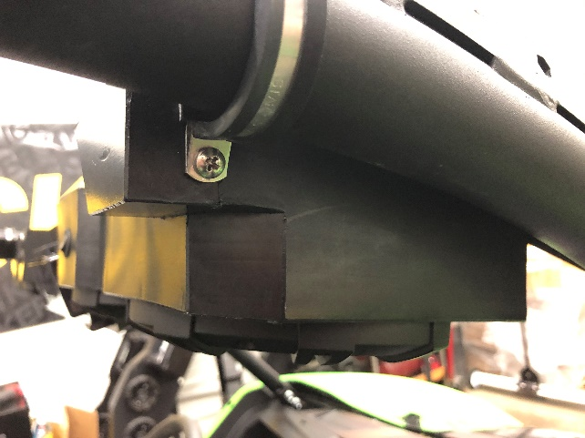

Step Two: Hang both 24E clamps on the frontmost crossbar of the roll cage.
Step Three: Grab the stereo (and a friend) to hold the stereo in between the clamps hung on the driver and passenger sides and run screws through the clamp directly into the side if the box on both sides. Let stereo hang. (Do not over tighten)
Step Four: Adjust the front clamps evenly from the center (they line up in the dips of the box)
Step Five: Run screws through the front clamps directly into the box. Tighten fully.
Step Six: Start routing the power wire back towards the drivers seat along the roll cage and attach with the supplied zipties.
Step Seven: Route wire down from the top bar behind drivers seat and down to the battery.
Step Eight: Attach the positive and negative wires to corresponding terminals and tighten fully.
Step Nine: Clip all ziptie tails, and enjoy your new Swamp Donkey Stereo!

