Jus Logistics Dispatch

Necessary documents

Owner Operator ✅ List

Starting

* Insurance certificate (your name as Owner )
* W-9
* Driver's license
* Certificate of Authority (DOT and MC)
* Truck registration
* Motor vehicle dimension
* load board and account for lanes (usernames and passwords)

Need for forms (DocuSign)

* Limited power
* Dispatcher Carrier Agreement
* Operator profile
* Monthly recurring payment
* Credit card authorization

Dedicated lanes (proactive): optional

* UCR
* Bank ACH (routing and account number) Voided check
* BO3
* A - Confirmation letter
* business article

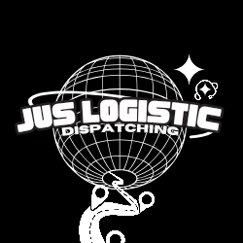

Email |[juslogisticdispatching@gmail.com](mailto:juslogisticdispatching@gmail.com)

[steven.carter@juslogisticdispatching.com](mailto:steven.carter@juslogisticdispatching.com)

Office : (484) 426-8612

CEO | Steven Carter

[www.juslogisticdispatching.com](http://www.juslogisticdispatching.com)