DGPA

Dreams Gymnastics Parents Association

www.dgpa.ca

September 20, 2025

To our friends, family, and local business community,

The Dreams Gymnastics Parents Association is a non-profit organization of parents and family members who support our local gymnasts in achieving their sporting aspirations. Through fundraising efforts, we support our member families by offsetting competition, travel expenses and training. These activities are essential to help our gymnasts achieve their goals and dreams in a sport they are passionate about.

On Thursday, November 20, 2025, we will host a Comedy Night at the Rec Room, South Common, in Edmonton. We are currently collecting items for a raffle at the event and would greatly appreciate any donation your organization would consider making. We will acknowledge our generous donors through social media and our website leading up to and on the night of the event.

On behalf of [Athlete’s Name] we thank you for your generosity. Please contact [Parent’s Name] at [Phone number] to pick up your donation prior to November 12th, 2025.

Please fill out the information below to help us acknowledge your support.

Thank you,

DGPA Member Families

| Organization Name: | | |
| --- | --- | --- |
| Donation Description: | | |
| Value of Donation: $ | | |
| Contact Person: | | Phone #: |
| Mailing Address: | | |
| City: | Prov: | Postal Code: |

High resolution logos can be emailed to [fundraising@dgpa.ca](mailto:fundraising@dgpa.ca).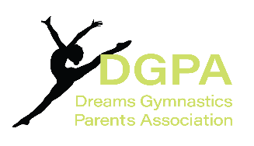

www.dgpa.ca