***Generational Engagement Matters***

***204 Inglewood Drive Rochester, NY 14619***

[***LentoryJohnson89@gmail.com***](mailto:LentoryJohnson89@gmail.com)

***www.generationalengagementmatters.com***

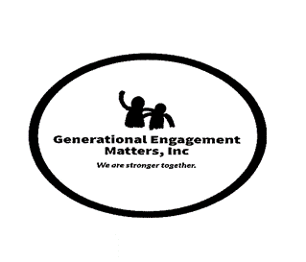***585-749-3494***

A bullied middle-schooler participated in a series of three discussions on gun violence held at his rec center. He was tired of being a victim. He had access to a gun and planned to use it on his tormentors. But, because of his involvement in those anti-gun violence discussions, where everyone—his peers and the staff members—shared how guns had impacted them, it touched him. At the third session, he confessed his plan and that he had decided he wasn’t going to shoot anyone.

Generational Engagement Matters (G.E.M) conducts many inter-generational discussions, which allow people of all ages to be educated and learn from each other. The older generation brings their life experiences. The young bring zeal and a spirit seeking to move society away from the guns they face every day. Working together with mutual respect, these teams can create safe communities.

The founder of G.E.M Lentory Johnson experienced gun violence firsthand. In 2015, Ms. Johnsons’ son, Johnny Ray Johnson was murdered in a drive-by shooting at the Boys and Girls Club of Rochester NY. Since that time, Ms. Johnson has fought against violence in the city of Rochester. In 2023, G.E.M, along with the United Christian Leadership Ministries’ Light the Way anti-gun violence campaign, educational leaders, and community members to engage young people in an opportunity to reflect on gun violence and solutions. Students in grades 6 -12 across Rochester, wrote heartfelt essays addressing how gun violence affected them. This effort gave a voice and platform to young people in past years.

This year we are preparing for a 2024 Youth Conference. This conference will be incorporating resources available to build and engage the youth and community to focus on solutions to stop the increasing violence which has become the normal throughout our nation. But we continue to need your support to make this happen.

G.E.M is proud to announce that the efforts of the young people who participated in the essay contest over the past 3 years will be honored in book format.

We are asking you to sponsor our effort to continue this work and increase our outreach with a financial donation, or by purchasing a book of essays written by our youth, and after you have read these heartfelt essays you would be moved to send the book on to a State or Federal representative for them to read as well.

Please contact me with questions regarding your sponsorship and/or concerning the essay contest. ***Donations can be made out to Generational Engagement Matters Inc. and mailed to the address listed above. GEM is a 5013c. not-for-profit organization.***

Respectfully,

*Lentory Johnson*