Westminster Nursery School and Kindergarten

New Family Pre-Registration

For brand-new families only,

please complete prior to re-registration/enrollment:

- Please visit https://www.myprocare.com/Default/Index?aWtuPTQ0MzMxMDE5NDkmc2NoSWQ9Mg==
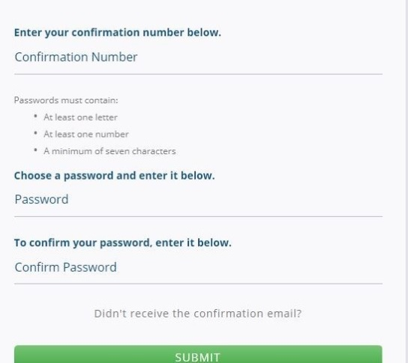
  - Families will begin by entering their email address.
  - A confirmation number will be sent via email and used to log in.
  - Families will enter information about themselves and their children.
- A confirmation email will be sent notifying families their pre-registration has been accepted by Westminster Nursery School and Kindergarten.
- Child(ren) are not enrolled until the re-registration /enrollment process has been completed by visiting www.myprocare.com/ .
- Re-registration / enrollment begins February 1 for in house families. Re-registration / enrollment begins February 5 for local community families.

Westminster Nursery School and Kindergarten

Re-Registration

  - Begin re-registration (February 1 for current families, February 5 for community families) by logging into www.myprocare.com/
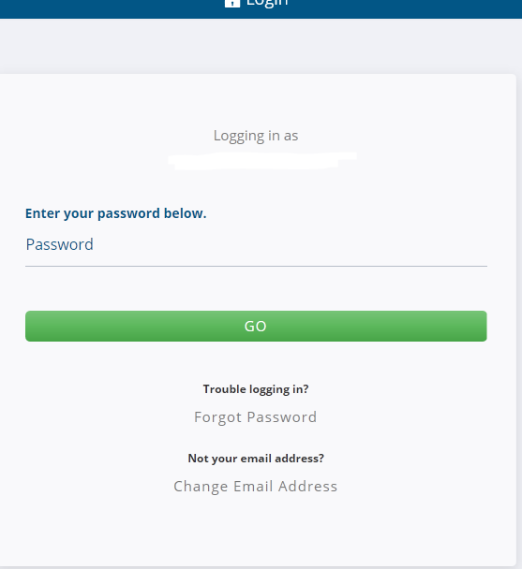

b) Once logged in, parents can view alerts – registrations are available
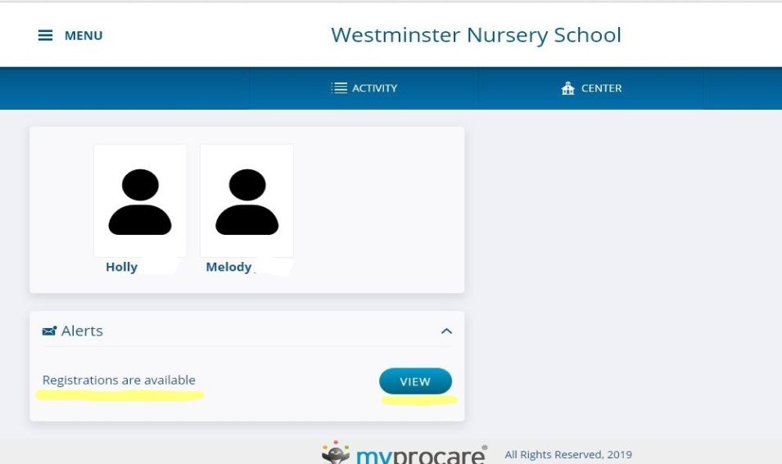

c) Begin re-registration
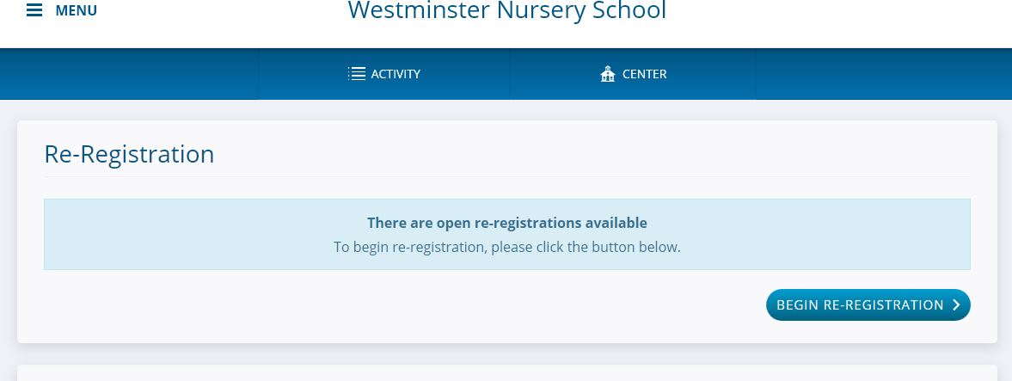
d) Select child to re-register, select programs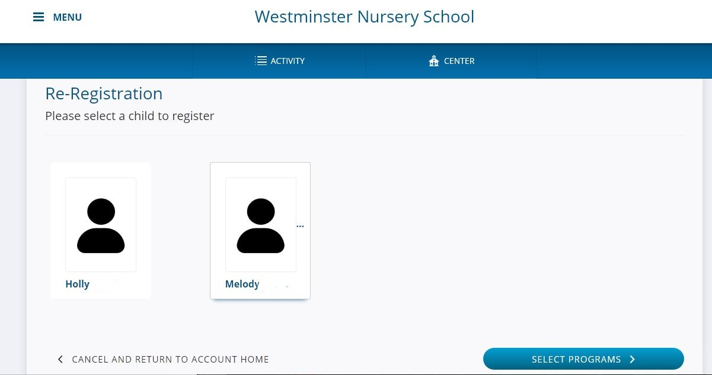

e) Sroll down to view classes, select one per child
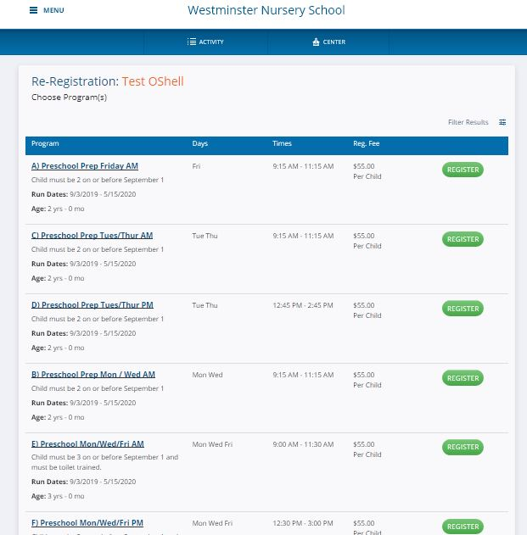
f) Continue and review child information, all fields must be completed (please type N/A in allergies and comments if there are none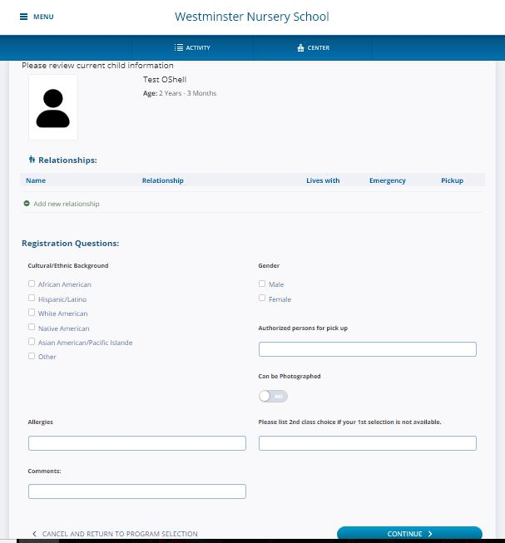
g) Continue to complete registration and provide payment information
h) Re-registration / enrollment is complete once you have received “Thank you for registering”
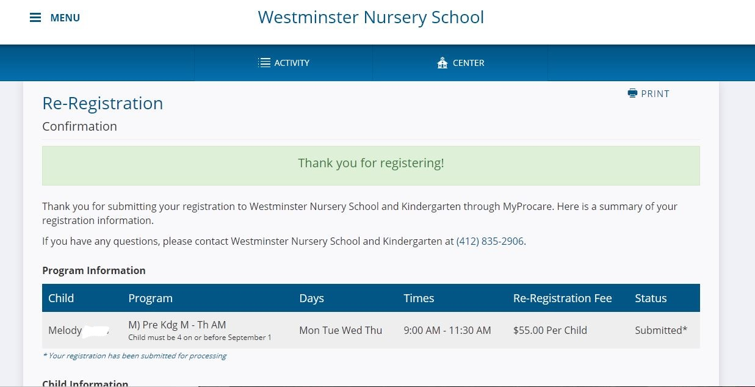

i) Student packets containing class placement information and enrollment steps will be sent at a later date.

Westminster Nursery School and Kindergarten
2040 Washington Road Pittsburgh, PA 15241 Phone 412-835-2906

