**BECAUSE OF WHAT WE BELIEVE**

“What comes to mind when we think about God is the most important thing about us.” –- A. W. Tozer

[The Apostle’s Creed](https://www.umc.org/en/content/apostles-creed-traditional) is a concise statement of Christian beliefs:

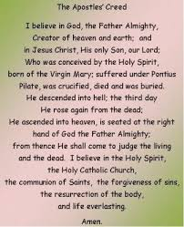

When we agree on what we believe, we are united in purpose.

To believe in these truths is to trust.

Proper doctrine is foundational.

*1Corinthians 3:9-11*

*“For we are God’s fellow workers; you are God’s field, God’s building. According to the grace of God, which was given to me, like a wise builder I laid a foundation, and another is building on it. But each man must be careful how he builds on it. For no man can lay a foundation other than the one which is laid, which is Jesus Christ.”*

The work of the Holy Spirit includes stimulating us to a life of obedience.

We live and operate in unity and purpose by the gift of grace.

God’s redemptive purpose embraces the entire world.